MODULE-9
ELECTRICAL CONTROL PANEL
The elevator control panel is a central unit that houses the electrical components responsible for controlling and managing an elevator’s movement, speed, and stopping points. Control panels contain motor drives, control boards, power supplies, and other essential components to ensure the safe and efficient operation of elevators.
The elevator panel can be considered the brain of the elevator system, managing a series of components and processes to ensure the elevator operates safely, smoothly, and efficiently. (9.1)
Basic Working Principles of Elevator Control Panels:
Input Signals: The elevator control panel receives signals from floor call buttons and cabin buttons. These signals indicate which floor the passengers wish to go to and determine the direction the elevator should move.
Control Board and Microprocessor: The control board and microprocessor inside the elevator control panel process the input signals and generate commands needed to adjust the elevator’s movement and speed.
Motor Drive: The commands from the control board are sent to the motor drive, which powers the elevator motor. The motor drive controls the motor’s speed and torque, ensuring the elevator transports passengers to the desired floor safely and comfortably.
Speed and Position Sensors: The elevator control panel communicates with sensors that monitor the elevator’s speed and position. These sensors provide feedback to ensure the elevator moves at the proper speed and stops accurately at each floor.
Safety and Emergency Systems: The elevator control panel is integrated with various safety systems and emergency devices to ensure safe operation. These include overload detection, door interlocks, emergency brakes, and rescue functions during power outages.
Communication: The elevator control panel also communicates with building management systems and maintenance teams to monitor and report the elevator’s status and performance.

Types of Control Panels:

1- VVVF DrIve Elevator Control Panels

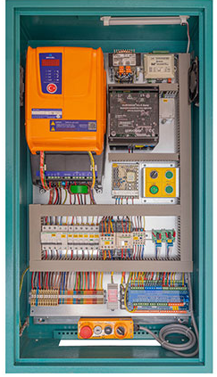
Figure 9.1 VVVF Drive Elevator Control Panel (9.2)
VVVF (Variable Voltage Variable Frequency) drives emerged with the advancement of power electronics technology and have increasingly replaced older single-speed and dual-speed systems over recent years. Today, in most modern elevator projects, the use of VVVF drives for motor control is a mandatory specification item. Compared to single-speed or dual-speed systems, VVVF systems offer numerous advantages. For example, up to 40% energy savings, significantly improved ride comfort, and the ability to reach much higher speeds make this system indispensable in elevators for high-end buildings.
VVVF-controlled elevators can be manufactured as open-loop systems for short travel distances, low speeds, and light load capacities. However, closed-loop systems—established by receiving feedback from the motor shaft via an encoder—are generally more preferred. This is because they enable millimeter-precise floor stops and deliver maximum comfort regardless of the load under all conditions in elevator operation. (9.3)
2. MACHINE ROOM-LESS (MRL) ELEVATOR CONTROL PANELS
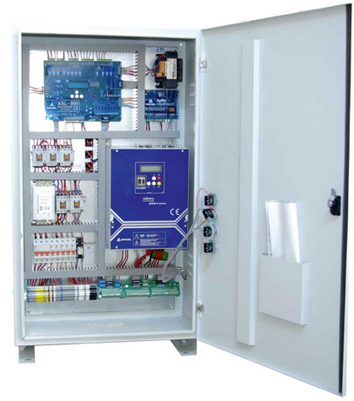
Figure 9.2 Elevator Control Panel (9.4)
Machine Room-Less (MRL) elevator systems, which are a new trend in elevator installation, have rapidly become widespread in developed countries and have begun to increase their market share in our country as well. The main difference between MRL elevators and traditional elevators is the use of synchronous motors instead of the asynchronous motors that were commonly used in almost all previous applications. This fundamental change makes it mandatory to use a VVVF-controlled closed-loop drive system. In addition, since MRL elevators do not have a machine room as in conventional systems, the control panel must be ergonomically designed and offered in a form that can be mounted near the top landing door or a similar location to accommodate the end-user’s needs.

3. HYDRAULIC DRIVE ELEVATOR CONTROL PANELS
Hydraulic elevators are sometimes preferred over machine-driven elevators due to certain application-specific advantages. Although their speed is much lower and their energy consumption is higher compared to machine-driven elevators, their structural characteristics make them necessary in certain architectural designs.Hydraulic control panels are manufactured with the capability to optimally drive hydraulic systems using three different motor drive techniques. Depending on the motor power, travel speed, and comfort requirements of the elevator, these techniques can be summarized as: direct-on-line drive, star-delta starting, or soft starter-controlled drive.
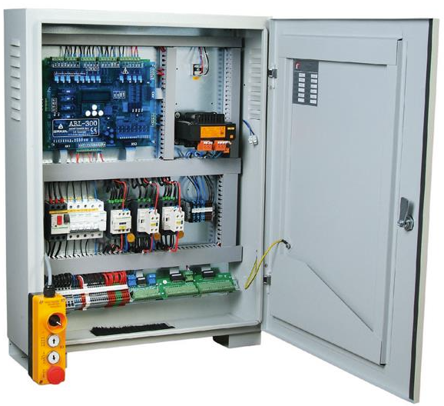
Figure 9.2 Hydraulic Elevator Control Panel (9.5)
In hydraulic elevator control systems, the motor drive technique and the method of controlling the hydraulic valves should be designed according to the specific project requirements and the type of hydraulic unit used.
4. DUAL-SPEED MOTOR-DRIVEN ELEVATOR CONTROL PANELS
In dual-speed elevators, a slightly more advanced version of basic on-off motor control, known as the dual-speed motor control technique, is used. A dual-speed elevator motor contains two windings with different pole numbers. The first winding is energized during the main travel of the elevator, while the second is energized during the landing phase.
The purpose of this system is to improve comfort during stops at floors compared to single-speed systems by using simple switching via contactors. However, due to the very high inrush currents and the vibrations it causes in the elevator cabin, this system is no longer widely preferred.
Today, dual-speed panels are generally used in low-rise, low-load-capacity, and low-speed budget elevators. Due to the high inrush currents caused by high motor powers, which can disrupt the power grid, these systems should be avoided and replaced with drive-controlled systems.

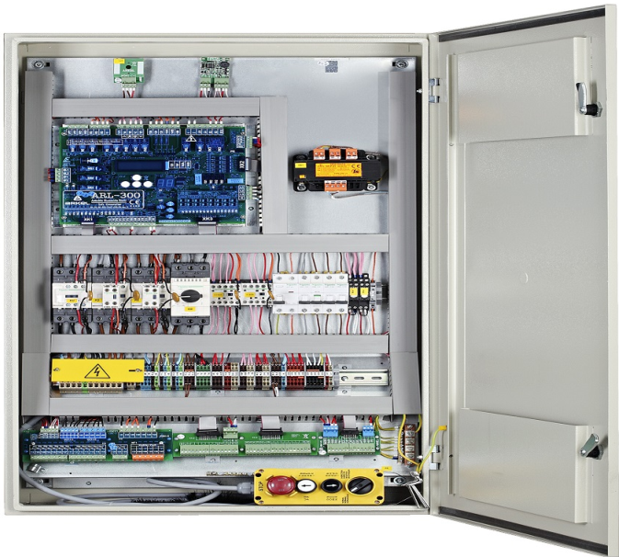
Figure 9.6 Dual-Speed Elevator Control Panel (9.6)
5. SINGLE-SPEED ELEVATOR CONTROL PANELS
Single-speed elevators are controlled by switching the drive motor on and off via a contactor. It is a very simple system, and no energy efficiency or ride comfort should be expected from it.
Today, it is generally only used in very basic applications such as dumbwaiters or office file elevators. Since single-speed control systems provide very poor comfort, they are almost never used in passenger elevators.

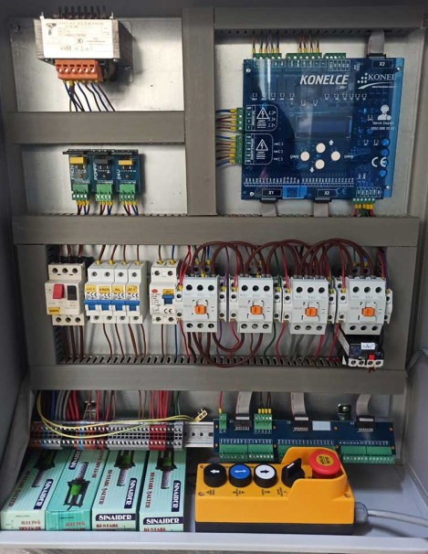
Şekil 9.7 Tek Hızlı Kontrol Panosu (9.7)

ABILITY TO CHECK MATERIALS REQUIRED IN THE ELECTRICAL CONTROL PANEL AND THEIR STANDARD VALUES
To obtain information about the materials that should be present in an electrical control panel and their required standard values, it is important to refer to specific standards and regulations. In Turkey, the applicable standards include TS EN 61439 and IEC 60068-3-3.
These standards provide detailed information about the design, manufacturing, and operating conditions of electrical panels. For instance, TS EN 61439-1 defines the electrical and mechanical properties of control panels. Additionally, IEC 60068-3-3 is used to determine whether panels comply with mounting and operational conditions.
Moreover, compliance with these standards must be ensured during the design and installation of electrical panels and related systems.
Some basic materials that should be included in elevator electrical control panels, along with the standards they must meet, are as follows:
- Motor Drivers: Devices that control the movement of the elevator.
- Control Boards: Boards that manage elevator motion and stopping points.
- Power Supplies: Units that provide the necessary electrical energy for the elevator.
- Speed and Position Sensors: Sensors used to monitor the elevator's speed and position.
- Safety and Emergency Systems: Systems used in safety-critical and emergency situations.
- Switches and Contacts: Components that control the electrical circuit.
- Coils and Capacitors: Used for current and voltage regulation.
- Diodes, LEDs, and Transistors: Devices used for system control.
- Cable Color Codes: Proper labeling of cables with standardized color codes.

MODULE-9 APPLICATION AND OUTPUTS

CHECKING LABELING AND ADDRESSING INSIDE THE CONTROL PANEL

Protection of the panel enclosure and markings inside the panel:

According to TS EN 81-1+A3, contactors, relays, fuses, and terminal blocks inside control panels must be labeled according to the control schematic. On or near fuse holders, the type and rating of the fuses must be clearly indicated.
If multi-pole connectors are used, only the connectors (not individual wires) should be labeled.
Additional requirements include:
The control panel located in a shared area of the building must be protected against unauthorized access.
Cable channel covers in the control panel must be closed.
Any loose components inside the control panel must be secured.

Control Board and Contactor

According to TS EN 81-1+A3 Elevator Motion Control:
The elevator's movement must be controlled electrically.
- Normal control:
This control should be via buttons or touch-sensitive devices (e.g., magnetic card), enclosed in casings that prevent user access to live parts.

- Contactor, Auxiliary Contactor:
Main contactors (used to stop the drive machine as per article 12.7) must comply with the following usage classes as defined in EN 60947-4-1:
a) For AC motor contactors: AC-3
b) Direct Current Supply Contactors (DC-3):
The contactors shall comply with utilization category DC-3. They shall additionally be capable of performing up to 10% of the switching operations in inching/step-by-step mode.

- Where auxiliary contactors are required to operate the main contactors due to the power carried, such auxiliary contactors shall comply with the utilization categories specified in EN 60947-5-1, as follows:
For controlling AC coils: AC-15,
For controlling DC coils: DC-13.

- The following operating conditions shall be deemed acceptable, provided that the above measures are implemented:
When one of the opening contacts (normally closed) closes while all closing contacts remain open,
When one of the closing contacts (normally open) closes while all opening contacts remain open.

Furthermore:
Arcing within contactors installed in the control panel shall be properly suppressed,
The control board shall be securely fixed,
The wiring of the control board shall be properly arranged.

RECOGNIZING MOTOR PROTECTION AND SAFETY CIRCUITS

Drive Motor Protection “Short-circuit, overheating (PTC circuit, etc.)”

The thermal relay located in the elevator control panel is a device that prevents the motor from overheating due to reasons such as overloading or operating at low speed. There are two thermal relays in the system — one for high-speed and one for low-speed motor lines.
The first-speed thermal relay is on the high-speed line of the elevator.
To test the first-speed thermal relay:
The current adjustment knob on the thermal relay in the elevator control panel is set to the lowest value.
One of the three motor phases (U1, V1, W1) is disconnected.
The elevator is put into inspection mode and moved slightly.
After a short time, the motor will overheat, and the thermal relay trips, cutting off the elevator’s power supply.
The second-speed thermal relay is on the low-speed line.
To test the second-speed thermal relay:
The current adjustment on the second-speed thermal relay is set to the lowest level.
One of the motor’s second-speed line phases (U2, V2, W2) is disconnected.
The elevator is switched to inspection mode and moved slightly.
The motor overheats, and the second-speed thermal relay trips, cutting off the power.
Safety Circuit Protection
According to TS EN 81-1+A3, safety circuits must meet the following requirements to prevent malfunction:
No shunt (short-circuit) connections are allowed in the safety circuit.
Any existing shunt connections must be removed.
Motor Running Time Limiter (TS EN 81-1+A3)
- Traction elevators must be equipped with a motor running time limiter that cuts off power and keeps it off under the following conditions:
a) When the drive machine fails to rotate despite receiving a movement command.
b) When the car or counterweight encounters an obstacle during downward movement that causes the ropes to slip on the traction sheave.
- The motor running time limiter must activate within the shorter of the following times:
45 seconds, or The time required for the longest travel distance + 10 seconds.
If the required time for the longest distance is less than 10 seconds, the time must be at least 20 seconds.
- Returning to normal operation must only be possible via manual intervention.
If the power is cut and then restored, it is not necessary for the machine to remain stopped.
The motor time limiter must not prevent movement during inspection or manual electric operation.
TESTING THE MOTOR TIME LIMITER: With the elevator at the lowest floor, the duration defined on the control board is set lower than the time needed to travel one floor.
A command is given to move to the top floor, and it is checked whether the limiter operates as expected. If the limiter is external to the control board, the main power switch is turned off, and the cables supplying power to the motor and brake are removed.
Then, the main switch is safely turned back on, and a command is given to go one floor up. The elevator’s response is monitored.
For inverter-controlled elevators, the motor time limit test is done by reducing the duration on the control board.
For example: If the default time to pass one floor is 3 seconds, reduce it to 1 second and test whether the limiter activates properly.
In elevators operated by frequency-controlled devices, when one or more motor phases are disconnected, the encoder system on the electronic board may need to be disabled.
PERFORMING CABLE CONNECTIONS AND TERMINAL BLOCK CHECKS

To ensure easy understanding of the electrical installation, the necessary markings must be made. If the voltage exceeds 50 V, it must be marked appropriately.
The following should be inspected for proper installation and connection:
Control panel enclosure condition,
Fastening and insulation in accordance with IP 2X (protection against finger contact),
Fuses, thermal relays, phase protection relay, transformer, control board, and other components.
All warning and information labels,
And the appropriateness of the cable connections.

CHECKING CONTROL BOARD, CONTACTORS, AND FUSES

When performing elevator maintenance, the following steps should be taken into account while inspecting the control board, contactors, and fuses:
Control Board Checks
- Physical Condition: Check if the control board is physically damaged. Look for signs of burn marks, cracks, or loose connections.
- Connections: Ensure all connections are tight and secure. Loose connections can lead to malfunctions.
- Testing and Calibration: Test components on the board and calibrate if necessary to ensure accurate and efficient operation.

Contactor Checks
- Visual Inspection: Check for burn marks, wear, or corrosion on the contactors.
- Connections: Ensure all connections are tight. Loose connections may cause improper operation.
- Operation Test: Test the contactors’ opening and closing mechanisms. Ensure smooth and reliable function.

Fuse Checks
- Condition: Inspect whether the fuses are intact. Replace any burnt or melted fuses.
- Ratings: Make sure the fuses have the correct rating. Incorrect ratings may fail to provide proper protection.
- Positioning: Verify the fuses are properly and safely positioned.

These inspections are critical for safe and efficient elevator operation. Regular maintenance helps prevent faults and increases system lifespan.

MATERIALS REQUIRED IN THE ELECTRICAL POWER PANEL AND THEIR CHARACTERISTICS

Elevator Power Panel: The elevator power panel supplies the control panel, machine room, elevator shaft, and cabins. When the 5-position lockable rotary switch on the electrical panel is turned off, it only cuts off the elevator control panel’s power, not the lighting and socket circuits.
Main power and motor cables must be N2XH FE 180, halogen-free, and flame-retardant.
Flexible cables between the junction box on the car top and the control panel in the machine room must be connected without any intermediate splices.
The elevator power panel must be connected to the main grounding bar of the main distribution panel.
The ground conductor should be minimum 16 mm² bare copper.

Required Equipment and Features:

- The elevator riser line must be connected to a power panel with the following components:
- Lockable rotary switch, 5-pole, 40 A / 380 V (three-phase)
- 1 unit 3-phase + 1 neutral breaker group fuse set, 32 A
- Residual Current Device (RCD) 300 mA, 32 A / 4P / 400 V (three-phase)
- RCD 30 mA, 25 A / 250 V (single-phase)
- Single fuse 20 A for machine room lighting
- Single fuse 16 A for shaft lighting, with 2-way switch (va-et-vien), in weatherproof (IP-rated) enclosure
- Single fuse 10 A for car cabin lighting
- Single fuse 20 A for grounded weatherproof socket at the shaft bottom
- Single fuse 20 A for grounded socket next to main power panel

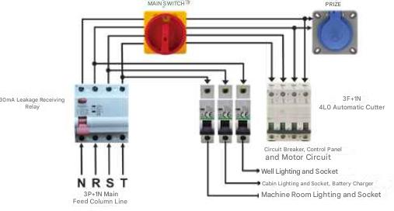

Figure 8.2 Main supply electrical system

MODULE-9 APPLICATION AND OUTPUTS

INSPECTION OF LABELING AND ADDRESSING INSIDE THE POWER PANEL
When inspecting the labeling and addressing inside the elevator power panel, the following important points should be considered:
- The electrical power panel must be enclosed in a protective housing.
- The electrical power panel must be located inside the machine room.
- All elements inside the power panel must be labeled and addressed to prevent confusion.
- Unauthorized access to the power panel must be prevented (in MRL systems, it must be locked).
- The machine room lighting switch must be functional.
- If the machine room lighting fixture is weatherproof (IP-rated), it must be double insulated.
- Lighting cable joints in the machine room must be protected.
- The machine room socket must be available, functional, and have grounded safety protection.
- The machine room socket must be properly mounted.
- The machine room lighting switch must be installed and labeled/addressed.
- There should be warning signs to clearly identify the main switch and the lighting switch.
- Hanging cables and lighting fixtures in the machine room must be securely installed.
- There must be a shaft lighting switch in the machine room and it must be labeled. (In MRL-type elevators, this should be located inside the control panel, near the main switch.)
- The shaft lighting switch in the machine room must be functional.
- Cable connections inside the electrical power panel must be well organized.

Protection Against Direct Contact in the Electrical Panel:
- Protection must be provided with enclosures rated at least IP2X.
- All other connections, terminal blocks, and connectors must be housed in dedicated panels, boxes, or boards.
- If voltage remains at any terminals after turning off the elevator's main switch, these terminals must be clearly separated from non-live terminals, and if the voltage is greater than 50 V, proper warning labels must be applied.
- On group fuses, warning signs must be provided for maintenance personnel indicating that voltage may still be present even when an individual fuse supply is turned off.
- To ensure continuity of mechanical protection, conductors and cables' protective sheaths must extend into the device or junction box, or be terminated with a suitable gland.
- Single-insulated power supply cables in the machine room must be double insulated or otherwise protected.
- Installations in machine and pulley rooms must be protected against direct contact with IP2X-rated enclosures, and all connections, terminal blocks, and connectors must be housed in proper enclosures, junction boxes, or panels.
Following all these steps ensures that the Power Panel has been thoroughly inspected.

LearnIng the CharacterIstIcs and RatIngs of Fuses and ResIdual Current DevIces (RCDs)
- A 30 mA residual current device (RCD) must be installed in the electrical panel.
- If the machine room lighting is powered by a separate circuit, it must be protected by a 30 mA RCD.
- Emergency electrical rescue systems (such as emergency power supply or UPS) that activate when the mains power fails must be protected by a 30 mA RCD. (Not required for isolated systems.)
- Safety circuits must be protected by a 30 mA RCD. (Not required for isolated systems. Necessary protective measures must be taken after the isolation transformer.)
- There should be a fuse for shaft lighting, and it must be properly labeled.
- The electrical panel must have a 4-pole group W circuit breaker for the motor line.
- The power supply for the 4-pole group W circuit breaker in the electrical panel must come after the residual current device.
- Machine room lighting must have a fuse and be labeled accordingly.
- Shaft lighting must have a fuse.
- Cabin, shaft, and machine/hoistway lighting must have separate fuses.
- The machine room fuse must be separate from the shaft and cabin fuses.
- The cabin lighting fuse must be installed and labeled.
Fuse ratings must be appropriate for the cable cross-section as follows:
  - 1.00 mm² max 6.0 A
  - 1.50 mm² max 10.0 A
  - 2.50 mm² max 20.0 A
  - 4.00 mm² max 32.0 A
  - 6.00 mm² max 50.0 A
- Terminal blocks in the power panel must be protected against direct contact with at least IP2X protection.
- Fuse holders must be installed in the power distribution panel.
- Fuses inside the electrical panel must be securely fixed and not loose.

Fuse Ratings Should Be As Follows:
- One 4-pole (3F + N) group fuse with 32 A rating must be present.
- A 300 mA residual current device must be installed (32 A/4P/400V).
- A 30 mA residual current device must be installed (25 A, 250 V).
- For machine room lighting, a 20 A single fuse must be installed.
- For shaft lighting, a 16 A single fuse with vavien wiring and waterproof enclosure must be installed.
- For cabin lighting, a 10 A single fuse must be installed.
- For grounded waterproof sockets at the shaft bottom, a 20 A single fuse must be installed.
- For grounded sockets near the main supply panel, a 20 A single fuse must be installed.

PerformIng GroundIng (EarthIng) Check wIth a MultImeter

(AVO Meter)
To perform this check:
- Identify all elevator equipment through which electrical current flows.
- All elevator equipment with voltage higher than 50 V AC must have proper grounding installed.
- The grounding cable must be yellow-green in color.
- The grounding cable ends should be fitted with lugs or ferrules.
- Each elevator equipment’s grounding cable should be connected in parallel to the corresponding grounding busbar.
- The cross-section of the grounding cable should not be smaller than the cross-section of the electrical cable used in the elevator equipment.
Grounding continuity can be checked with a multimeter as follows:
- Set the multimeter to the continuity (beep) mode.
- Place one probe on the grounding busbar or grounding point, and the other probe on the metal surface of the elevator equipment where grounding is being checked.
- If the multimeter emits a beep sound, grounding continuity is confirmed.
- Measurements should be made on the equipment’s surface as free from paint as possible for accurate results.
Elevator equipment with voltage higher than 50 V AC must be protected by a 30 mA residual current device (RCD). If parts of elevator equipment that conduct current (such as hinges, bolts, nuts, and other connecting elements) are connected mechanically, the grounding cable should not be connected to these common connection points but should be connected with a separate cable directly to the elevator equipment’s surface. (Example: grounding the cover of the control panel.) (8.2)

Figure 8.3. Grounding Measurement

CheckIng LIghtIng SwItches and Sockets
1.29 Socket and Shaft Lighting Switch (TS 10922 EN 81-1, Clause 13.6)
- A switch or similar device should be installed near the machine room entrance to control the machine room lighting.
- Shaft lighting should be controlled by a two-way (vavien) switch located in both the machine room and the shaft pit.
- Sockets required on top of the cabin, in machine and sheave rooms, and at the shaft pit should be grounded and independent from the machine-motor circuit.
1.30 Socket and Lighting Switches (TS 10922 EN 81-1, Clause 13.6)
- Sockets required on top of the cabin, in machine and sheave rooms, and at the shaft pit must be grounded and independent from the machine-motor circuit.
- Lighting circuits for the cabin, shaft, machine room, and sheave room must be independent from the power circuit supplying the machine.

Important Steps for Checking Lighting Switches and Sockets in the Machine Room
- Safety Precautions:
Before working with electricity, turn off the relevant circuits and use appropriate protective equipment for your safety.
- Visual Inspection:
Check the physical condition of lighting switches and sockets. Replace any with cracks, breaks, or wear.
- Connection Checks:
Ensure all cables and connections are tight and secure. Loose connections can cause faults and safety hazards.
- Testing and Functional Checks:
Test all lighting switches and sockets. Verify that each switch correctly turns its corresponding light on and off and that sockets operate properly.
- Labeling:
Check that all switches and sockets are properly labeled. This facilitates future maintenance or interventions.
- Cleaning and Organization:
After inspections, clean the work area and leave it organized.
By following these steps, the lighting switches and sockets in the machine room can be safely and effectively checked and maintained.

Checking Cable Connections and Terminal Blocks
TS 10922 EN 81-1, Clause 13.5.3
- Terminal blocks and connectors must be located inside panels, junction boxes, or cabinets designed for this purpose. If the voltage exceeds 50 V, they must be properly labeled.
- Terminal blocks belonging to circuits not disconnected by the main switch (if any) must be clearly marked.

Important Points to Consider When Checking Cable Connections and Terminal Blocks
- Safety Precautions:
Before starting work, the relevant circuit should be turned off and safety equipment worn. Always exercise caution when working with electricity.
- Visual Inspection:
Visually inspect cable connections and terminal blocks. Check for any signs of wear, damage, or deterioration.
- Tight Connections:
Ensure all connections are tight and secure. Loose connections can cause electrical faults and fire hazards.
- Cable Arrangement:
Make sure cables are neatly organized and not tangled or cluttered. This facilitates future maintenance and repairs.
- Labeling:
Ensure all cables and terminal blocks are properly labeled. This helps identify which cable goes where and prevents confusion.
- Testing and Verification:
After checking all connections, test the system to ensure correct operation. If any abnormalities are detected during testing, take necessary corrective actions.
- Cleaning and Organization:
After completing inspections, clean and organize the work area.
Following these steps ensures the safe and effective inspection and operation of cable connections and terminal blocks.

