MODULE-8
ELECTRICAL POWER PANEL
The main power panel of the elevator contains many components that manage the elevator's electrical system and power control. These panels ensure the elevator operates in a controlled, safe, and efficient manner.
A typical elevator main power panel consists of the following components:
- Main Switch: The primary element that controls the flow of electricity.
- Fuse: Provides overcurrent protection.
- Contactor: A switch that opens and closes the circuit.
- Measuring Instruments: Measure parameters such as current, voltage, and power.
- Control Buttons and Indicators: Allow operators to manage the electrical system and monitor its status.
- Terminal Blocks and Cable Connections: Places where cables are secured and connected.
- Power Consumer Elements: Motors and other electrical devices.
These components work together to help manage the elevator's electrical energy effectively and safely.
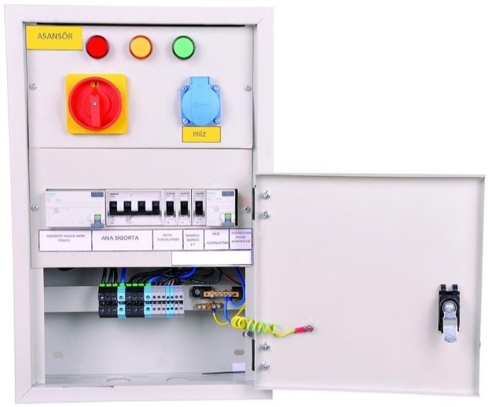

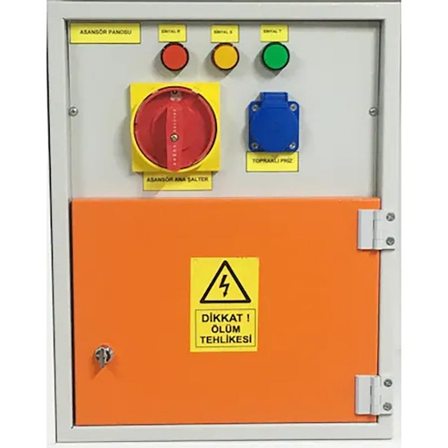

Figure 8.1 Sample Main Power Panel (8.1)

MATERIALS AND SPECIFICATIONS REQUIRED IN THE ELECTRICAL POWER PANEL
The elevator power panel supplies the control panel, machine room, elevator shaft, and cabins. When the 5-pole lockable knife switch on the electrical panel is turned off, it only cuts the power to the elevator control panel; the power for other lighting and outlet circuits is not cut off.
The main supply cable and power cables supplying the elevator motor must be N2XH FE 180 halogen-free and flame-retardant.
A flexible cable must be connected between the junction box above the cabin and the control panels in the machine room without any splices.
The elevator power panel must be connected to the main grounding busbar of the main distribution panel. The conductor cross-section must be at least 16 mm² of pure copper.
The characteristics of the materials used should be as follows:
- The elevator column line must be connected to the power board equipped with the following devices.
- Lockable knife switch must be used: 5-pole, 40 A, 380 V (Three-phase).
- One 3-phase + 1 neutral circuit breaker with 32 A, 4-group fuses must be present (Three-phase).
- 300 mA Residual Current Device (RCD) must be installed, 32 A/4P/400V (Three-phase).
- 30 mA Residual Current Device (RCD) must be installed, 25 A, 250 V (Single-phase).
- For machine room lighting, a 20 A single fuse must be used.
- For shaft lighting, a 16 A single fuse with double switch wiring in an IP-rated enclosure must be used.
- For cabin interior lighting, a 10 A single fuse must be used.
- For grounded IP-rated outlet at the shaft bottom, a 20 A single fuse must be used.
- For grounded outlet near the main supply board, a 20 A single fuse must be used.
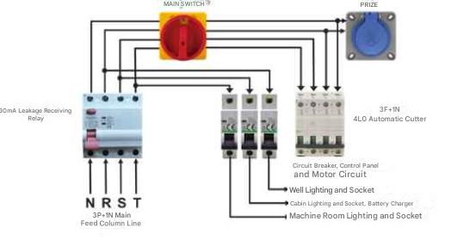
Figure 8.2 Main Power Electrical System

MODULE-8 APPLICATIONS AND OUTCOMES

CHECKING LABELING AND ADDRESSING INSIDE THE POWER PANEL
When checking the labeling and addressing inside the elevator power panel, some important points to pay attention to are listed below:
- The electrical power panel must be housed inside an enclosure.
- The electrical power panel must be located inside the machine room.
- The electrical power panel and its components must be addressed (labeled) to prevent confusion.
- Unauthorized access to the electrical power panel must be prevented (in MRL elevators, it must be locked).
- The lighting switch of the machine room/space must be functional.
- If the machine room/space lighting is installed in an IP-rated enclosure, the cables must be double-insulated.
- Cable splices in the machine room/space lighting must be protected.
- The machine room/space outlet must exist, be functional, and grounded for safety.
- The machine room/space outlet must be properly mounted.
- The lighting switch for the machine room/space must be installed and labeled.
- Warning signs must be placed to clearly identify the main switch or switches and the lighting switch.
- Hanging cables and fixtures in the machine room/space must be properly installed.
- A shaft lighting switch must be present and labeled in the machine room/space. (In MDRSZ elevators, this switch should be near the main switch inside the control panel.)
- The shaft lighting switch in the machine room/space must be functional.
- Cable connections in the electrical power panel must be organized.
- Protection against direct contact in the electrical panel:
  - Must be provided with enclosures having at least IP 2X protection rating. All other connections, terminals, and connectors must be located inside panels, junction boxes, or enclosures designed for this purpose.
  - If voltage remains on some terminals after the main switch(es) of the elevator is turned off, these must be clearly separated from terminals without voltage and marked properly if voltage exceeds 50 V.
  - In group fuses, warning signs must inform maintenance personnel that electricity may still be present in the system after each fuse’s main supply is turned off.
- To ensure continuous mechanical protection, the protective sheaths of conductors and cables must be inserted into the switch boxes or devices, or terminated inside suitable cable glands.
- Single-insulated power cables in the machine room/space must be double-insulated or otherwise protected.
- The wiring in the machine and sheave rooms must be protected against direct contact with enclosures that have at least IP2X protection rating; connections, terminals, and connectors must be inside appropriate panels, junction boxes, or enclosures designed for this purpose.

After all these checks, the power panel inspection is considered complete.

FEATURES AND VALUES OF FUSES AND RESIDUAL CURRENT DEVICES (RCDs)
- A 30 mA residual current device (RCD) must be installed in the electrical panel.
- If the machine room lighting is supplied by a separate circuit, it must be protected by a 30 mA RCD.
- The electric emergency rescue system (such as a backup power supply or UPS), which activates during a power outage, must be protected by a 30 mA RCD against leakage current. (Not required in isolated systems)
- Safety circuits must be protected by a 30 mA RCD against leakage currents. (Not required in isolated systems. Necessary protective measures should be taken after the isolation transformer.)
- Shaft lighting fuse must be installed and labeled.
- A 4-pole group W circuit breaker for the motor line must be installed in the electrical panel.
- The 4-pole group W circuit breaker's power supply must be connected after the residual current device (RCD).
- Machine room lighting fuse must be installed and labeled.
- Shaft lighting fuse must be installed.
- Lighting fuses for the cabin, shaft, and machine/sheave rooms must be installed.
- Machine room fuse and shaft fuse must be separate from the cabin fuse.
- Machine room fuse and shaft fuse must be separate from each other.
- Cabin lighting fuse must be installed and labeled.
- Fuse values must match the cable cross-sectional area. mm² max 6.0 A, 1.50 mm² max 10.0 A, 2.50 mm² max 20.0 A, 4.00 mm² max 32.0 A, 6.00 mm² max 50.0 A)
- Terminal blocks and electrical power panel components must be protected against direct contact with enclosures having at least IP 2X protection rating.
- Fuse holders must be installed in the electrical power panel.
- Fuses inside the electrical panel must be fixed securely.
Fuse values should be as follows:
- One 3F + 1N (three-phase plus neutral) 32 A 4-group fuse must be present.
- 300 mA Residual Current Device (RCD) must be installed. 32 A / 4P / 400 V (three-phase).
- 30 mA Residual Current Device (RCD) must be installed. 25 A / 250 V.
- For machine room lighting, a 20 A single fuse must be installed.
- For shaft lighting, a 16 A single fuse with a two-way switch (vavien) and IP-rated installation must be installed.
- For cabin lighting, a 10 A single fuse must be installed.
- For grounded IP-rated outlet at the shaft bottom, a 20 A single fuse must be installed.
- For grounded outlet near the main power panel, a 20 A single fuse must be installed.

PERFORMING GROUNDING CHECK WITH AVO METER

To perform this operation:

Identify all elevator equipment through which electrical current passes.
Elevator equipment with a voltage higher than 50 V AC must have a grounding system installed.
The grounding cable should be yellow-green in color.
The ends of the grounding cables must be fitted with cable lugs or ferrules.
The grounding wiring for each elevator equipment should be connected in parallel to the grounding busbar it is attached to.
The cable cross-section of the grounding system must not be smaller than the cable cross-section of the electrical line used in the elevator equipment.
Grounding continuity can be checked with a multimeter. To do this:
Set the AVO meter to the sound or continuity test mode.
Place one probe on the grounding busbar or grounding conductor, and the other probe on the metal surface of the elevator equipment where grounding is being checked.
If the multimeter emits a beep sound, grounding continuity is confirmed.
Measurement should preferably be done on an unpainted surface of the equipment to ensure accuracy.
Elevator equipment operating above 50 V AC must be protected with a 30 mA residual current device (RCD).
If parts of elevator equipment through which electrical current passes are connected with hinge, bolt, or nut-type connectors, the grounding cable should NOT be connected to these common connection points. Instead, it should be connected to the equipment surface via a separate cable. (See Figure 8.2)
An example of this is the grounding of the control panel cover.

Figure 8.3 Gound measuring

CHECKING LIGHT SWITCHES AND SOCKETS
Socket and shaft lighting switch (TS 10922 EN 81-1 ARTICLE NO 13.6)
- A switch or similar device should be installed near the entrance of the machine room for machine room lighting.
- Shaft lighting should be controlled by a two-way (vavyen) switch located in the machine room and at the shaft bottom.
- The sockets required on the cabin roof, machine and pulley rooms, and shaft bottom should be grounded and independent from the machine-motor circuit.
Sockets and lighting switches (TS 10922 EN 81-1 ARTICLE NO 13.6)
- The sockets located on the cabin roof, machine and pulley rooms, and shaft bottom must be grounded and independent from the machine-motor circuit.
- Lighting circuits of the cabin, shaft, machine and pulley rooms should be independent from the circuit supplying the machine.
When performing lighting switch and socket checks in the machine room, pay attention to the following important steps:
- Safety Precautions: Before working with electricity, turn off the relevant circuits and use appropriate protective equipment for your safety.
- Visual Inspection: Check the physical condition of lighting switches and sockets. Replace any cracked, broken, or worn parts.
- Connection Checks: Ensure all cables and connections are tight and secure. Loose connections can cause malfunctions and safety hazards.
- Test and Functional Checks: Test the lighting switches and sockets. Verify that each switch properly turns the correct light on/off and that sockets function correctly.
- Labeling: Make sure proper labeling is done for each switch and socket. This facilitates future maintenance or interventions.
- Cleaning and Organization: After inspections, clean and leave the work area organized.
Following these steps ensures the safe and effective inspection and operation of lighting switches and sockets in the machine room.

PERFORMING CABLE CONNECTION AND TERMINAL BLOCK CHECKS
TS 10922 EN 81-1 ARTICLE NO 13.5.3
- Terminal blocks and connectors must be located inside panels, junction boxes, or cabinets designed for this purpose. If the voltage exceeds 50V, it must be properly marked.
- Terminal blocks belonging to circuits that are not disconnected by the main switch (if any) must be clearly marked.
When performing cable connection and terminal block inspections, here are some important points to pay attention to:
- Safety Precautions: Before starting work, switch off the relevant circuit and wear appropriate safety gear. Always exercise caution when working with electricity.
- Visual Inspection: Visually examine all cable connections and terminal blocks. Look for any signs of wear, damage, or deterioration.
- Tight Connections: Ensure all connections are tight and secure. Loose connections can lead to electrical faults and fire hazards.
- Cable Arrangement: Make sure cables are arranged neatly and not tangled. A clean cable layout makes future maintenance and troubleshooting easier.
- Labeling: Confirm that all cables and terminal blocks are properly labeled. This ensures clear identification of each wire’s destination and helps avoid confusion.
- Testing and Verification: After completing the checks, test the system to ensure everything functions correctly. If any abnormalities are detected during testing, take the necessary steps to resolve the issue.
- Cleaning and Organization: Once inspections are complete, clean up and organize the workspace. (8.3)
Following these steps ensures safe and efficient operation and inspection of cable connections and terminal blocks.

