MODULE-7
ELEVATOR MACHINE ROOM MOTORS
Elevator machine room motors are located in a room above the elevator shaft called the machine room.
These motors are used to move the elevator cabin in the desired direction and speed. (7.1)

Machine Room Elevators:
This type of elevator places the drive machine in a room above the elevator shaft. The drive motor in the machine room operates based on commands received from the control panel, moving the cabin in the desired direction. The cabin works together with a counterweight. Movement is achieved by the friction between the steel rope and the drive pulley, causing the cabin to move up and down. The cabin and counterweight have approximately equal weights, resulting in energy savings. These types of drive machines are called friction drives.
The elevator machine room is part of the elevator space, together with the elevator shaft. The size of the machine room is determined according to the elevator's speed and rated load. The area must be protected from external factors, dry, well-lit (at least 200 lux and lit in a way that prevents stroboscopic illusion), well ventilated, temperature controlled between +5°C and +40°C, and arranged to prevent noise and vibrations.
The floor where the machine parts are located in the machine room must be strong enough to withstand impacts and forces that may occur during elevator operation. Passageways between equipment and entrances to the machine room must comply with standards and regulations. Unauthorized personnel must be prevented from entering elevator machine rooms.

Elevator Types by Capacity:
- Residential elevators: 100, 180, 240, 320, 400, 630, 1000 kg (7 types)
- Non-residential elevators: 630, 800, 1000, 1200, 1600 kg (5 types)
- Elevators in healthcare facilities: 1600, 2000, 2500 kg (3 types)

Elevator Speeds:
Elevators are categorized by speed as 0.63 m/s, 1 m/s, 1.6 m/s, 2.5 m/s, and speeds above 2.5 m/s (5 types). The dimensions of the cabin, machine room, and shaft vary accordingly. Additionally, different motor powers and braking systems are used based on speed. (7.3)
Regulator Mechanism:
This is a safety device that activates and brakes the cabin in case the elevator ropes break.

Machine Room Elevator Motors:
Machine room elevators are implemented in two types: geared and gearless. The gearless machine room elevator application is preferred for high-capacity elevators and in tall buildings. (7.3)

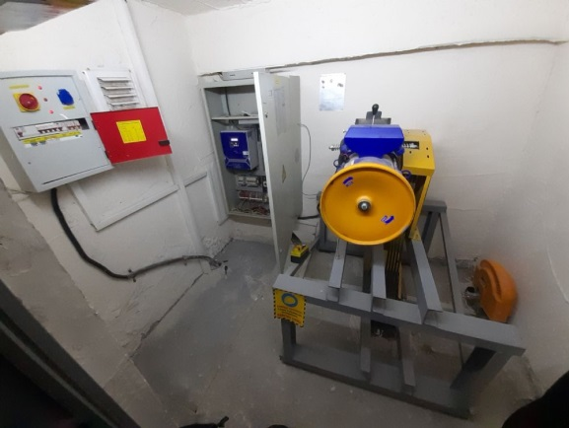
Figure 7.1 General View of Machine Room
Geared Elevator Motors (MR):
These motors are generally preferred for buildings with a machine room. Geared elevator motors have various travel speeds.
A geared elevator motor is equipped with a gearbox connected to the motor shaft.
A good elevator should provide high capacity, comfort, usability, and economical operation. Acceleration and braking should be at a level that does not disturb passengers, electricity consumption should be low, and maintenance costs should be minimal.
Considering that the energy efficiency of geared elevator motors ranges between 55% and 75%, it is clear that these motors are at a disadvantage in terms of energy consumption. Due to these limitations, the motor power must be selected 1.5 to 2 times greater than the required power, which also necessitates selecting larger related equipment. This leads to an increase in the dimensions of the machine room.
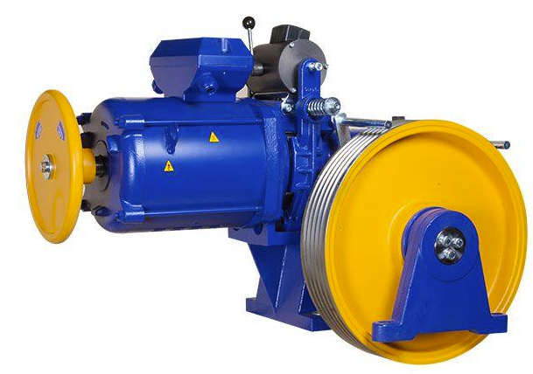
Figure 7.2 Geared Elevator Motor
- Advantages:Provides high capacity, comfortable, and convenient operation.
- Disadvantages:Energy efficiency can be low (approximately 55-75%).
- Usage Area:Generally preferred for buildings with machine rooms. (7.2)
Gearless Elevator Motors (MRL):
These motors were developed as a solution for buildings without machine rooms.
MRL motors are available in various speed options depending on the travel distance.
In gearless motors, the drive sheave is directly connected to the motor shaft.
Their biggest advantage is that they do not have the disadvantages found in geared motors, such as maintenance requirements and noise.
A good elevator should provide high capacity, comfort, ease of use, and economical operation. Acceleration and braking should not disturb passengers, and both electricity and maintenance costs should be low.
Since the drive sheave is directly connected to the motor shaft in gearless motors, they achieve high efficiency and allow heavier loads to be carried with smaller motors.
Advantages:
- Higher energy efficiency
- Quiet and comfortable ride
- Low maintenance requirements
Usage Area:
- Ideal for buildings without machine rooms. (7.3)
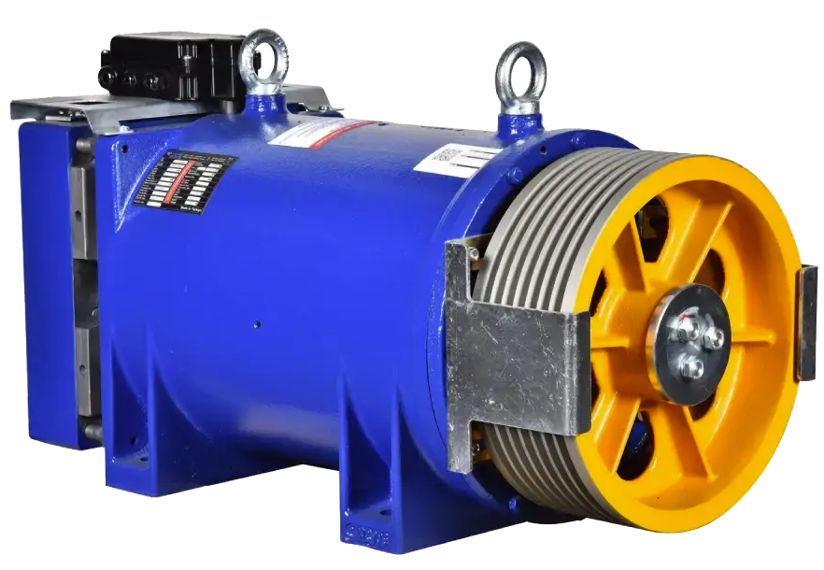
Figure 7.3 Gearless Elevator Motor

PerformIng PerIodIc InspectIon of All Components of the Elevator MachIne Motor
Working Principle of the Elevator:
A traction elevator uses ropes or cables together with a motor-driven pulley system to facilitate the vertical movement of the elevator cabin.
The ropes or cables are connected to a pulley or sheave located at the top of the elevator shaft and then linked to a motor-driven traction machine that controls the elevator's movement.
When the elevator is called to a floor, the traction machine motor is activated, moving the ropes or cables and thereby transporting the elevator cabin in the desired direction.
For descent, the traction machine motor reverses, allowing the ropes or cables to unwind from the pulley or sheave, easing the elevator cabin's descent.
The movement of the ropes or cables is precisely controlled by the traction machine to ensure a smooth and safe ride between floors.
Once the elevator cabin reaches the desired floor, the traction machine stops and holds the cabin in place until a new destination is selected.

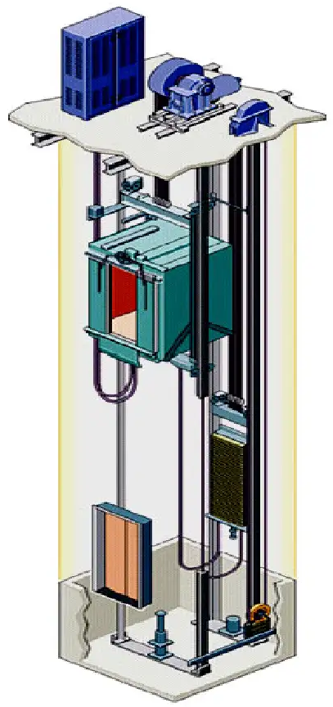
Figure 7.4 Example Elevator System

What is the Working Principle of an Elevator Motor? (7.4)
The elevator motor converts electrical energy into mechanical energy to move the elevator. Its working principle is based on electromagnetism and magnetic principles.
An elevator motor consists of electromagnetic coils that create a magnetic field. These coils are wound around an iron core, which is a magnetic material. When current flows through the coils, they generate a magnetic field. This magnetic field magnetizes the iron core and produces a magnetic force.
The elevator motor uses this magnetic force to rotate a magnetic drum or pulley. The drum or pulley winds the elevator cable and causes the elevator to move. When torque is applied to the drum or pulley, the motor’s output shaft rotates, and the elevator moves.
The speed of the elevator motor depends on the input voltage and the strength of the magnetic field. The elevator’s movement is controlled by motor speed control systems, which regulate the elevator’s speed, direction, and stopping points.
The working principle of the elevator motor is a complex electromechanical process. However, modern elevator motors are designed to provide high performance, reliability, and energy efficiency.
Which Components Work Together With the Elevator Motor?
The elevator motor works with several different components, including:
- Drum or pulley: This wraps the elevator cable and moves the elevator. It is connected to the motor output shaft and rotates using the motor’s magnetic force.
- Elevator cable: Wrapped around the drum or pulley, it enables the elevator to move up or down. These cables are made of high-strength steel and come in various sizes depending on the elevator’s weight capacity and speed.
- Control systems: These regulate the elevator motor to control the elevator’s movement, speed, direction, and stopping points.
- Gearbox: The elevator motor drives the elevator cable via the gearbox, which transmits motor power to the drum or pulley.
- Brake system: The brake works together with the elevator motor to stop and hold the elevator in place. In emergencies, the brake system rapidly stops the elevator for safety.
All these parts work together to ensure the elevator operates safely and efficiently.
What Types of Elevator Motors Are There?
Elevator motors come in various types and sizes for different applications. Some common types include:
- Direct Current (DC) elevator motor: These provide high efficiency and linearity, using a commutator to reverse the magnetic field direction.
- Alternating Current (AC) elevator motor: Commonly used in smaller elevators found in homes and offices. They operate by rotating magnetic fields.
- VVVF (Variable Voltage Variable Frequency) elevator motor: These control elevator speed, direction, and braking by adjusting the frequency and voltage of the magnetic field.
- Pneumatic elevator motor: Operates using compressed air pressure to move the elevator cable.
- Hydraulic elevator motor: Uses hydraulic fluid pressure to move the elevator cable.
These motor types differ and are chosen according to the specific application. For example, DC motors are preferred for large elevators needing high efficiency, while AC motors are common in smaller elevators. VVVF motors control speed and braking characteristics.
In What Types of Elevators Are Elevator Motors Used?
Since elevator motors are produced in various types and sizes, they can be used in many elevator types, including:
- Elevators in high-rise buildings: Usually equipped with DC or AC motors, designed for high efficiency and heavy loads.
- Hydraulic elevators: Use motors powered by hydraulic fluid, typically for low to medium load capacities and buildings with 5 floors or less.
- Pneumatic elevators: Use motors powered by air pressure, suitable for smaller capacities and short distances.
Escalators and Moving Walkways:
Escalators and moving walkways are typically equipped with direct current (DC) motors. These motors are used to drive the movement of the escalators and walkways.
Elevator motors can be used in different types of elevators and ensure the safe and efficient operation of all kinds of elevators.
What is the Importance of the Elevator Motor?
Elevator motors play a vital role in ensuring the safe and efficient operation of elevators. This can be summarized as follows:
- Enabling elevator movement: Motors move the elevator cable, allowing people to travel easily within buildings.
- Increasing load capacity: Elevator motors provide greater carrying capacity for people and loads traveling to higher floors, enabling buildings to transport more occupants and cargo.
- Improving energy efficiency: Elevator motors can increase energy efficiency by using direct current (DC) or alternating current (AC) technologies, allowing elevators to operate more efficiently with less energy consumption.
- Providing a comfortable ride: Elevator motors are designed to ensure a smooth and quiet ride. Excessive vibration or noise can affect passenger comfort, so motors are designed to operate quietly and without vibration.
- Ensuring safety: Elevator motors contribute to safe operation. Their brake systems allow elevators to stop suddenly in emergencies, preventing accidents.
Elevator motors are indispensable components of modern buildings. Their safe and efficient operation enables comfortable travel within buildings.
Why is Elevator Motor Maintenance Important?
Maintenance of elevator motors is extremely important for the safe and efficient operation of elevators. Its functions can be summarized as:
- Ensuring safety: Regular maintenance keeps the elevator operating safely. Without maintenance, motors may slow down or stop, brakes may malfunction, or cables may break. Regular maintenance ensures safe operation and protects users.
- Preventing breakdowns: Regular maintenance helps prevent faults. Motors can suffer from wear or damage that, if left unaddressed, can cause more serious failures or complete motor breakdown.
- Extending lifespan: Regular maintenance helps prolong motor life. Without maintenance, wear accelerates, shortening motor life. Maintenance extends lifespan, reduces repair needs, and lowers costs.
- Increasing efficiency: Well-maintained motors operate more efficiently. Neglected motors may consume more energy and cause the elevator to work slower or less efficiently. Maintenance improves efficiency and reduces energy costs.
- Meeting legal requirements: Elevators must comply with various legal regulations, which may require regular motor maintenance. Maintenance helps meet these legal standards and ensures insurance compliance.
In summary, elevator motor maintenance is crucial for safe, efficient, and long-lasting operation. It helps prevent failures, reduces energy costs, and ensures compliance with regulations.

How is Elevator Motor Safety Ensured?
Elevator motor safety is ensured through a combination of several measures. These measures include:
(The list of safety measures would continue here if provided)
- Brake Systems: Elevator motors are equipped with brake systems to control and stop their speed. These brakes prevent sudden stops of the motor and stop the cabin from falling.
- Cable Systems: The cables used in elevator motors are made of high-strength materials and supported by a multiple-cable system. This ensures that if one cable breaks or loosens, the other cables hold the elevator safely.
- Emergency Buttons: Elevator cabins have emergency buttons. These buttons stop the elevator and ensure passengers inside remain safe during emergencies.
- Door Systems: Elevator cabins are designed to ensure the doors open and close securely. The doors are locked during motor operation to prevent opening and avoid passengers falling.
- Sensors: Sensors in elevator motors ensure the elevator stops correctly at each floor and the doors open safely. Additionally, sensors detect if something is trapped in the elevator cabin and take necessary safety precautions for passengers.
- Regular Maintenance: The safety of elevator motors is ensured through regular maintenance and repair. Motors without proper maintenance can cause malfunctions and accidents. Therefore, regular maintenance ensures safe operation and extends the motor’s lifespan.

MODULE-7 APPLICATION AND OUTPUTS
PERFORMING FLYWHEEL AND SPEED CONTROL
Flywheel and speed control in elevator motors are very important to ensure smooth operation and safety of the elevator. Here are some key points about this process:
Flywheel (Volan)
- Purpose: To store energy and release it when needed. In elevator systems, the flywheel helps keep the motor speed stable and reduces vibrations.
- Working Principle: The flywheel stores kinetic energy while the motor is running and releases this energy when needed to quickly respond to load changes on the motor. This optimizes energy consumption and extends the motor's life.
- In case of failure, it allows manual operation to rescue people trapped in the elevator and pull the elevator to the nearest floor. By releasing the brake lever, the motor is turned with the help of the flywheel, and the elevator can be pulled to the floor.
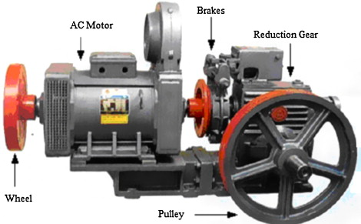
Figure 7.5 Flywheel in Elevator Machine Room Motor System
Speed Control
- Motor Drivers: Motor drivers (drives) are used to control the speed and torque of elevator motors. These drivers regulate the electric current and voltage supplied to the motors.
- Variable Frequency Drives (VFD): VFDs are commonly used to adjust the speed of elevator motors by changing the frequency of the electrical current.
- Closed-Loop Control System: Speed control is typically achieved through a closed-loop control system. This system monitors the real-time speed and position of the motor and makes adjustments when necessary.
Speed Control and Safety
- Speed Governor: Speed governors are used to keep elevator speeds within a set limit. In cases of overspeed, these governors ensure the elevator stops safely.
- Speed Sensors: Speed sensors continuously monitor the motor’s speed in elevator systems. These sensors allow the system to make speed adjustments as needed.
Flywheel and speed control systems are critically important for ensuring elevators operate safely, comfortably, and efficiently. Thanks to these components, elevators are protected from sudden speed changes and vibrations, resulting in longer service life.

CHECKING THE SUITABILITY OF THE BRAKE SYSTEM
Checking the suitability of the elevator brake system is very important for safety. Here are the basic steps and points to consider during this inspection process:
a. Inspection of the Brake System
Brake Pads: The wear condition of the brake pads should be checked. Worn or damaged brake pads must be replaced.
Brake Discs: Ensure the discs are smooth and free from damage. Any cracks, deformation, or wear should lead to replacement.
Connections and Parts: All connecting elements, bolts, and screws must be tightly and securely fastened. Loose connections should be fixed.
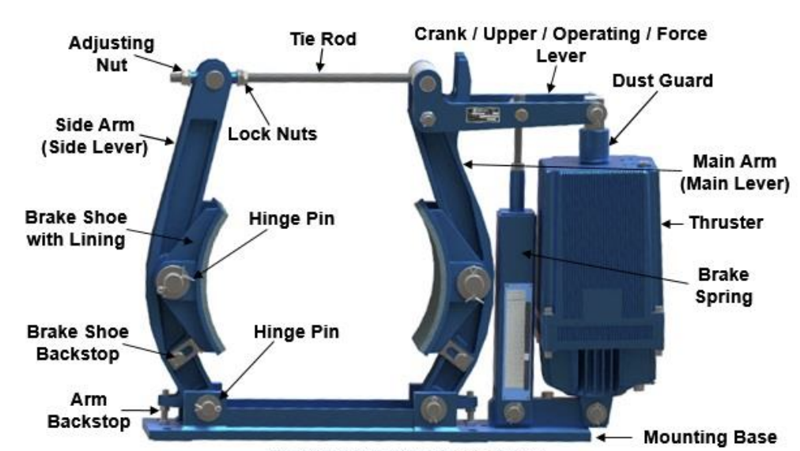
Figure 7.6 Brake System
b. Functional Tests:
Braking Force: Ensure the brake system provides sufficient braking force. The elevator cabin must stop quickly and safely during braking.
Brake Response: The brake system should respond quickly and correctly when the brake command is given. Delayed or slow braking indicates a problem.
Emergency Braking: Emergency brakes must be tested. The emergency braking system should stop the elevator safely in unexpected situations.
Electrical and Control System:
Electrical Connections: All electrical connections related to the brake system should be checked. Loose or damaged connections must be repaired.
Control Panel: All control elements related to the brake system (sensors, switches, etc.) must work properly. Faulty parts should be repaired or replaced.
Periodic Maintenance:
Lubrication: Moving parts of the brake system should be lubricated regularly to reduce friction and extend the lifespan of components.
Cleaning: The brake system and surrounding area should be kept clean. Dirt and dust buildup can hinder the brake system’s performance.
Wear and Tear: Brake system components should be checked regularly and replaced if signs of wear are detected.
Safety Measures:
Regular Inspections: Regular inspections and maintenance of the elevator brake system prevent possible failures.
c. Authorized Personnel: Brake system inspections and maintenance must be carried out by authorized and experienced personnel.
d. Documentation: All inspections and maintenance activities should be documented and recorded. This is important for future reference.

