MODULE-6

PERFORMING PERIODIC INSPECTION OF THE ELEVATOR MACHINE ROOM
Inspections in the Machine Room
One of the inspection stages includes controls in the machine room. The parts to be inspected in the machine room are as follows:
- Location of the machine room
- Entrance door
- Dimensions in the machine room
- Inspection covers
- Logbook and instructions
1. Location of the Machine Room
The room or area where the elevator machine and other equipment are located is called the machine room. The machine room should be easily accessible. Access should be arranged so that only authorized personnel can enter. Unauthorized entry to this area must be strictly prevented.
2. Entrance Door of the Machine Room
The entrance door of the machine room must be designed in accordance with TS EN 81-20 standard. The door must be at least 60 cm wide and 200 cm high. The door should open outwards from the machine room. The door must be opened by a key from the outside, while it can be opened without a key from the inside. A warning sign saying "Unauthorized entry is dangerous and prohibited" must be placed on the door.
3. Dimensions in the Machine Room
- The dimensions of the areas inside the machine room are determined according to the TS EN 81-20 standard:
- Working areas
- Clearance in front of control panels
- Emergency working area
- Free height for movement
- Passage widths to free spaces
- Cover over rotating parts of the drive machine
- Entry doors to the sheave rooms
- Emergency doors
Size of Working Areas: The working area inside the machine room should be sufficient for safe and easy work. In areas where maintenance, repair, or inspection takes place, the height should be at least 2.10 m.
Clearance in Front of Control Panels: There must be at least 70 cm depth clearance in front of the panel. The width of the space in front of the panel must not be less than 50 cm and should be at least equal to the width of the panel.
Emergency Working Area Size: For elevators with manual operation equipment for emergency intervention (e.g., manual lowering device), there should be a horizontal working area of at least 0.50 x 0.60 m for maintenance and inspection of related parts.
Free Height for Movement: The clear height in free movement areas without elevator equipment must be at least 1.80 m.
Passage Widths to Free Spaces: The width of passages to free spaces inside the machine room must be at least 50 cm. In places without moving parts or hot surfaces, this width may be reduced to 40 cm.
Clearance Over Rotating Parts in Drive Machines: There must be at least 0.30 m of vertical clearance above unguarded rotating parts in the machine room.
Size of Entry Doors to Machine Rooms: Entry doors to sheave rooms must be at least 1.40 m high and 0.60 m wide.
Size of Emergency Doors: Emergency doors must be at least 180 cm high and 50 cm wide.
4. Internal Features of the Machine Room
The machine room must meet standards for ventilation, lighting, and other features. These include:
- Differences in floor levels
- Ventilation
- Lighting
- Electrical outlets
- Purpose of the machine room
- Openings in the floor
- Floor and other surface materials
- Suspension points for moving equipment
Differences in Floor Levels: If the floor level difference in the machine room exceeds 50 cm, stairs and handrails must be provided between the levels.
Ventilation: The ventilation must provide a suitable working environment for technical personnel. It should protect the equipment from dust, harmful fumes, and moisture. The elevator shaft may be used for ventilation but only for elevator-related sections, not other parts of the building.
Lighting: There must be permanently installed lighting in the machine room with at least 200 lux intensity.
Electrical Outlet: At least one grounded electrical outlet must be present in the machine room. The power supply for this outlet should be independent of the machine’s electrical supply.
Purpose of the Machine Room: The machine room must not be used for purposes other than housing elevator machinery and equipment. Only elevator-related machinery should be placed there.
Openings in the Floor: Openings in the machine room floor should be as small as possible. Where openings exist, protective barriers must be at least 50 mm above the floor or finished surface.
Floor and Other Surfaces: Elevator floors must be made of non-slip material. All surfaces in the machine room should be durable and dust-free materials.
Suspension Points for Equipment Handling: The machine room should have properly placed suspension points with specified safe working loads for safely lifting elevator equipment as needed. Suspension points may also be installed at the top of the shaft if necessary.
MODULE-6 PRACTICE AND OUTCOMES
RECOGNIZING WARNING AND INFORMATION SIGNS IN THE MACHINE ROOM
Various warning and information signs are found in elevator machine rooms. These signs are placed to ensure safety and inform users. Here are some common signs:
1- Caution! High Voltage: Warns of the risk of electric shock. Indicates the presence of electrical equipment in the machine room and the need to be cautious.
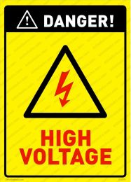
2- Unauthorized Entry Prohibited: Indicates that only authorized personnel are allowed to enter the machine room.

3- Fire Extinguisher Location: Marks the location of the fire extinguisher.
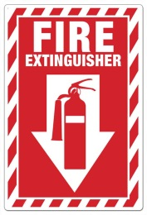
4- Emergency Exit: Indicates the exit routes to be used in case of an emergency.
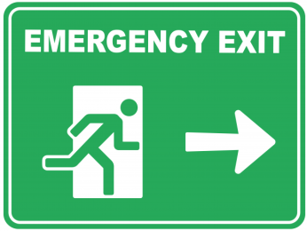
5- Use of Personal Protective Equipment (PPE): Indicates the protective gear to be worn when entering the machine room.
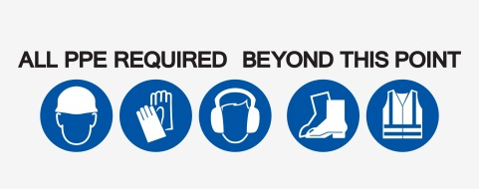
These types of signs are critically important to ensure a safe working environment.

LEARNING MACHINE ROOM DOOR, LIGHTING, AND VENTILATION STANDARDS
It is very important to understand the lighting and ventilation standards for machine rooms. The basic standards are as follows:
Lighting Standards
1- Adequate Lighting: Machine rooms, working areas, and machinery spaces must provide lighting with an intensity of at least 200 lux at floor level.
2- Fire Resistance: Lighting installations must be made from fire-resistant materials and be independent from the circuit feeding the motor. (6.1)
Ventilation Standards
1- Ventilation Ducts: Machine rooms must have sufficient ventilation ducts. These ducts are important to ensure the safety of the machines inside the room and the personnel working there.
2- Ventilation Fan Room: Machine rooms must include ventilation fan rooms. These rooms are used to control temperature and humidity levels within the machine room. (6.2)
These standards are critical to provide a safe and healthy working environment in machine rooms.

WHAT TO DO FOR MACHINE ROOM FLOOR AND DIFFERENT LEVEL PROTRUSIONS
Here are some important points to consider for cleaning and safety regarding floors and level changes in machine rooms:

Floor Cleaning
- Regular Cleaning: Floors should be cleaned regularly to prevent the accumulation of dirt and dust. This improves the overall cleanliness of the machine room and the health of personnel.
- Appropriate Cleaning Equipment: Cleaning equipment suitable for the type of floor should be used. For example, different machines should be used for hard floors.
- Vacuuming: After cleaning, vacuuming the floors ensures complete removal of dirt and dust. (6.3)

Different Level Protrusions (Steps, Rises, or Drops)
- Fire Resistance: Exits and level changes should be made of fire-resistant materials and be easily usable in case of fire.
- Isolation: These exits or protrusions should be isolated from other parts of the machine room to prevent the spread of fire and harmful gases.
- Safety Checks: Regular safety inspections should be performed on these exits, and they should not remain permanently closed.
These precautions are critical to ensure a safe and healthy working environment in machine rooms.

STANDARDS FOR METAL SUPPORTS AND RINGS FOR LIFTING EQUIPMENT
The standards for metal supports and rings used in lifting equipment are crucial for safety and durability. Below are the main standards and important points:

Metal Support Standards (6.4)
- EN 61537 / IEC 61537: This standard serves as a reference for cable management products, covering mechanical strength, electrical continuity, corrosion resistance, and fire resistance.
- DIN 4012-12: Specifies fire resistance requirements for electrical cable systems.
- NEMA VE1: Specifies requirements for metal cable trays and related fittings designed according to the Canadian Electrical Code and National Electrical Code.

Metal Ring Standards
- CE Marking: Guarantees that products traded within the European Union comply with all EU directives.
- RoHS Directive: Defines rules for restricting the use of hazardous substances.
- LVD Directive: Indicates compliance with safety regulations for low voltage equipment.

