MODULE-4

USING MEASURING INSTRUMENTS IN ELEVATOR INSPECTION

What is Length?
Length refers to the distance from one end of an object to the other. In the physical world, length measurements are used to determine the dimensions of objects and the distances between two points.
The unit of length measurement in the International System of Units (SI) is the meter, represented by the symbol “m.”
One meter is defined as the distance that light travels in a vacuum in 1/299,792,458 of a second. This definition has been accepted to enable accurate comparisons of precise measurements conducted in laboratories around the world.
History:
Length measurement has been important since the beginning of human history. Ancient civilizations developed various units of measurement based on body parts (e.g., foot length). For instance, in ancient Egypt, a "cubit" represented the distance from the elbow to the tip of the middle finger. Today, a universal system has been established through the use of standard measurement units.
Length Measurement Units and Conversion to Meters
Length measurement units are standardized units used to measure specific distances or lengths.
Some commonly used length units are listed below:
Metric System:
- Millimeter (mm): Equals 1/1000 of a meter.
- Centimeter (cm): Equals 1/100 of a meter.
- Decimeter (dm): Equals 1/10 of a meter.
- Meter (m): The base unit of length.
- Kilometer (km): Equals 1000 meters.
Imperial System:
- Inch: Equals 2.54 centimeters.
- Foot: Equals 12 inches.
- Yard: Equals 3 feet.
- Mile: Equals 1760 yards or approximately 1.609 kilometers.
Nautical and Aviation Units:
- Nautical Mile: Equals 1852 meters.
- Cable (cable length): Equals 185.2 meters (1/10 of a nautical mile).
These length units are used across various fields and industries to conduct measurements.

USING LENGTH MEASURING INSTRUMENTS
Length measuring instruments are used to measure distances, lengths, and heights.
Commonly used length measuring tools and their usage are explained below:
- Ruler:
A ruler is a straight and rigid measuring tool used to measure distances and lengths on flat surfaces. It is typically made of materials like wood, plastic, or metal.
It usually features metric units such as centimeters (cm) and millimeters (mm), or imperial units like inches.
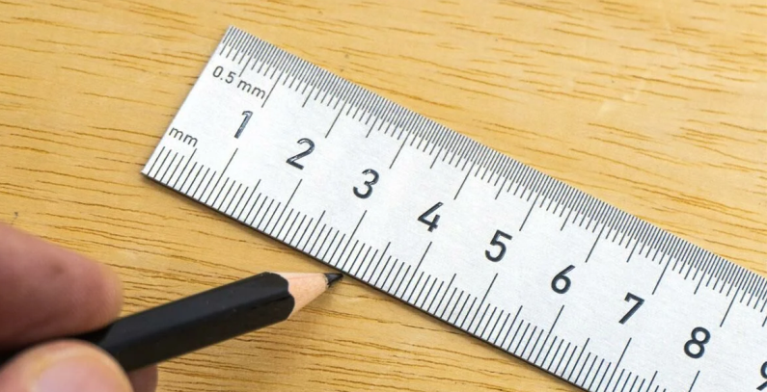
Figure 4.1 Using a Ruler
- Usage: It is used to measure short distances on flat surfaces. The ruler is aligned with the surface to be measured, and the reading is taken from the measurement scale.
- Areas of Use: Frequently used in schools, offices, and hobby projects.
2. Tape Measure (Measuring Tape): Can be made of steel or cloth. Its flexibility allows measurement of curved or movable surfaces.
- Usage: A flexible measuring tool used to measure long distances. The tape is extended along the distance to be measured, and the reading is taken from the measurement scale.
- Areas of Use: Used in fields such as construction, carpentry, and interior decoration.
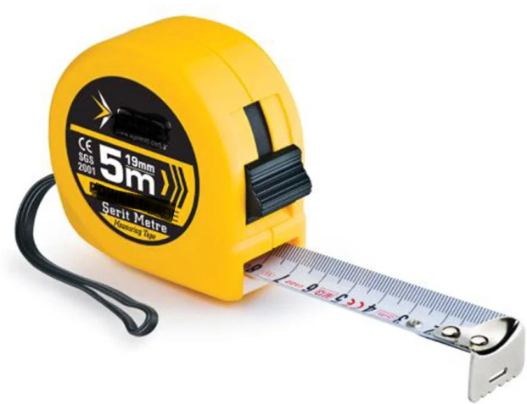
Figure 4.2 Tape Measure and Its Use

3. Micrometer:
A micrometer is a device used to measure the length of objects at the micro level, meaning very small dimensions. Micrometers are highly precise instruments used to perform millimetric measurements of tiny objects.
- Usage: Used for making very precise and small measurements. The micrometer is tightened around the object to be measured, and the reading is taken.
- Areas of Use: Used in engineering, mechanics, and precision work.

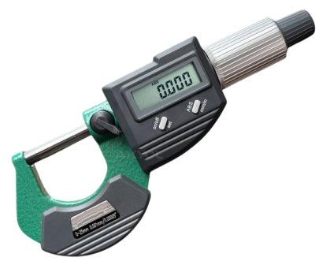
Figure 4.3 Micrometer

4. Caliper (Vernier Caliper):
A caliper is a precision measuring instrument used to measure the width, length, and depth of objects. There are different types based on measurement accuracy and method.
- Usage: Used to measure internal and external diameters, depths, and lengths. The caliper is placed on the object to be measured, and the measurement is read from the scale.
- Areas of Use: Commonly used in engineering, metalworking, and workshops.

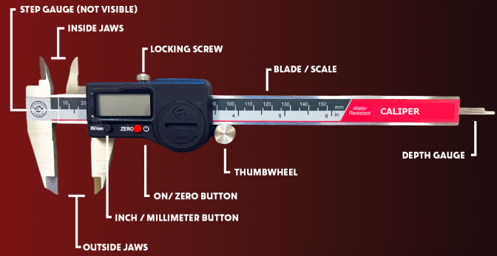
Figure 4.4 Digital Caliper

5. Multimeter:
A multimeter is used for measuring the voltage of pit and cabin top sockets, battery power levels, rescue output voltage, and grounding continuity. It is also used to check the power in safety circuits of control panels.
- Usage: Used to measure electrical quantities such as current, voltage, and resistance.
- Areas of Use: Used in electrical and electronic fields.
Figure 4.5 Multimeter

6. Clamp Meter (Clamp Ammeter):
- It measures current without contact by utilizing magnetic current sensing.
- Usage: Allows current measurement without disturbing the wiring while the elevator is in motion.

Areas of Use: While the elevator is operating at high speed, the current passing through the cables supplying energy to the motor can be measured without contact.
Figure 4.6 Clamp Meter
7. Insulation Tester (Megger):
Used to measure the earth continuity and insulation resistance of electrical installations.
- Usage: Measures insulation resistance by pressing the test lead onto the circuit or conductor.
- Areas of Use: Used in all types of grounding (earthing) tests.

Figure 4.7 Megger Device
8. Tachometer (Turtmeter): A device used to measure the speed of moving equipment. There are two types: contact and non-contact.
- Usage: During measurement, the tachometer unit should match the rated value specified on the elevator’s machine-motor label. Generally, this value is expressed in m/s.
- Contact Tachometer: A device that measures by being placed in contact with the cabin ropes or the governor rope.
- Non-contact Tachometer:
Also known as an optical tachometer. Colored reflective labels are attached to the side surface of the sheave. The tachometer is activated and its laser is aimed at the rotating sheave. As the sheave rotates, the label passes the laser beam in each revolution, and the elevator speed is measured accordingly.

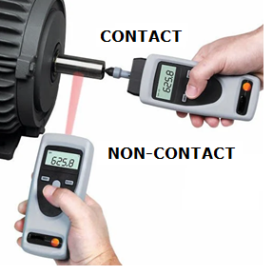
Figure 4.8 Tachometer and Its Use
9. Lux Meter:
A measuring device used to assess lighting levels in the elevator cabin, shaft, pit, cabin top, and machine room.
- Usage: Measures the amount of light in the environment. If the light level is insufficient, additional lighting sources should be installed. Its unit is lux.
- Application Areas: Used for all types of lighting level measurements.

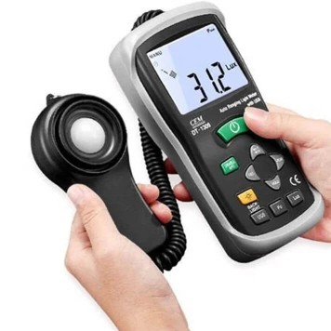

Figure 4.9 Lux Meter and Its Use

10. Newton Meter:
A measuring device that measures torque and rotational force.
- Usage: Measures through physical contact.
- Application Areas: Used to measure the strength of shaft walls, cabin walls, machine room walls, and door panels, as well as the closing force of floor doors. For example, the closing force of a floor door should be below 150 N. The force applied to a 5 cm² area on shaft walls should not exceed 300 N.

Correct and precise use of these devices increases the reliability and accuracy of the measurements. The choice of measurement tool depends on the length to be measured and the required precision. Therefore, maintenance and calibration of measuring instruments are important.

Calibration of Measuring Instruments

All measuring instruments used in the final inspection of elevators must be calibrated by organizations authorized by the Turkish Accreditation Agency. Calibrations should be performed at least once a year. Additionally, if the instruments are dropped or physically impacted during use, calibration must be done before the scheduled calibration date. Calibration is a certification that a measuring instrument provides accurate measurements. No operations should be performed based on the values shown by uncalibrated instruments. Even the smallest measurement error can affect the entire system.

Maintenance of Measuring Instruments

After use, devices should be cleaned and stored in their cases. For battery-operated devices that are used infrequently, the batteries should be removed and stored separately. Repairs must be carried out by authorized service centers appointed by the manufacturer. Instruments that are not regularly maintained may provide inaccurate measurements or break down when needed, causing delays in work.

MODULE-4 APPLICATIONS AND OUTPUTS
MEASURING LENGTH WITH A TAPE MEASURE

The tape measure (mezura) is a flexible and portable measuring tool widely used for measuring long distances. Its usage is described in the following steps:

Using a Tape Measure

1- Preparation:
- Before using the tape measure, identify the surface or object to be measured.
- Release the tape measure and get it ready for use.
2- Determining the Starting Point:
- Align the metal or plastic starting part of the tape measure (usually marked “0”) with the starting point of the surface or object to be measured.
- Ensure this point is fixed and accurate as a starting reference.
3- Pulling the Tape:
- Carefully pull the tape measure along the distance you want to measure. Keep the tape straight and taut to avoid measurement errors.
- If measuring long distances, having an assistant can be helpful for accuracy and ease.
4- Reading the Measurement:
- Read the measured distance from the scale on the tape measure.
- Record or memorize the measurement result. Pay attention to the unit of measurement (centimeters, meters, inches, etc.).
5- Rewinding the Tape:
- Once measurement is complete, carefully rewind the tape measure. Most tape measures have a mechanism that automatically retracts the tape.
- Be careful to protect your fingers and hands while rewinding.
6- Checking and Verifying:
- Check and verify the measurement result for accuracy. If necessary, repeat the measurement and compare the results.

Precautions When Using a Tape Measure:

- Store the tape measure properly and avoid damage.
- Avoid bending or twisting the tape while measuring, as this can affect accuracy.
- Use the tape measure carefully and patiently, avoiding sudden movements.

The tape measure is a practical and easy-to-use measuring tool.

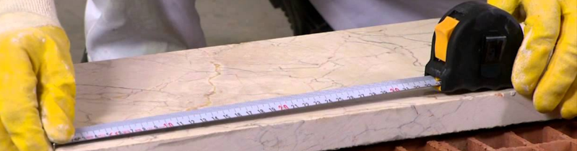

Figure 4.10 Measuring with a Tape Measure

,

MEASURING CROSS-SECTION DIAMETER AND DEPTH WITH A CALIPER
A caliper is a measuring tool used for precise measurements such as internal diameter, external diameter, depth, and cross-sections. Here is a step-by-step guide for measuring cross-section diameter and depth using a caliper:
Measuring Cross-Section Diameter
- Preparing the Caliper:
  - Ensure the caliper is clean and functioning properly.
  - Zero the caliper to make it ready for measurement.
- Using the External Measuring Jaws for Cross-Section Diameter:
  - Use the caliper’s external measuring jaws to measure the cross-section diameter.
  - Place the external jaws on both edges of the cross-section you want to measure.
- Clamping the Jaws and Reading the Measurement:
  - Clamp the jaws along the cross-section firmly in the correct position.
  - Once the jaws are securely in place, read the measurement from the caliper’s scale or digital display.
Measuring Depth
- Preparing the Caliper:
  - Ensure the caliper is clean and working properly.
  - Zero the caliper to prepare for measurement.
- Using the Depth Measuring Rod:
  - Use the depth measuring rod located at the bottom of the caliper to measure depth.
  - Insert the depth measuring rod into the hole or recess you want to measure until it reaches the bottom.
- Clamping the Rod and Reading the Measurement:
  - Insert the depth rod into the hole and align the caliper’s body with the surface of the hole to fix it in place.
  - Read the depth measurement from the caliper’s scale or digital screen.
General Tips:
- When measuring with a caliper, keep the caliper straight and steady.
- For accurate and precise measurements, firmly place the jaws and the rod on the object being measured.
- Regularly calibrate the caliper to ensure its precision and accuracy.
By following these steps, you can perform accurate and precise cross-section diameter and depth measurements using a caliper.
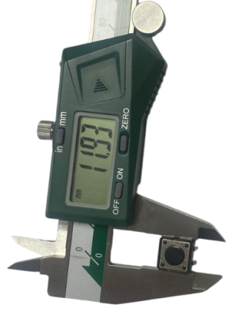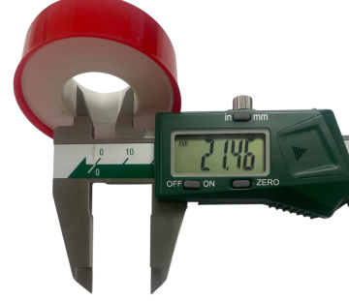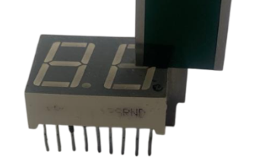
Figure 4.11 Caliper and Various Measurements
MEASURING EARTHING (GROUNDING) WITH A MEGGER DEVICE

Measuring grounding with a Megger device is used to measure the earth resistance of an electrical line. Below is a step-by-step explanation of how to perform the measurement. (4.1)

Measuring Grounding with a Megger Device

1- Preparation:
- Before using the Megger device, ensure that the device is clean and functioning properly.
- Perform the zeroing/reset process to prepare the device for measurement.

2- Grounding Cables and Stakes:
- Drive the Megger device’s stakes into the ground. The distance between stakes should be at least 5 meters, preferably 10 meters.
- Connect the green cable to the device’s E terminal, the yellow cable to the P terminal, and the red cable to the C terminal.

3- Taking the Measurement:
- Set the Megger device’s switch to the 2000 ohm position.
- Press the test button to start the measurement.
- The device measures the earth resistance and displays the result on the screen.

4- Evaluating the Results:
- The measured earth resistance equals the sum of the earth plate spreading resistance and the resistance of the grounding conductor.
- If the earth resistance exceeds a certain value, it may not trip the circuit breaker during a leakage, endangering people’s safety.

By following these steps, you can perform accurate and precise grounding measurements with a Megger device.

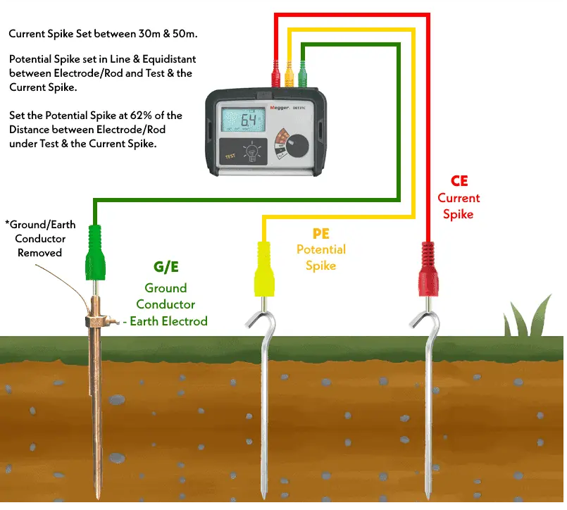

Figure 4.12 Operation of the Megger device
MEASURING LIGHT INTENSITY WITH A LUXMETER
A luxmeter is a device used to measure the light intensity of an environment.
Using a Luxmeter
- Preparation:
  - Ensure the luxmeter’s battery is sufficient and the device is clean.
  - Make sure the luxmeter’s screen and sensors appear to be on and functioning.
- Device Settings:
  - Check the luxmeter’s settings and make necessary adjustments, such as the measurement unit (lux) and measurement mode.
- Selecting the Measurement Area:
  - Identify the area where you want to measure. This is typically a workspace, room, or a specific zone where light intensity is to be measured.
- Taking the Measurement:
  - Point the luxmeter’s sensor towards the measurement area.
  - Wait for the reading on the device’s screen or display. The device measures light intensity in lux and shows the result on the screen.
- Evaluating the Results:
  - The measured lux value represents the light intensity in the selected area. Record or note this value.
  - Evaluate whether the light intensity meets required standards. For example, office workspaces typically require about 200-300 lux.
General Tips:
- Hold the luxmeter steady and ensure the sensor is directed straight at the light source during measurement.
- Consider factors like the size of the measurement area and positions of light sources to get an accurate reading.
- Regularly check and calibrate the luxmeter as needed.
By following these steps, you can obtain accurate and precise measurements of light intensity using a luxmeter.
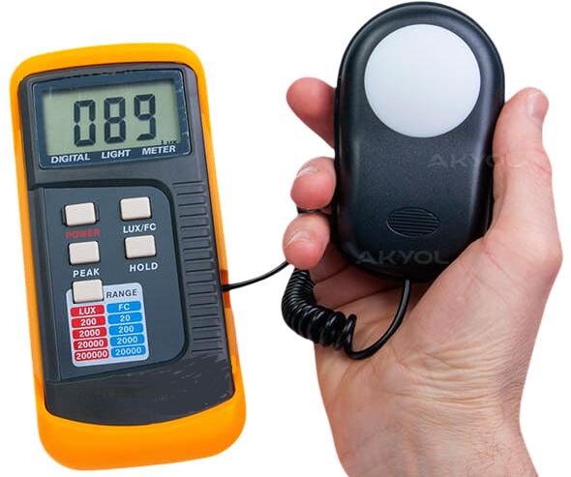
Figure 4.13 Measuring with a Luxmeter
MEASURING PRESSURE WITH A NEWTONMETER
A Newtonmeter (Nm) is a unit used to measure torque or rotational force. To measure torque using a Newtonmeter, typically a torque wrench or a similar tool is used. Below is a step-by-step guide on how to perform torque measurement with a Newtonmeter (Torque Wrench):
Using a Newtonmeter (Torque Wrench)
- Preparation:
  - Before measuring torque, ensure that the torque wrench is functioning correctly and has been calibrated.
  - Identify the bolt or nut you want to measure.
- Setting the Torque Wrench:
  - Use the adjustment mechanism on the torque wrench to set the desired torque value (e.g., 50 Nm).
  - Make sure the setting mechanism is firmly and accurately adjusted.
- Placing the Wrench:
  - Place the tip of the torque wrench on the bolt or nut to be measured.
  - Ensure the wrench is properly positioned and securely placed.
- Applying Torque:
  - Turn the torque wrench clockwise and apply force until the preset torque value is reached.
  - The torque wrench typically gives a "click" sound or sensation when the set torque is reached, indicating that the desired torque value has been applied.
- Checking and Verification:
  - Carefully remove the torque wrench and check the tightness of the bolt or nut.
  - Repeat the measurement if necessary to verify accuracy.
General Tips:
- Before using the torque wrench, carefully read the manufacturer’s instructions and safety warnings.
- Store the torque wrench properly and have it regularly calibrated.
- Use the torque wrench only for torque measurement; using it for other purposes may damage its precision.
By following these steps, you can perform accurate and precise torque measurements using a Newtonmeter.
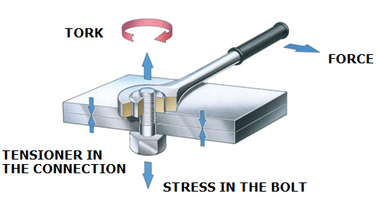
Figure 4.14 Explanation of the Torque Concept
MEASURING CURRENT WITH A CLAMP METER (PENS AMPERMETRE)
A clamp meter (pens ampermetre) is a device used to measure the electric current flowing through a circuit without needing to make direct contact with the conductor.
Using a Clamp Meter
- Preparing the Device:
  - Ensure the clamp meter’s battery is sufficient and the device is operational.
  - Set the measurement range correctly, usually done via a dial or digital screen on the device.
- Selecting the Measurement Mode:
  - Choose the correct mode on the device. Usually, there are modes for AC (alternating current) and DC (direct current) measurements. Select the appropriate mode according to the current type to be measured.
- Opening the Clamp:
  - Use the trigger or lever on the device to open the clamp.
  - Place the clamp around the conductor you want to measure. Make sure the clamp fully closes and is centered around the conductor.
- Taking the Measurement:
  - Once the clamp is around the conductor, read the current value on the device’s display.
  - The measured current is shown in amperes (A).
- Evaluating the Results:
  - Record or note the measured current value.
  - If needed, measure at different points along the same conductor to verify accuracy.
Important Points:
- Always ensure the clamp meter is correctly set and in the right mode before measuring.
- Avoid touching the insulated parts of the conductor while using the device.
- Be cautious when measuring high currents and follow safety precautions.
Using a clamp meter allows for safe and quick current measurements in an electrical circuit.

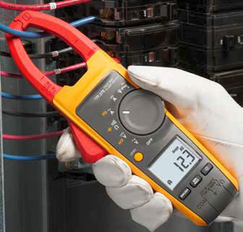
Figure 4.15 Using the Clamp Meter

