MODULE-20
TYPES OF FLOOR DOORS (Landing Doors)
Elevator floor doors are important components that provide the passage between the elevator cabin and the landing on each floor. They support both user safety and aesthetic integrity. These doors are categorized based on their usage features, mechanisms, and design approaches. Below is a detailed explanation of elevator floor door types:

1. Basic Categories
Elevator floor doors are mainly divided into two categories: automatic and manual models. Among automatic systems, telescopic, center-opening, and sensor-supported doors stand out, while manual door systems are simpler and preferred in situations requiring on-site operation. Each model is selected according to user safety, energy efficiency, ease of maintenance, and aesthetic criteria.
A. Automatic Floor Doors
Automatic doors are the most preferred systems in modern buildings. These doors increase mechanical comfort while ensuring user safety through various subtypes.
- Sensor-Supported Automatic Sliding/Opening Doors:
These doors stop closing or speed up opening when any obstacle is detected inside or outside. This system is critically important for user safety.
- Telescopic Door Systems:
In this model, door panels move telescopically on rails, following each other according to a certain number of panels (usually two, three, or four). This saves floor space at the door opening and prevents the doors from covering a wider area.
- Center-Opening/Sliding Doors:
In this model, door panels open from the center towards the sides. It reflects a modern design approach, usually controlled by a central mechanism, offering ergonomic and aesthetic advantages.
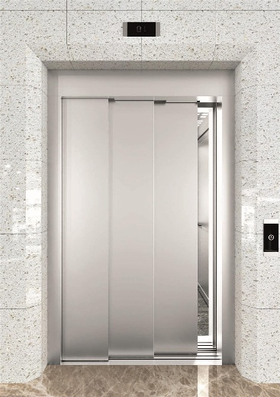
Figure 20.1 Example of Sliding Door

B. Manual Floor Doors
Manual doors, mostly used in older elevator systems or special cases, are operated manually by the user. These doors generally have simpler mechanisms and differ from automatic doors in terms of maintenance and usage.
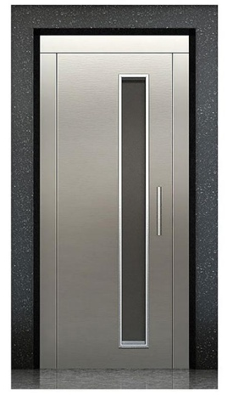
Figure 20.2 Example of Floor Door
- Subtypes and Design Features
- Number and Structure of Panels:
Elevator floor doors exhibit different mechanical behaviors depending on the number of panels used (for example, two-panel, three-panel, or four-panel doors). An increase in the number of panels allows the door to open and close more compactly.
- Movement Direction of Panels:
The doors can slide sideways, telescope by sliding into each other, or fold open. Each method is optimized according to various building architectures and usage areas.
- Safety Sensors and Integration:
Modern automatic floor doors are integrated with obstacle detection sensors, emergency stop mechanisms, and locking systems. These systems are designed to prevent accidents during door movement.
- Selection Criteria
- Building Type and Usage Density:
Sensor-equipped automatic systems are preferred in high-density buildings, whereas manual systems may be considered for less crowded or historical buildings.
- Energy Efficiency and Maintenance Ease:
Motors used in automatic systems consume less energy thanks to technological advances, while regular maintenance ensures long-term performance.
- Aesthetic and Architectural Compatibility:
The design of the doors should harmonize with the interior decor and overall architectural concept of the building. Center-opening and telescopic door models are frequently preferred in modern designs.

PERIODIC INSPECTIONS OF FLOOR DOORS
Inspection Periods and Methods
- Inspection Interval:
Floor doors are generally inspected once a year or at specified intervals (e.g., every six months), depending on usage intensity and environmental risk factors.

- Authorized and Certified Personnel:
Inspections are carried out by authorized technicians or engineers who are experienced and knowledgeable about relevant standards, in compliance with the Occupational Health and Safety legislation of the Republic of Turkiye.

- Measurement and Testing Devices:
Precision measuring tools such as laser measurement devices, tape measures, and calipers are used to assess door alignment, gaps, and clearance settings. For automation systems, digital testing devices are utilized to evaluate sensor and motor performance.

MODULE-20 APPLICATIONS AND OUTPUTS
CHECKING FLOOR DOOR ELECTRICAL CONTROLS USING AVO METER
Electrical Maintenance
- Contact Durability Test
If no value is specified, the declared values should be as follows:
a) Alternating current: 230 V, 2 A
b) Direct current: 200 V, 2 A. Unless otherwise specified, the breaking capacity of the circuit must be examined for both AC and DC.
- Tests must be performed with the door lock in the operating position.
- If multiple operating positions exist, tests should be carried out in the least favorable position.
- The test sample must include covers and electrical connection cables used in normal operation.
- For door locks equipped with alternating current contacts, a circuit at 110% of the rated voltage should be opened and closed 50 times at normal speed with intervals between 5 to 10 seconds. The contact must remain closed for at least 0.5 seconds.
- This electrical circuit must include a series-connected inductance (choke coil) and a resistor. The circuit power factor must be 0.7 ± 0.05 and the test current should be 11 times the rated current declared by the lock manufacturer.
- For door locks equipped with direct current contacts, a circuit at 110% of the rated voltage should be opened and closed 20 times at normal speed with intervals between 5 to 10 seconds. The contact must remain closed for at least 0.5 seconds.
- This circuit must include a series-connected inductance (choke coil) and resistor chosen so that the circuit current reaches 95% of the steady-state current in 300 ms. The test current should equal 110% of the rated current declared by the lock manufacturer.
2- Leakage Current Resistance Test:
This test should be performed according to the procedure specified in EN 60112. Electrodes must be connected to a source producing 175 V, 50 Hz sinusoidal AC voltage.

3- Inspection of Clearances and Creepage Distances:
Air clearances and creepage distances must comply with the requirements in standards governing the application of this standard (e.g., EN 81-20:2014, Clause 5.11.2.2.4).

4- Inspection of Safety Contacts and Their Accessibility:
This inspection should consider the installation location and arrangement of the door lock.

5- Special Test for Specific Door Lock Types:
Locks for sliding doors with multiple panels moving horizontally or vertically:
According to the requirements in applicable standards (e.g., EN 81-20:2014, Clauses 5.3.14.1 and 5.3.14.2), devices providing direct mechanical connection between panels or indirect mechanical linkage are considered part of the door lock.
These devices must be subjected to the durability tests mentioned above. The number of cycles per minute in these endurance tests must be adjusted according to the device size.

6- Breaking Capacity Test:
This test must be conducted after the durability test to verify that the device’s ability to interrupt an energized circuit is adequate. The test must be performed according to the procedures specified in EN 60947-4-1 and EN 60947-5-1.

Type Examination Certificate:
This certificate should include:

- Information according to Annex A;
- Type and application area of the locking device;
- Type (AC and/or DC) and values of the declared voltage and current;
- For flap-type door locks: The force required to operate the electrical safety device during elastic deformation control of the leaf.

The current and declared voltage values used in the tests must be those specified by the manufacturer of the device.

PERFORMING PHYSICAL INSPECTIONS OF FLOOR DOORS
The inspection process of elevator floor doors is carried out according to specific standards to ensure safety and functionality. These inspections, conducted in accordance with standards such as TS EN 81-1 and TS EN 81-80, are typically performed during annual periodic examinations.
The main stages of the inspection process are as follows:
1- Preparation:
The inspection team wears personal protective equipment (PPE) and takes necessary safety precautions. Warning tapes are placed to prevent the use of the elevator during the inspection.

2- Door Safety Contact Test:
Floor door locking devices can be defined as mechanisms—either automatic or manual—that both ensure the floor door closes and electrically monitor the door’s closed status via a contact. During the opening and closing of the door, it is checked whether the safety contact functions properly.
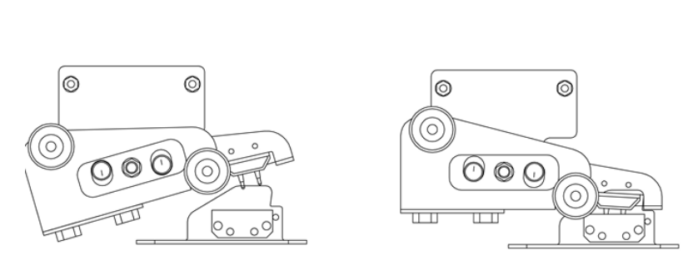
Figure 20.3 Door Safety Contact
- Stop Button Test:
The functionality of the elevator’s emergency stop button is tested.
- Door Gaps:
The gaps between the door panels are measured to ensure compliance with the specified standards.
- Fire Resistance Test:
The fire resistance of the floor doors is tested according to the TS EN 81-58 standard.
- Electrical Safety Inspections:
The elevator’s electrical installation is checked for safe operation and insulation.
- Final Evaluation:
Inspection results are documented, and recommendations are provided to address any deficiencies.

