MODULE-2
WORKING IN COMPLIANCE WITH ENVIRONMENTAL PROTECTION LEGISLATION ENVIRONMENTAL PROTECTION
Environmental protection refers to all efforts aimed at preventing the destruction, degradation, and loss of environmental values and ecological balance, as well as remedying existing damages, improving, and enhancing the environment. (2.1)
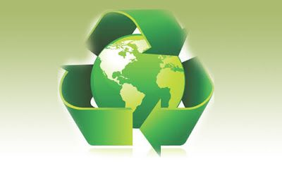
Figure 2.1 Environmental-Friendly World Order

Environmental protection activities aim to preserve and sustainably manage natural resources and ecosystems.
Some possible actions include:

1. Recycling:
Recycling is defined as the process of reintroducing out-of-use recyclable waste materials into the production cycle as raw materials using various recycling methods. The difference between recycling and recovery is that, in recycling, the waste is not converted into different products or energy through physical, chemical, or biochemical methods depending on the characteristics of the waste. Preventing recyclable waste from mixing with other types of waste at the source significantly reduces recycling costs and increases the value of the waste. (2.2)

a- Recyclable Materials:
Paper, glass, metal, plastic, organic waste, and electronic waste are recyclable. If properly separated, they can be included in the recycling process.

b- Zero Waste Project:
Projects developed with this goal aim to protect nature, collect waste efficiently, and recycle it. Avoiding the use of plastic materials for packaging in a production facility, preferring new-generation systems to reduce paper consumption, and implementing solutions to ensure waste is separated during collection are all steps toward achieving the zero waste goal.

c- Waste and Waste Types:
Waste refers to any used, unwanted, and environmentally harmful substance.

Types of Waste:
- Organic waste: These are plant- and animal-based wastes. For example, leftover food, chicken breasts, or vegetables. Such waste can be used for biogas production or decomposed through composting to be used as natural fertilizer in soil.
- Plastic waste: Plastic waste can be reused through recycling. However, due to inadequate recycling facilities, most plastic waste cannot be recycled and ends up in landfills. Therefore, reducing plastic usage and increasing recycling rates is important.
- Glass waste: Glass waste can be reused through recycling. Glass can be melted at high temperatures and turned into products like bottles or jars. Recycling glass is important to reduce glass waste.
- Metal waste: Metal waste, such as aluminum, copper, and steel, can be reused through recycling. Recycling metal products is essential to reduce metal waste.
- Paper waste: Paper waste, such as newspapers, magazines, and cardboard, can be recycled and reused. Recycling paper products helps eliminate paper waste and prevents environmental damage.
- Electronic waste: This includes technological devices and their components, such as computers, phones, tablets, batteries, and hard drives. Recycling electronic devices properly is crucial for reducing electronic waste.
- Chemical waste: These include household chemicals such as detergents and bleach. Since they may contain harmful substances, proper disposal is essential to prevent environmental harm.
- Medical waste: This includes materials used in the healthcare sector, such as sterile supplies and medical devices. Because of potential contamination, medical waste must be disposed of properly.
- Toxic waste: These contain harmful chemicals, such as paint markers and solvents. Proper disposal is critical to reduce environmental damage.
- Nuclear waste: These are produced or used in nuclear reactors and include substances such as uranium.

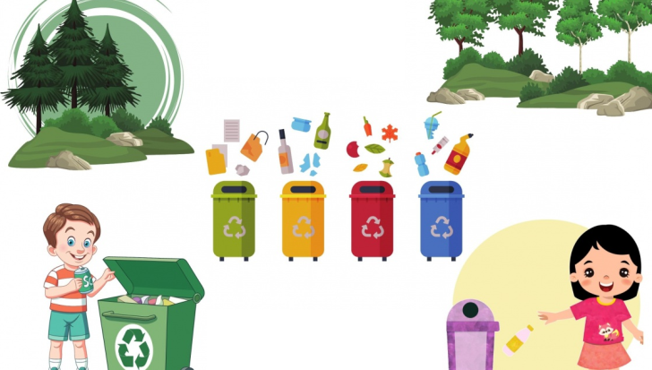

Figure 2.2 Poster Example for Zero Waste Project

2. Energy Conservation
Energy conservation refers to the effort to reduce energy consumption by using less energy for a particular energy service. It can be achieved by using energy more efficiently (performing the same task with less energy) or by simply reducing the amount of energy used (e.g., driving less).
Energy conservation supports the sustainability of natural resources and slows the depletion of limited sources like fossil fuels. It plays a major role in environmental protection by reducing environmental pollution and greenhouse gas emissions associated with energy production, contributing to the fight against climate change. It also holds significant economic value by lowering energy costs, offering savings opportunities for individuals and businesses. In addition, it brings benefits such as improved energy security, better air quality, and the preservation of natural resources. Energy conservation is a critically important practice with positive impacts for both the environment and the economy.

a- How to Conserve Energy:
- Use Energy-Efficient Appliances: Choose energy-efficient household appliances, lighting, and electronics. These devices consume less energy and can reduce utility bills in the long term.
- Turn Off Lights: Turn off lights when leaving a room and try to use natural daylight. Use energy-saving light sources like LEDs or compact fluorescent bulbs.
- Optimize Heating and Cooling Systems: Ensure that heating and cooling systems are regularly maintained for efficient operation. Setting the thermostat a few degrees lower in winter and higher in summer can save energy.
- Save Hot Water: Be mindful when using hot water. Use low-flow faucets and showerheads to reduce water consumption and adjust water heater settings for efficiency.
- Check Energy Labels: When purchasing new appliances, review the energy labels and choose A+++ or ENERGY STAR-certified products.
- Shut Down Electronics: Turn off computers and other electronics when not in use or switch them to sleep mode. Unplug rechargeable devices when they are fully charged.
- Improve Home Insulation: Enhance insulation in your home to reduce heat loss. Proper insulation of windows, doors, and the roof can significantly lower heating and cooling costs.
- Promote Energy Awareness: Educate family members on energy-saving habits. Encourage turning off lights, unplugging devices, and conserving water.
- Consider Solar Energy: Invest in renewable energy sources such as solar panels or solar water heaters to generate energy at home.
- Change Transportation Habits: Use public transportation more often or switch to energy-efficient vehicles. For short distances, choose eco-friendly alternatives like walking or biking.

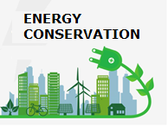
Figure 2.3 Energy Conservation Should Be Encouraged

b- Renewable Energy
Renewable energy is the energy obtained from the continuous flow of natural processes.
Types of Renewable Energy:
- Solar Energy:
The sun is the energy source for all planets in the solar system and is an indispensable resource for all living beings on Earth. (2.3)
Due to the practicality of its use—especially during the summer months—and the significant reductions it offers in electricity bills, solar panels are among the most prominent renewable energy sources today.
Solar panels, commonly seen on rooftops of houses in both cities and villages, can be used to heat water, meet a household's hot water needs, or provide hot water to the heating system for space heating.
Solar energy technologies collect sunlight to generate heat or electricity. Solar energy can be harnessed in the form of light, heat, or electricity.
Solar energy systems directly convert collected energy into electricity and can be installed on rooftops, devices, or vehicles. Concentrated solar power (CSP) plants operate based on focusing sunlight using mirrors and lenses onto a relatively small area and are used to produce electricity or heat.

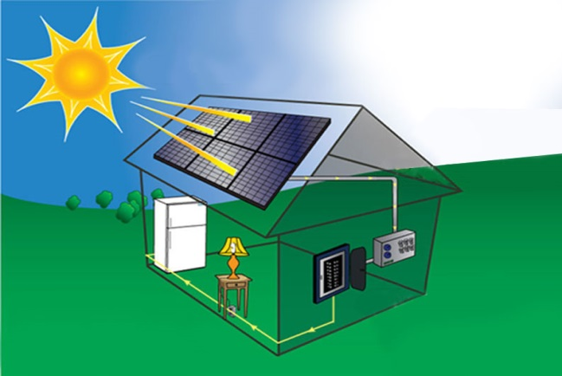
Figure 2.4 Solar Energy System

Wind Energy:
The source of wind energy is actually solar energy. Since solar energy does not heat land and sea surfaces equally, pressure differences occur, resulting in wind. Wind turbines installed in areas where the wind is strong convert the kinetic energy of the wind into mechanical energy, and then into electrical energy.
The amount of energy obtained from wind depends on the wind's current speed and the duration of the wind flow. (2.4)
Today, wind energy provides about 2% of the world’s electricity needs. Compared to other electricity generation methods, wind turbine technologies have significantly fewer negative environmental impacts.
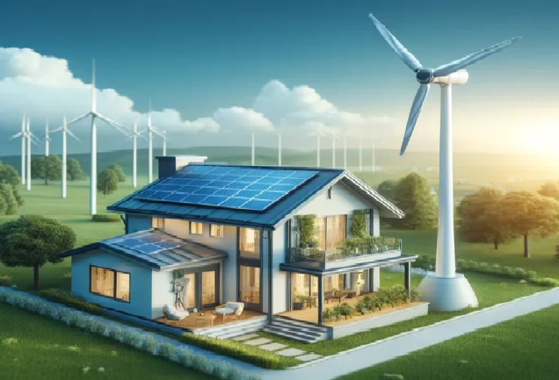
Figure 2.5 Wind Energy System

Bioenergy / Biomass Energy
This type of energy is an inexhaustible resource and can be obtained almost anywhere. It is considered a suitable and important energy source, especially for rural areas, due to its potential to support socio-economic development. (2.5)
Sources of biomass include specially cultivated plants such as corn and wheat, grasses, algae, seaweed, animal manure, fertilizers, industrial waste, and all organic household waste (such as fruit and vegetable scraps).
As fossil fuels (like coal) are being depleted and cause significant environmental pollution, the use of biomass is becoming increasingly important as a solution to the global energy problem.

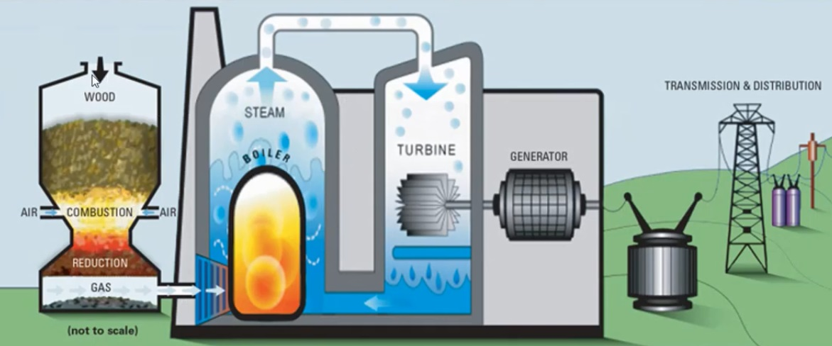

Figure 2.6 Bioenergy SYstems

Geothermal Energy
Geothermal means "earth heat." As a result of natural events and especially precipitation, water seeps through cracks in the Earth's crust and reaches the magma layer. This water, heated by the magma, returns to the surface as hot water and steam. The water and steam that reach the surface can be converted into various forms of energy through turbines.
In general terms, geothermal energy is the thermal energy stored within the Earth’s crust. This energy, when brought to the surface, can be transformed into electricity using geothermal power plants. Additionally, it can be used in central heating and cooling systems in homes and workplaces, in physical therapy centers preferred by patients, and in touristic facilities. (2.6)
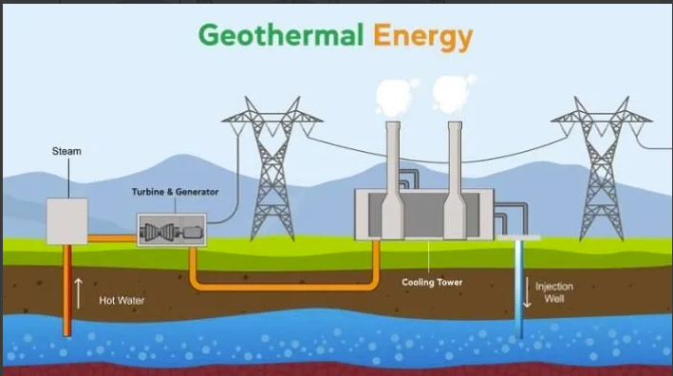

Figure 2.6 Bioenergy System
- Hydroelectric Energy:

The basis of hydroelectric energy is to use the energy of flowing water and convert it into electrical energy. Hydroelectric power plants are renewable. They are considered a clean source of energy for nature. Since the flow rate of water is higher in areas with greater elevation, these plants are more useful in such regions. As hydroelectric plants are based on the energy of flowing water, they are used in improving fisheries, facilitating transportation, irrigation, and most importantly, energy production. (2.7)
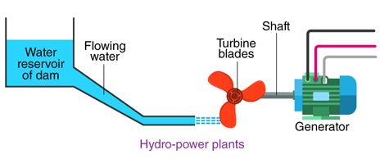
Figure 2.8 Hydroelectric Energy System

Hydrogen Energy
Due to current technological limitations and production difficulties, hydrogen energy is not yet widely used today. However, with the advancement of technology, it is considered one of the most promising candidates for meeting the world’s energy needs as a clean energy source. (2.8)
In the future, hydrogen energy is expected to be used in the production of electricity, heat, and fuel cells.
Among the most likely areas of use are internal combustion engines.
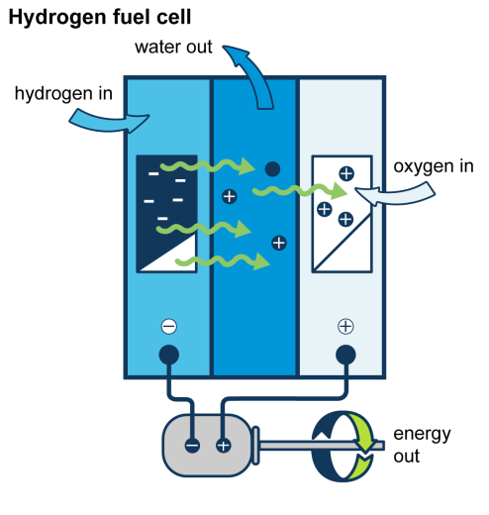
Figure 2.9 Hydrogen Energy System

- Wave/Ocean Energy

Oceans can actually be considered as two separate energy sources. The first is thermal energy dependent on solar heat, and the second is mechanical energy derived from waves and tides. (2.9)
Covering about 70% of the Earth's surface, oceans also act as the world's largest solar collectors.
The temperature difference between the warm surface water and the cooler deep water creates a natural thermal energy source.
If sufficiently harnessed, even a small portion of this energy could meet the entire world’s energy needs.
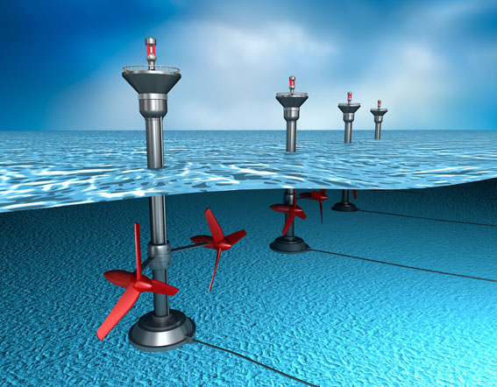

Figure 2.10 Wave Energy System

Advantages of Renewable Energy
Renewable energy has many advantages. These energy sources help reduce environmental impacts and contribute to the fight against climate change.
- Renewable sources such as solar, wind, water, and geothermal energy are unlimited and infinitely renewable, which increases energy security and helps stabilize energy prices.
- Renewable energy technologies provide economic benefits and can contribute to local economies.
- They can create new job opportunities.
- While increasing energy independence, they reduce energy imports, positively affecting the balance of trade.
- This sector promotes technological advancements and offers new opportunities for economies based on advanced technology.
In conclusion, the advantages of renewable energy sources form an important driving force for a sustainable energy future and play a critical role in the global energy transition.

3. Tree Planting and Forest Protection
Tree planting campaigns and forest conservation play an important role in combating climate change by increasing carbon sequestration.
Biodiversity: Forests host a large portion of the world’s biodiversity. They enable plants, animals, and microorganisms to coexist, ensuring a balanced and healthy functioning of ecosystems. The biodiversity provided by forests contributes to the discovery of new medicines and materials in medicine, agriculture, and industry.
- Trees Combat the Greenhouse Effect
The main cause of climate change is the excessive amount of greenhouse gases released due to deforestation and fossil fuel use. After heat from the sun is reflected by the Earth’s surface, these gases trap the heat in the atmosphere, causing a permanent rise in temperature. The most well-known greenhouse gas is carbon dioxide (CO₂). Trees absorb carbon dioxide, sequester the carbon, and release oxygen back into the atmosphere. The amount of carbon absorbed by a 1,000 square meter forest area equals the carbon dioxide emitted by driving your car for 10,000 kilometers.
- Trees Clean the Air
Trees absorb pollutants in the atmosphere such as ammonia, nitrogen dioxide, sulfur dioxide, and ozone. Through their bark and leaves, they filter airborne particles.
- Trees Produce Oxygen
A 4,000-square-meter forest area produces enough oxygen to support 18 people per year.
- Trees Cool Cities and Streets
While asphalt roads and buildings that absorb heat have rapidly increased worldwide in the last 50 years, urban temperatures have risen by 14.5 degrees Celsius. Trees create shaded areas over buildings and roads, preventing the formation of urban heat islands. Through transpiration from their leaves, they can reduce city temperatures by up to 12 degrees Celsius, depending on their density.

- Trees Save Energy
By planting trees strategically around a detached house, air conditioning costs can be reduced by up to 50% in summer. Reducing the energy used for cooling also lowers carbon emissions caused by power plants.
Additionally, trees reduce the urban heat island effect, leading to approximately 20% energy savings across entire cities.
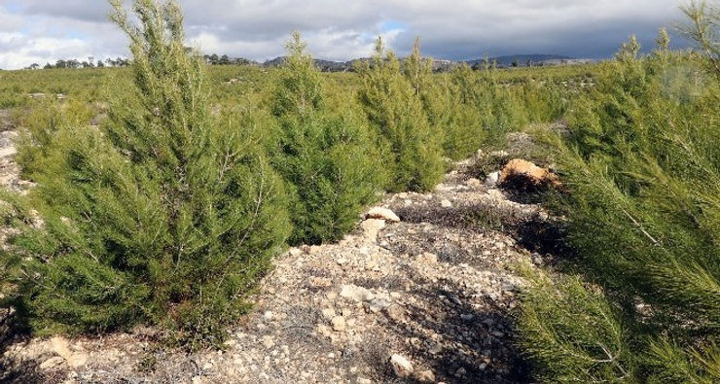
Figure 2.11 The Importance of Afforestation
- Trees Save Water
In areas with limited water, tree shade slows evaporation. Even a newly planted tree requires at most 55 liters of water per week and returns this water to nature as groundwater.
- Trees Prevent Erosion
Trees on hillsides and riverbanks reduce surface runoff and hold the soil together, preventing fertile soil from washing into the oceans.
- Trees Create Economic Opportunities
Fruits grown on trees in neighborhood gardens can be sold to generate income. Businesses focused on waste management and green spaces can be established, and youth can be guided towards green-centered jobs.
- Trees Provide Shelter and Habitat for Animals
Especially oak and plane trees serve as excellent nesting sites for urban wildlife such as birds, bees, and ants. Animals can breed in wooded environments.
- Trees Produce Food
A single apple tree can be planted in a small area and produce 300 kg of fruit annually. Trees provide food not only for humans but also for birds and other animals.
- Trees Improve Quality of Life
Areas with abundant green spaces are preferred over others, especially in business districts. The number of companies moving into an area increases with green space. Streets lined with trees tend to have slower traffic because drivers prefer to enjoy their surroundings rather than speed, which reduces traffic accidents.
- Trees Protect Against Earthquakes and Disasters
Tree roots extend meters underground and hold the soil together. Trees planted near residential areas help reduce damage caused by earthquakes by stabilizing the soil.

The Importance of Tree Planting:
Protecting nature and sustainability is an increasingly important issue today. In this context, tree planting is one of the most effective ways to conserve nature. Planting trees contributes to nature in many ways and also provides numerous benefits to people.
The balancing role of trees in ecosystems is vital not only for humans but for all living beings. Forests host many animal species, maintain plant diversity, and contribute to the sustainability of natural life.
In addition to their environmental contributions, trees also offer many social and individual benefits. Green areas provide places where people can gather, socialize, relax, and spend time in nature. Especially to escape the stressful pace of city life, parks, gardens, and forests offer great relief.

4. Water Conservation:
Currently, at least 40% of the world’s population experiences water scarcity. It is estimated that by 2050, water shortages will become more frequent, affecting one in every four people. We must conserve water not only to avoid being part of this affected group but also to make the planet’s resources more equitable and sustainable. (2.10)
Water is an indispensable part of every ecosystem on Earth, at least as vital as oxygen. When natural water resources are overused, the amount of fresh water decreases, and even the quality of water deteriorates, life continuity is at risk.
- It is the beginning of drought prevention: Water conservation minimizes the impacts of drought and water scarcity. Although there is a water cycle, water does not always return to the soil in the same quantity or quality. Therefore, by reducing the amount of water we use, we can better protect our resources.
- It is the key to environmentally friendly agriculture and livestock: Over 90% of human water footprints come from agricultural activities, with one-third of that being livestock. Using less water in the production and supply chain makes these sectors more sustainable.
- It saves energy: Water treatment and recycling facilities consume a large amount of energy. The more water we use, the more energy we consume, leading to increased pollution.
- It ensures hygiene: We need safe and clean water sources for basic needs such as cleaning and hygiene.
- It guarantees the continuation of the food chain: Water is essential for the growth and sustainability of all living things’ food sources. At least 80% of plants, which form the base of the food chain, consist of water. Animals obtain a significant portion of the water they need from plants. Maintaining this cycle depends on water conservation.
- It protects biodiversity: Water is vital for the survival of all ecosystems. Without water, many plant and animal species may become extinct.
- Livable cities: Most fresh water sources are also used for recreational purposes. Not conserving water means losing common spaces such as parks and gardens.
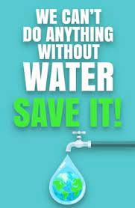
Figure 2.12 Example Poster for Water Conservation
Today, we face environmental and climate change challenges, and we all have responsibilities in solving these issues. We must protect the environment by taking steps such as using clean energy, renewable energy sources, and energy-efficient technologies, while reducing pollution caused by fossil fuels. Additionally, by adopting carbon capture, storage, and utilization technologies more widely, we should reduce the amount of carbon released into the atmosphere. Protecting our forests and reducing food waste are also important steps for the ecosystem.

WATER CONSERVATION IN AGRICULTURE
Approximately 74% of the total water used in our country is for irrigation. Among irrigation methods, the greatest water loss occurs in surface irrigation, which is the most widely applied method in our country (water loss ranges between 35% and 60%), while sprinkler and drip irrigation have lower water losses (between 5% and 25%). Farmers’ careless and unplanned use of water harms not only themselves but also the natural resources they rely on (soil and water) and the country. Due to unplanned irrigation, thousands of hectares of land in our country have become unusable for agriculture, resulting in yield losses. Over-irrigation causes environmental problems such as soil erosion, rising groundwater levels, and salinization or desertification, threatening the sustainability of natural resources. On the other hand, delayed irrigation stresses plants, leading to unnecessary losses in yield and income.
The sustainability of water resources is a social, physical, economic, and ecological concept. Sustainable water resource management covers the use of water for drinking, irrigation, industrial, and recreational purposes while protecting ecosystems, ensuring that present and future generations can meet their needs without jeopardizing them.
To achieve sustainability, the following must be considered:
- Preventing water waste and conserving water,
- Increasing the efficiency of irrigation systems,
- Improving water quality,
- Limiting surface water use according to soil type, crop type, and irrigation method requirements,
- Restricting groundwater withdrawals.

SPRINKLER IRRIGATION
In sprinkler irrigation, water is delivered through closed pipes to sprinkler heads placed on the land. Water is sprayed into the atmosphere at a certain pressure and allowed to reach the soil surface. Water that reaches the soil infiltrates and is stored in the plant root zone. This method can be used for all plants that are not sensitive to diseases caused by wet leaves.

DRIP IRRIGATION
Drip irrigation saves more water compared to other methods, provides higher yield and quality, protects and sustains soil and water resources, allows fertilizer application through irrigation water, consumes less energy, and can be successfully used under conditions where other methods cannot be applied. It also requires less labor and agricultural pest control costs, is easy to operate and control, highly automatable, and utilizes technology at the highest level.
The principle of drip irrigation is to apply small amounts of water frequently to the soil around the plant roots without causing moisture deficiency or stress to the plants. Water is given to the soil under low pressure in droplets from emitters placed near the plants. Only the area where droplets fall is wetted, not the entire soil surface.
There is no water loss due to deep percolation or surface runoff. Water application efficiency is high. The soil is kept continuously moist, resulting in high yield and quality.

5. Protecting Wildlife:
Wildlife ensures the health of ecosystems and the continuation of biological diversity. It is also important for protecting clean air, water, and soil, and for leaving a more livable world for future generations.
Environmentally friendly habits such as saving energy at home, practicing recycling, and using sustainable products contribute to the conservation of natural resources and help prevent damage to ecosystems.
To prevent forest fires, it is important to avoid behaviors that increase fire risk, support preventive infrastructure such as fire watchtowers, and receive necessary training for rapid response during fires.
Various types of protected areas, such as national parks, natural conservation sites, biosphere reserves, and specially protected areas for wildlife, are critical for the sustainability of wildlife.
Reducing plastic use helps prevent pollution in marine and terrestrial ecosystems and decreases harmful effects on wildlife.
Sustainable hunting and fishing are possible through monitoring stocks, preventing overfishing, and adopting fishing methods that do not harm marine ecosystems.
Individually, we can take steps such as avoiding products harmful to nature, keeping the environment clean during nature walks, contributing to local conservation projects, and supporting education efforts to raise environmental awareness.
Protecting the environment is possible by using organic fertilizers instead of chemical ones. Nitrogen and phosphorus are among the basic needs of plants. Meeting these needs naturally positively affects plant growth. It also reduces costs for pesticides and irrigation. Plants enriched with organic fertilizers produce much healthier crops. Thus, both human health and environmental health can be preserved. Organic fertilizers do not leave waste in the soil and do not pollute groundwater.
Chemical substances used in many sectors such as food, cleaning, and industry are major pollutants. Their use negatively affects the natural balance in the ecosystem. It is important to prefer products with natural content. We can learn about product ingredients by reviewing the information on their labels.
Single-use products greatly increase waste and solid waste problems. To protect the environment, reusable products should be preferred. (1)
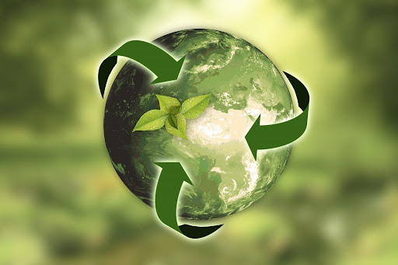

Figure 2.13 Example Logo for Wildlife Protection

6. Environmental Education:
Environmental education is a learning process aimed at increasing the well-being of individuals and society, understanding density issues, and ensuring focused, sustainable production on these matters.
Objectives of Environmental Education:
- To provide knowledge and awareness about the environment
- To develop environmentally sensitive attitudes and behaviors
- To increase consciousness of sustainable living
- To instill habits of protecting natural resources
- To encourage understanding and preservation of ecological balance
- To empower individuals to make environmentally friendly decisions
Content of Environmental Education:
- Ecosystem and biodiversity: The functioning of natural life
- Environmental pollution and problems: Air, water, soil pollution, climate change
- Sustainability: Renewable energy, recycling, carbon footprint
- Environmental policies and laws: National and international environmental protection laws
- Individual and social responsibilities: Ways to protect the environment in daily life
Where is Environmental Education Provided?
- In schools (from primary to university)
- In seminars and workshops organized by environmental organizations and NGOs
- In projects run by public institutions and municipalities
- Through media, documentaries, and campaigns
Environmental education is a process that everyone must participate in to protect nature and ecological balance. Environmental awareness directly affects not only individuals but also the future of entire societies.
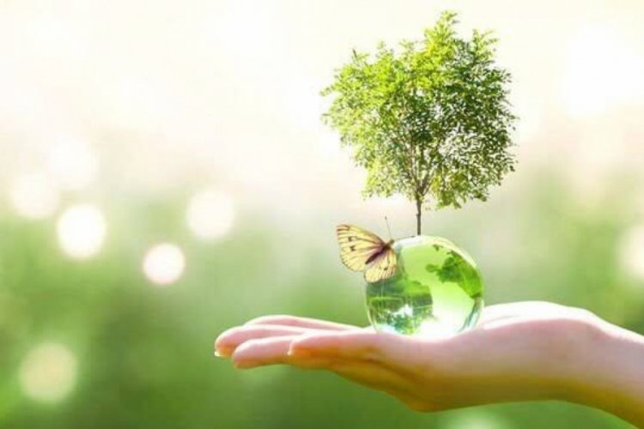

Figure 2.14 Environmental Education Visual

7. Pollution Control:
Pollution is defined as the intense contamination of air, water, and soil by foreign substances that negatively affect living and non-living components of the environment, causing structural damage and deterioration in quality.
It is the unnatural degradation of the environment caused by human activity.
Pollution control encompasses all activities aimed at identifying, monitoring, and reducing pollutants. Controlling pollution is critically important for both human health and ecosystem protection.
Some basic strategies to control environmental pollution are as follows:
Air Pollution Control
- Reduction of Industrial Emissions: Filtering harmful gases from factories and power plants and ensuring compliance with emission standards.
- Reduction of Vehicle Emissions: Encouraging the use of electric and hybrid vehicles to reduce fossil fuel consumption.
- Increasing Green Areas: Expanding afforestation and parks to help improve air quality.
Water Pollution Control
- Wastewater Treatment: Preventing industrial and domestic wastewater from contaminating clean water sources by treating it properly.
- Reducing Chemical Use in Agriculture: Controlling the use of pesticides and fertilizers and promoting organic farming methods.
- Waste Management: Preventing plastics and other wastes from entering water bodies.
Soil Pollution Control
- Management of Hazardous Waste: Safe storage and disposal of hazardous chemicals and industrial waste.
- Agricultural Practices: Using appropriate farming techniques to prevent erosion and supporting organic farming.
Noise Pollution Control
- Sound Insulation: Installing sound barriers in urban areas with high noise levels and constructing soundproof buildings.
- Traffic Regulations: Managing traffic flow and setting speed limits to reduce noise pollution.
Education and Awareness
- Environmental Education: Organizing educational programs in schools and communities to increase environmental awareness.
- Campaigns: Running awareness campaigns to inform and mobilize the public against pollution.
Pollution control is achievable through the joint efforts of individuals, communities, and governments. By implementing these strategies, we can create a cleaner and healthier environment.

ENVIRONMENTAL PROTECTION IN ELEVATOR USE
Environmental protection in elevator use involves practices aimed at saving energy, reducing the carbon footprint, and contributing to a sustainable lifestyle. Various strategies can be applied to reduce the environmental impact of elevator usage.
- Energy Efficiency: Modern elevator systems can reduce energy consumption by using energy-efficient motors and lighting. LED lighting and motion sensors can be used in elevators for this purpose.
- Upgrades and Maintenance: Modernizing old elevators can significantly decrease energy consumption. Regular maintenance increases energy efficiency and prevents additional energy consumption caused by malfunctions. Proper maintenance ensures efficient operation and prevents energy waste.
- Group Control Systems: In buildings with multiple elevators, group control systems can be used to coordinate the operation of elevators together. This reduces energy consumption and provides more efficient transportation.
- User Awareness: Raising awareness among users about efficient elevator use can contribute to energy saving. Choosing stairs over the elevator for short distances reduces energy consumption and benefits your health.
- Regenerative Systems: Using regenerative drives that recover energy generated during elevator movement and feed it back into the building’s power system can improve energy efficiency. This technology can significantly reduce energy consumption.
- Standby Mode: Standby modes can be used to minimize energy consumption when elevators are not in use. This system automatically turns off lighting and other electrical devices when the elevator cabin is not in use.
- Supportive Technologies: Intelligent systems that monitor elevator usage intensity and ensure they operate in the most efficient way can be used. These systems prevent unnecessary energy consumption.
Environmental protection in elevator use is an important step both individually and socially. Through energy-efficient practices and conscious use, we can reduce our environmental impact.

Figure 2.15 More Environmentally Friendly Elevator Designs

RECYCLING IN ELEVATOR USE AND MAINTENANCE
Recycling practices in elevator maintenance can make a positive contribution to the environment. Some of these methods include:
A- Recycling of Old Parts: Recycling old parts replaced during elevator maintenance means reusing elevator components that have become unusable or replaced with new ones, instead of disposing of them as waste. This process helps conserve natural resources and minimizes environmental impact by reducing waste.
Materials used in elevators such as metal, plastic, glass, and electronic components, when properly recycled, can be reintroduced as raw materials in the production process.
For example:
- Metals: Steel cables, gears, and rails can be melted down and used in the production of new metal products.
- Plastics: Plastic parts in control panels or door mechanisms can be processed and transformed into different plastic products.
- Electronic Components: Sensors, circuit boards, and buttons can be separated at specialized recycling facilities to recover valuable metals and components.
Why is Recycling Important?
- Conservation of Natural Resources: Reduces the need for raw materials required for new production.
- Energy Savings: Recycling generally consumes less energy compared to manufacturing new products.
- Waste Reduction: Eases the burden on landfill sites and prevents environmental pollution.
- Economic Benefits: The recycling sector creates new job opportunities and contributes to economic growth.
User Preferences and Contributions:
- Making Informed Choices: When obtaining elevator maintenance and repair services, users can inquire about the provider’s recycling policies.
- Supporting Sustainable Practices: Choosing environmentally friendly and energy-efficient elevator systems positively impacts both the environment and energy costs in the long term.
In addition to recycling, regular maintenance and energy efficiency of elevators are critical for environmental protection. Modern elevator systems can reduce building energy consumption by recovering energy generated during braking through regenerative drive technologies. Moreover, intelligent elevator control systems optimize usage intensity to prevent unnecessary energy consumption.
By adopting an environmentally conscious approach, we invest not only in today’s world but also in the future. Remember, small steps are the precursors to great changes.

B- Reuse of Oils: Recycling oils used after elevator maintenance is one of the most effective steps toward environmental protection. This not only shows respect for nature but also contributes to the sustainable use of resources.
What is the Reuse of Elevator Oils?
Hydraulic and mechanical oils used in elevator systems lose their properties over time and may need to be replaced. Disposing of these used oils directly into the environment causes soil and water pollution, harming ecosystems. However, when collected and processed correctly, these oils can be made suitable for reuse.
Benefits of Reuse:
- Reducing Environmental Impact: Waste oils can be a significant source of pollution due to their toxic substances. Reuse helps minimize this impact.
- Resource Conservation: It reduces the consumption of crude oil needed to produce new oils, helping conserve natural resources.
- Economic Gains: The resale or reuse of recovered oils lowers costs, providing economic benefits.
How Does the Oil Reuse Process Work?
- Collection and Storage: Used oils are gathered in leak-proof, durable containers. It is crucial to ensure oils do not mix with water or other chemicals at this stage.
- Transportation: Oils are safely transported to recycling facilities by licensed and authorized companies.
- Treatment and Reprocessing: At recycling plants, oils are purified, filtered, and refined to restore properties close to the original.
- Reuse or Sale: Processed oils are reused in suitable industries or put back on the market.
Reuse of oils is critical for a sustainable future. Additional related information:
- Biodiesel Production: Waste oils can serve as raw material for biodiesel, a clean energy alternative to fossil fuels.
- Industrial Lubrication: Refined oils can be reused for machine lubrication or hydraulic systems.
- Reducing Carbon Footprint: Reuse helps decrease greenhouse gas emissions.
C- Management of Electronic Waste:
When elevator control panels, sensors, and other electronic components are renewed or replaced, these wastes must be sent to electronic recycling centers.
The management of electronic waste in elevator maintenance is a comprehensive process that requires adherence to environmental impacts as well as legal regulations. The following steps should be followed:
- Inventory and Record Keeping:
- Keeping inventory of unused or to-be-replaced electronic parts.
- Recording details such as model number, manufacturer information, and replacement date for each part.

- Collection and Storage:
- Creating a dedicated collection area for electronic waste.
- Ensuring this area is safely maintained to protect the environment and human health.
- Sorting:
- Sorting electronic waste by type (e.g., circuit boards, motors, cables).
- Identifying and separating hazardous materials (e.g., parts containing heavy metals).
- Recycling and Reuse:
- Identifying recyclable materials and sending them to appropriate recycling centers.
- Evaluating reusable parts and using them as spare parts if possible.
- Hazardous Waste Management:
- Proper treatment and disposal of hazardous materials (e.g., mercury-containing parts).
- Complying with legal regulations during transportation and disposal of hazardous waste.
- Training and Awareness:
- Training maintenance staff on electronic waste management.
- Informing employees about safe and environmentally conscious working methods.
- Legal Compliance and Reporting:
- Complying with local and national legal regulations.
- Preparing regular reports on electronic waste management and notifying authorities.
Additional Points:
- Technological Innovations: Replacing outdated technologies with more efficient and environmentally friendly new technologies.
- Energy Efficiency: Implementing innovations that increase energy efficiency in elevator systems.
- Waste Reduction: Developing solutions to reduce the use of parts that are difficult to recycle.
Managing electronic waste is critical not only for environmental protection but also for reducing costs and ensuring occupational health and safety. Proper implementation of these processes benefits both the business and the environment.
D- Material Selection:
Material selection in elevator maintenance is a very important topic. Some of the approaches to be followed are explained below:
- Durability:
- Selected materials should be long-lasting and durable, especially important for elevators in high-rise buildings with continuous use.
- Materials resistant to wear, tear, and corrosion should be preferred.
- Safety:
- Materials must be safe against fire, electric shock, and other hazards.
- Materials should comply with safety standards and regulations.
1- Maintenance Ease:
• Materials that are easy to clean and maintain should be selected.
• Parts that can be quickly and practically replaced when needed should be preferred.
2- Compatibility:
• Materials compatible with the existing elevator system should be used.
• At the same time, materials compatible with innovative and energy-saving technologies should be considered.
3- Environmental Impact:
• Environmentally friendly and recyclable materials should be preferred.
• The environmental effects of material production and waste management processes should be taken into account.
4- Aesthetics:
• Materials that are visually pleasing in the interior and exterior design of elevator cabins should be used.
• Materials that contribute to modern and stylish designs, enhancing user experience, should be preferred.
5- Cost:
• Cost-effectiveness should be considered during material selection.
• Materials that reduce maintenance costs and failure rates in the long term should be preferred.
6- Performance:
• Selected materials must be optimal in terms of performance.
• Performance criteria such as load capacity, speed, and reliability should be taken into account.
7- Supply Chain Reliability:
• Materials procured from reliable suppliers should be preferred.
• Disruptions in the supply chain can negatively affect elevator maintenance processes.
- Regular Updates: Following technological and industrial developments in material selection to benefit from innovative solutions is important.
- User Feedback: Evaluating user feedback to improve material selection.
- Compliance with Standards: Using materials compliant with international standards is crucial for both safety and quality.
E- Document and Paper Usage:
Digitizing paper documents used in maintenance processes protects the environment by reducing paper consumption.
Additionally, the use of recycled paper should be encouraged.

Digitization of Documents in Elevator Maintenance:
Digitization of documents in elevator maintenance helps carry out tasks more efficiently and safely. (2.11) Using Internet of Things (IoT) and cloud technologies, elevators can be monitored and managed remotely. These technologies allow faults to be detected in advance and immediate intervention. Moreover, digital documents offer significant advantages in terms of workplace safety and efficiency. (2.12)
Reducing the Environmental Impact of Paper Usage
Some methods to reduce the environmental impact of paper use are as follows:
• Reducing paper consumption: Online documents can be preferred to minimize paper use.
• Paper recycling: Paper documents can be recycled and reused.
• Sustainable methods in paper production: Environmentally friendly methods can be used in paper manufacturing.
• Paper alternatives: Electronic documents can be used instead of paper.
Could this information help you in understanding how digitization in elevator maintenance and reducing paper use contribute to lessening environmental impact?

Figure 2.16 Elevator maintenance should be performed annually.

F- Waste Separation: It is important to separate different types of waste (metal, plastic, electronic) generated during maintenance and direct them to appropriate recycling channels.
Certainly, waste separation in elevator maintenance is very important. Here are some key points to consider:
- Reducing Environmental Impact:
• Waste generated during elevator maintenance should be properly separated to avoid harming nature.
• Proper disposal of environmentally harmful materials such as electronic waste, plastic parts, and metal parts prevents environmental pollution.
- Safety and Health:
• Waste generated during elevator maintenance should be carefully separated to ensure the safety of workers and technicians.
• Proper disposal of hazardous waste such as electrical components and magnets prevents emergencies and accidents.
- Legal Compliance:
• Waste generated during elevator maintenance must be separated in accordance with local and national legal requirements.
• Proper waste management helps building managers fulfill their legal responsibilities.
- Cost Savings:
• Proper waste separation prevents unnecessary costs.
• Recycling parts and reusing them can save costs when purchasing new parts is necessary.
- Sustainability:
• Recycling and reusing waste generated during elevator maintenance ensures sustainable maintenance practices.
• Environmentally friendly maintenance practices support the long life and efficient operation of elevators.
Waste Separation Process:
- Waste Consumption Plan:
• Identify the types of waste generated during elevator maintenance and create a plan for how these wastes will be separated.
• Electronic waste, plastic parts, metal parts, and other wastes should be separated accordingly.
- Waste Storage and Transportation:
• Waste should be stored and transported properly to prepare for recycling or disposal.
• Electronic waste, plastic parts, and metal parts should be stored in separate containers.
- Recycling and Disposal:
• Electronic waste should be taken to appropriate recycling facilities to be reused.
• Plastic and metal parts should be sent to suitable facilities for recycling or disposal.
Regular application of waste separation reduces environmental impacts during elevator maintenance and provides safety and health benefits. These methods make elevator maintenance more environmentally friendly and contribute to the conservation of natural resources.

SAFE STORAGE OF FLAMMABLE AND COMBUSTIBLE MATERIALS
Safe storage of flammable and combustible materials is of great importance for both human safety and environmental protection.
Some basic rules and recommendations for the safe storage of these materials are as follows:
- Proper Containers and Labeling:
Flammable and combustible materials should be stored in approved and suitable containers. Containers must be properly labeled, clearly indicating their contents.
- Ventilation:
Areas where these materials are stored should be well-ventilated. Ventilation reduces the accumulation of gases and the risk of explosion.
- Keeping Away from Heat and Fire Sources:
Flammable materials must be kept away from heat and fire sources. They should be stored away from electrical outlets, smoking areas, and similar sources.
- Special Storage Areas:
These materials should be kept in separate, dedicated storage areas apart from other chemicals. These areas must be designed according to fire safety standards.
- Fire Extinguishing Equipment:
Appropriate fire extinguishing equipment (fire extinguishers, fire blankets) should be available nearby. Employees should be trained on how to use this equipment.
- Emergency Plans:
Emergency plans for possible fires or leaks should be prepared, and employees should be trained about these plans. Emergency exits should be identified and kept clear of obstacles.
- Temperature Control:
Temperature in areas where flammable materials are stored should be controlled. Excessive heat increases the risk of spontaneous ignition of these materials.
These precautions ensure the safe storage of flammable and combustible materials, preventing possible accidents and environmental damage.
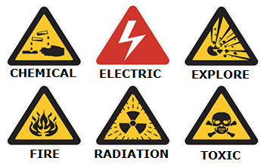
Figure 2.17 Various Warning Labels

HARDWARE, MATERIALS, AND EQUIPMENT USED TO PREVENT SPILLS AND LEAKS
Hardware, materials, and equipment used to prevent spills and leaks are commonly employed in workplaces, laboratories, and environmental protection areas. Here are some commonly used equipment and materials:
Hardware and Equipment:
- Spill Kits:
Designed to clean chemical spills and perform decontamination. These kits typically include absorbent materials, contaminated chemical waste bags, gloves, and brooms.
- Leak Monitoring Systems:
Used to detect leaks early. These systems monitor the locations and amounts of leaks.
- Leak Containment Booms:
Used to prevent the spread of leaks. These booms limit and control the spread of spills.
- Leak Management Systems:
Used to manage and control leaks. These systems provide detection, monitoring, and regulation of leaks.
Materials:
- Absorbent Materials:
Materials that absorb chemical spills. These materials prevent the spread of spills by soaking them up.
- Contaminated Chemical Waste Bags:
Bags that collect and store spills. These bags are used to safely clean up and dispose of chemical waste.
- Gloves:
Chemically resistant gloves used for cleaning chemical spills. They enable personnel to safely handle spills.
- Brooms:
Used to clean up spills. These brooms absorb spills and prevent them from spreading.
These equipment and materials are critical to reducing spill and leak risks and ensuring a safe environment. After identifying the types of spills and leaks that may occur in the workplace or laboratory, it is important to select the appropriate equipment and materials.
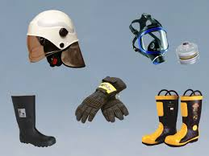
Figure 2.18 Personal Protective Equipment
MODULE-2 APPLICATIONS AND OUTCOMES
IMPLEMENTING ENVIRONMENTAL PROTECTION STANDARDS AND METHODS
Applying environmental protection standards and methods during elevator maintenance and repair is very important. Compliance with the necessary laws and regulations is required for these processes.
Environmental Protection Standards and Methods During Elevator Maintenance and Repair
- Use of Protective Materials:
During maintenance and repair, chemicals, liquids, and other substances used must be environmentally friendly. For example, biodegradable or recyclable materials should be preferred.
- Waste Management:
Proper collection and recycling of waste generated during maintenance and repair are important. Hazardous wastes like chemical waste and electronic components must be managed appropriately.
- Energy Design:
Improving the energy efficiency of elevators can help reduce negative environmental impacts. Energy consumption can be lowered using energy design and innovative technologies.
- Recycling and Reuse:
Recycling and reusing elevator components during maintenance and repair should be encouraged. This helps conserve natural resources and reduces waste.
- Environmental Impact Assessment:
Potential environmental impacts of elevator maintenance and repair activities should be evaluated and minimized. This assessment aids in developing environmentally friendly practices.
- Training and Awareness:
Personnel should be trained and informed to apply environmental protection standards and methods. This ensures that employees adopt and implement eco-friendly practices.
- Regular Inspections and Audits:
Regular inspections should be conducted during elevator maintenance and repair to ensure environmental protection standards are being followed. These audits ensure compliance and effectiveness.
These standards and methods minimize environmental damage during elevator maintenance and repair, while also being important for human health and safety.

CONTRIBUTING TO THE REDUCTION OF ENVIRONMENTAL RISKS
During elevator maintenance and repair, the following methods and practices can be implemented to help reduce environmental risks:
Applications for Reducing Environmental Risks
- Management of Hazardous Materials:
- Chemicals and oils used have a high potential to harm the environment, so they must be handled and stored carefully.
- Recyclable and less harmful alternative materials should be preferred.
- Waste Control:
- Waste generated during elevator maintenance and repair should be separated and included in recycling processes.
- Proper disposal of electronic and mechanical parts, oils, and other hazardous materials is essential to prevent environmental damage.
- Energy Efficiency:
- Methods to minimize energy consumption during maintenance and repair should be used.
- Energy-efficient elevator components should be preferred, and existing systems optimized for energy efficiency.
- Training and Awareness:
- Maintenance and repair personnel should be trained on environmental protection.
- Environmental awareness should be fostered so that personnel understand and recognize environmental risks.
- Regular Inspections:
- Regular audits and inspections should be conducted to ensure compliance with environmental standards.
- These inspections are important for identifying and preventing potential environmental risks.
- Environmental Impact Assessment:
- The environmental impacts of maintenance and repair activities should be evaluated.
- Strategies should be developed based on these assessments to reduce environmental risks.
- Use of Renewable Resources:
- Renewable energy sources should be used whenever possible.
- Technologies and equipment that increase energy efficiency should be preferred.
These methods help minimize environmental risks during elevator maintenance and repair and promote the implementation of environmentally friendly practices.
REDUCING ENVIRONMENTAL RISKS
Reducing environmental risks during elevator maintenance and repair is crucial for adopting an environmentally sensitive and sustainable approach. The key steps and methods to consider are as follows:
Reducing Environmental Risks
- Management of Chemical Use:
- The potential environmental harm of chemicals used in elevator maintenance should be taken into account. Environmentally friendly alternative chemicals should be preferred.
- Proper collection and disposal of chemical waste must be ensured.
- Energy Efficiency:
- Energy-saving components should be used to increase the energy efficiency of elevators.
- Unnecessary energy consumption during maintenance operations should be prevented.
- Waste Management:
- It is important to separate and include the waste generated during elevator maintenance and repair in recycling processes.
- Electronic waste, oils, and other hazardous wastes should be disposed of properly.
- Use of Renewable Energy:
- Renewable energy sources should be used whenever possible.
- Environmentally friendly energy sources such as solar power should be preferred.
- Environmental Training and Awareness:
- Maintenance and repair personnel should be trained on environmental risks and protection.
- Employees’ environmental awareness should be developed, encouraging environmentally friendly practices.
- Environmental Impact Assessment:
- The environmental impacts of elevator maintenance and repair operations should be evaluated.
- Strategies and practices to minimize environmental impacts should be developed.
- Regular Inspections and Audits:
- Regular inspections should be conducted to ensure compliance with environmental standards.
- These inspections are important for minimizing environmental damage.
In conclusion, these steps contribute to reducing environmental risks during elevator maintenance and repair while helping to create a sustainable working environment.
SAVING NATURAL RESOURCES CONSUMPTION

Saving natural resources consumption during elevator maintenance and repair is very important for a sustainable environment. Here are some key steps and methods to consider:

Methods to Save Natural Resources Consumption

- Energy Efficiency:
Energy consumption can be reduced by using energy-efficient motors and lighting.
Modern and efficient components should be preferred to increase elevator energy efficiency.

- Digital Monitoring Systems:
Using digital systems to monitor elevator performance and energy consumption helps prevent energy waste.
These systems can detect maintenance needs in advance, avoiding unnecessary energy use.

- Recycling and Reuse:
Recycling and reuse should be encouraged whenever possible during elevator component maintenance and repair.
Reusing old parts can prevent the depletion of natural resources.

- Natural Lighting and Ventilation:
Energy consumption can be reduced by providing natural lighting and ventilation in elevator shafts and machine rooms.
Window and skylight systems can be installed to utilize sunlight.

- Water Conservation:
Low water consumption methods should be preferred during elevator cleaning and maintenance to minimize water use.
Water recycling systems can be used to prevent water wastage.
Energy-saving Systems:
Systems that provide low energy consumption in standby mode should be used for elevators.
Energy management should be optimized with energy-saving software and control systems.

- Periodic Maintenance:
Regular and periodic maintenance ensures efficient operation of components and prevents energy waste.
Periodic maintenance extends elevator lifespan and reduces natural resource consumption.
These methods help ensure more efficient use of natural resources during elevator maintenance and repair and contribute to a sustainable environment.

SECTION-2 EVALUATION
1- What is the term for all activities aimed at preventing the destruction, deterioration, and disappearance of environmental values and ecological balance, repairing existing damages, and improving and developing the environment?
A- Energy Conservation
B- Environmental Protection
C- Water Conservation
D- Renewable Energy
2- Which of the following is the energy obtained from the continuous natural flow of energy in ongoing natural processes?
A- Renewable Energy
B- Chemical Energy
C- Kinetic Energy
D- Static Energy
3- What is the name of the educational activity that includes raising awareness and educating society about the environment through programs such as environmental education in schools and community events?
A- Occupational Safety Training
B- Information Training
C- Social Support Training
D- Environmental Education
4- Which system is used to minimize energy consumption when elevators are not in use?
A- Standby Modes
B- Group Control Systems
C- Regeneration Systems
D- Hazardous Waste Management Systems
5- What is the name of the procedure implemented in case of a possible fire or leakage?
A- Work Plan
B- Action Plan
C- Emergency Plan
D- Escape Plan

