MODULE-17

ELECTRICAL CONTROLS AT THE BOTTOM OF THE WELL
WELL INSTALLATION:

Cables inside the well are routed through plastic (PVC) conduits. These conduits are installed on the well surface in a way that prevents damage. After the cables are placed inside the conduits, their covers must be securely closed.
.
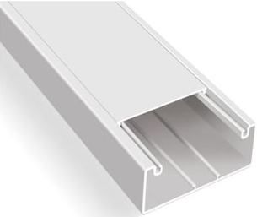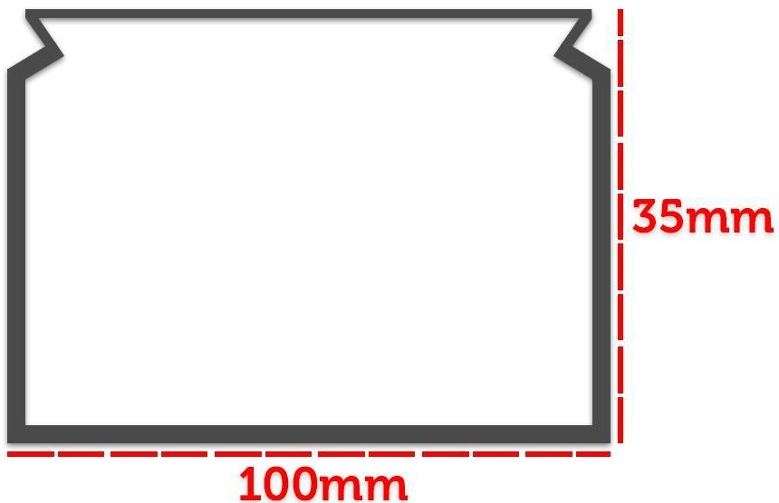

Figure 17.1 Moist Location Fixture (Type E)

WELL LIGHTING:
Lighting elements (lamp holders) should be installed so that the interior of the well shaft can be clearly seen when all floor doors are closed and the well is in use as needed. The illumination level must be 200 lux.
Well lighting is provided using Type E fixtures with steel cages, installed as follows: one fixture 1 meter above the bottom of the well, one fixture 50 cm below the top of the well, and along the entire well shaft at intervals not exceeding 7 meters.
Depending on the elevator shaft characteristics, the 7-meter spacing may be reduced. The goal is to ensure sufficient illumination inside the well.

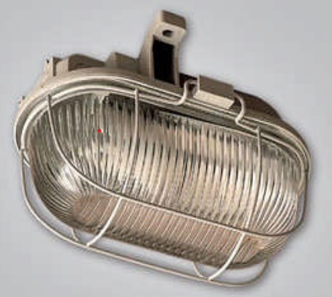

Figure 17.2 Moist Location Fixture (Type E)

The lighting installation of the cabin, well, and machine rooms must be independent from the circuit supplying the elevator machine.
These lighting circuits should be powered either by a separate supply line or by a line separated from the input side of the main switch.

A residual current device (RCD) must definitely be connected to this circuit.

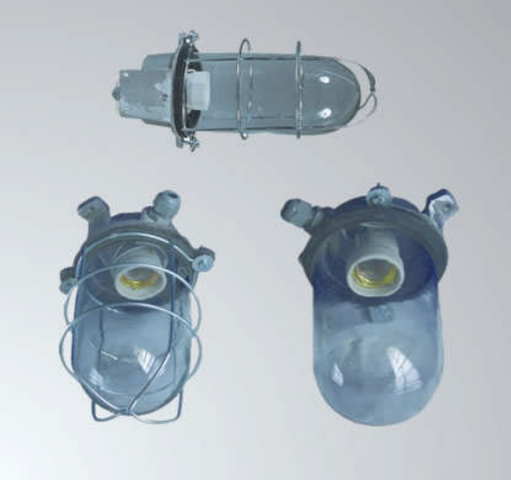
Figure 17.3 Moist Location Fixture (Type E, with Lamp Holder)

At the bottom of the well, there should be one socket next to the lowest lighting fixture. The well must be illuminated so that the interior of the shaft can be easily seen when all floor doors are closed and the well is used as needed. Inside the well, lighting fixtures should be installed at a distance of 1 meter from the bottom, 0.5 meters from the top, and at intervals of at least 7 meters. The lighting fixtures must be Type E watertight, and the installation must be sealed. The lighting circuits for the cabin, well, and machine rooms must be independent from the circuit supplying the machine.

SOCKET: According to document C-KYS-T-03 / Rev.01 / Issue Date: 20.10.2004 / Revision Date: 01.09.2005 Page 10/30 The well bottom socket must be an outdoor type with grounding, protected against dripping water, and mounted at least 1 meter above the floor. It must be installed with a sealed conduit, and cable cross-sections must be sufficient (at least 3 x 1.5 mm²). If a fuse is placed at the end of the lighting circuit, its rating must not exceed 10 A.
These lighting circuits may be powered either by a separate supply line or by a line separated from the input side of the main switch or switches. Under all conditions, they must be connected through a residual current device (RCD).
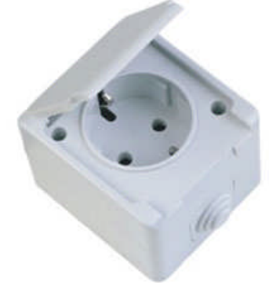
Figure 17.4 Socket Used in Wet Locations

ELECTRICAL INSTALLATION INSIDE THE WELL - EMERGENCY STOP BUTTON:
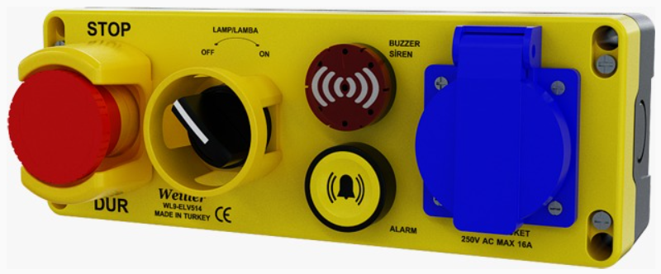
Figure 17.5 Emergency Stop Button and Revision Key
The electrical installation inside the well, including connections, terminals, and connectors, must be housed within dedicated panels, junction boxes, or cabinets designed for this purpose. To ensure uninterrupted mechanical protection, the protective sheaths of conductors and cables must extend into the switch boxes or equipment enclosures or terminate within suitable cable glands. If there is a risk of damage due to moving parts or sharp edges of enclosures, the conductors leading to the electrical safety devices must be mechanically protected.
Conductors and cables used in the machine room, sheave room, and elevator shaft (except the cabin flexible cable) must be selected according to TS standards and installed inside metal or plastic conduits or ducts.
The cross-sectional area of conductors for electrical safety devices on doors must not be less than 0.75 mm². The energized parts of safety contacts must be enclosed within a protective housing. Wear of conductor material must not cause short circuits in the contacts.

To ensure the safety of personnel working or cleaning inside the well, a stable stop switch that can disable and keep the elevator out of service must be installed in two positions accessible from the entrance door to the lower well pit. This switch must be tested to confirm it functions properly for its intended purpose. The emergency stop button must be mounted at a height easily accessible and sufficiently distant from moving parts inside the well. The installation must be watertight.

Electrical installations in the cabin top and well must be properly arranged.
Exposed cables must be secured, exposed splice points covered, and placed inside junction boxes. Exposed cables should be routed inside conduits. Uninsulated cable sections must be protected.
Cable connection splices on the cabin top must be placed inside terminal boxes with covers securely attached. Single insulated cables on the cabin top must be double insulated or placed inside spiral or cable ducts. A grounded socket must be installed and functional on the cabin top. (If available) The unprotected lamp/socket on the cabin top maintenance control must be watertight. The cabin top ventilation fan must be enclosed within a protective housing.

(Protection against direct contact with elevator shaft installations must be provided by enclosures with at least IP2X protection rating. All other connections, terminals, and connectors must be housed within panels, junction boxes, or cabinets designed for this purpose. (Clause 5.10.1.2.2 TS EN 81-20))

If double-insulated cables are not used for the well electrical installation, the cables must be routed through protective conduits or pipes. Double-insulated installations must be supported and arranged neatly by means of a guide wire or rope. Cables used in safety circuits must have a minimum cross-sectional area of 0.75 mm². A grounding busbar must be created using at least 2.5 mm² yellow-green grounding cable.

ABILITY TO PERFORM INSPECTIONS OF ALL ELECTRICAL AND SAFETY EQUIPMENT LOCATED AT THE BOTTOM OF THE WELL

Inspection of electrical and safety equipment located at the bottom of the well is of great importance for safety. Inspections performed in areas such as elevator shafts must be conducted in accordance with standards such as TS EN 81-1.

Some key points to consider during these inspections are:

- Safety measures before entering the well: The safety contact of the landing door must be checked before entering the well.
- Electrical safety: Before performing panel-related tests in the machine room, it must be verified with a low voltage detector whether there is any electrical leakage.
- Lighting and visibility: The well interior must be sufficiently illuminated and arranged to avoid creating risks.
- Safety buttons: The emergency stop button and revision button must be tested to ensure they are functional.
- Grounding checks: All grounding systems must be ensured to be independent from each other. (17.1) A
Recommended equipment for electrical and safety inspections at the bottom of the well includes:
- Personal Protective Equipment (PPE): Helmet, insulating gloves, protective goggles, and safety shoes.
- Electrical Testing Devices: Low voltage detector, multimeter, insulation tester.
- Lighting Equipment: Portable LED lamps, lamp holders.
- Safety Buttons and Testing Devices: Emergency stop button, revision button test devices.
- Grounding Testing Devices: Ground resistance meters.
- Communication and Warning Systems: Emergency communication devices, warning signs.
- Inspection and Maintenance Tools: Inspection tapes, maintenance controls.

The equipment used at the bottom of the well must comply with international standards such as ISO and EN, as well as occupational health and safety regulations in Turkey. Some important standards are:
- ISO 16530-1: Specifies requirements for maintaining the integrity of the well throughout its lifecycle.
- ISO 10423: Covers standards for drilling and production equipment such as explosion preventers and pressure control devices.
- TS EN 81-20 and TS EN 81-50: European standards defining safety requirements for elevator shafts.
- Regulation on Health and Safety Conditions in the Use of Work Equipment: Sets minimum requirements for the safe use of work equipment in Turkey.
- Occupational Instruction - Well Foundation Workers Occupational Safety Instruction: Contains occupational health and safety rules to be followed in well foundation work.

MODULE 17 – APPLICATIONS AND OUTPUTS

Perform controls such as well bottom socket and lighting inspections using appropriate measuring instruments.

Suitable measuring instruments for elevator well bottom socket and lighting inspections include:

- Multimeter: Used for measuring voltage, current, and resistance at sockets.

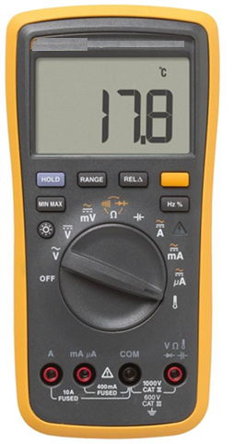
- Low Voltage Detector: Necessary for checking whether there is an electrical leakage.

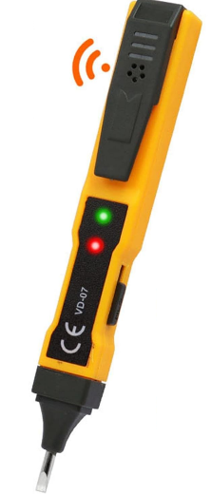

- Lux Meter: Used to measure the illumination level inside the well.
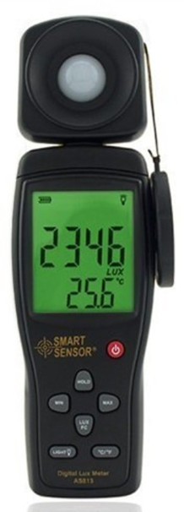
- Grounding Test Device: Checks whether the grounding connections of sockets and other electrical equipment are proper.

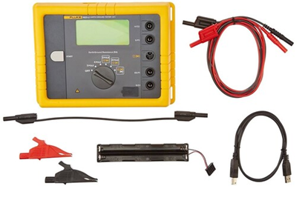
- Insulation Tester: Ensures safety by measuring the insulation resistance of cables and electrical circuits.
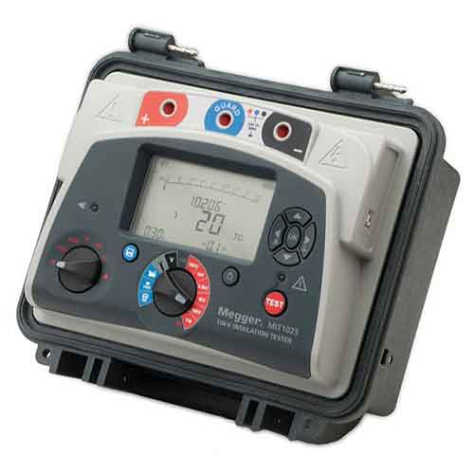
These measuring instruments are necessary to ensure a safe and standards-compliant working environment in the elevator shaft.

Performing Inspections of Well Bottom Safety Switches:
Inspections of elevator well bottom safety switches are a critical process for safety. These inspections must be carried out in accordance with international standards such as TS EN 81-20 and TS EN 81-50. Here are the basic inspection steps:
- Door Safety Contact Test: Verify that the safety contact is activated when the landing door is opened.
- Emergency Stop Button Check: Before entering the well, press the stop button to confirm that the system goes into a safe state.
- Revision Button Test: Place the elevator in revision mode and test that the button is functioning properly.
- Grounding Connections: Ensure that all grounding systems are independent of each other.
- Lighting Checks: Verify that the interior of the well is sufficiently illuminated.
- Electrical Leakage Test: Use a low voltage detector to check for leakage in the panel and other electrical components.

These inspections must be performed regularly to ensure a safe working environment in the elevator shaft and to minimize potential risks.

