MODULE-15

PerIodIc InspectIon of RaI ls and Rollers

Rails and rollers in elevator systems are fundamental components that ensure the safe, stable, and comfortable vertical movement of the cabin and counterweight.

1. Functions of Rails

- Guiding the cabin: Ensures smooth vertical movement of the cabin, preventing swinging and wobbling.
- Providing balance: Works in harmony with the counterweight to maintain system balance.
- Safety: Enables emergency brakes to effectively stop the cabin.
- Reducing vibration and noise: Absorbs vibrations caused by movement, providing a more comfortable ride.

2. Materials Used in Rails

- Steel: Offers high strength and durability, preferred for high-capacity and high-speed elevators.
- Cold-drawn steel: Has a smoother surface and reduces vibration.
- Stainless steel: Suitable for humid environments or outdoor installations due to corrosion resistance.
- Aluminum: Lightweight and corrosion-resistant but generally used in low-capacity elevators.

3. Types of Rails
- T-profile rails: The most common, T-shaped cross-section rails.
- Round rails: Used in older elevator systems and now less common.
- Custom-designed rails: Used in some specialized elevator systems.
- Rail type selection depends on the elevator's speed, capacity, and building structure.

4. Installation of Rails
Proper alignment and secure fixing of rails are critical for smooth and quiet cabin operation. Installation must be performed by expert teams with thorough inspections.

5. Factors to Consider When Selecting Rails
- Material quality and durability
- Compatibility with the elevator's load capacity
- Rail type suitable for elevator design and speed
- Ease of installation and maintenance
- Availability of spare parts
- Correct rail selection directly affects elevator safety and performance.

6. Standards and Certifications

- TS EN 81-20/50: European standard specifying dimensions, materials, and testing requirements for rails.
- ISO 7465: International standard covering safe design, manufacturing, and testing procedures for elevator rails.

During periodic maintenance of rails and rollers, wear, deformation, installation errors, and corrosion should be carefully checked. Regular maintenance and compliance with standards are essential for elevator safety and comfort.
- CE Marking
The CE marking is mandatory for elevator guide rails to be marketed in the European Union. It indicates that the product complies with relevant European standards. The CE mark signifies that the product meets safety, health, and environmental protection requirements.
- TSE Certificate
In Turkey, the TSE certificate is issued by the Turkish Standards Institute (TSE) for elevator guide rails. It shows compliance with Turkish standards and guarantees the product’s quality and reliability. When selecting elevator guide rails, it is important to choose products that conform to these standards and certifications for safety and performance.

Maintenance and Repair of Elevator Guide Rails
Elevator guide rails may wear, deform, or get damaged over time. Regular maintenance and repair are critical to ensure safe and efficient elevator operation.

Maintenance activities typically include:
- Cleaning: Removing dust, dirt, and grease to ensure smooth operation and reduce wear.
- Lubrication: Regular lubrication between rails and guide shoes to reduce friction and wear.
- Inspection: Regularly checking for cracks, breaks, or deformations on rail surfaces.
- Adjustment: Ensuring proper alignment and smoothness of the rails and making corrections if needed.
- Repair activities generally include:
- Replacement of damaged rails: Cracked, broken, or excessively worn rails must be replaced.
- Correction of deformed rails: Minor deformations can be corrected using special tools.
- Inspection and tightening of mounting elements: Loose or damaged mounting hardware should be tightened or replaced.
Maintenance and repair of elevator guide rails must be performed by qualified technicians. Regular upkeep extends the elevator’s lifespan, increases safety, and reduces the risk of malfunctions.

Technological Developments in Elevator Guide Rails
Elevator technology continually evolves, and these advances are reflected in guide rail design and manufacturing. New materials, production methods, and design approaches yield more durable, efficient, and safer guide rails.
For example, nanotechnology coatings enhance wear resistance and extend rail life. Vibration-damping rails provide quieter and more comfortable rides.
In the future, smart elevator systems may incorporate sensors and other electronics in guide rails to monitor their condition in real time and predict potential faults.

Environmental Considerations
The production and use of elevator guide rails have environmental impacts. Therefore, sustainable practices such as using eco-friendly materials and recycling are important.
Guide rails made from recyclable materials help reduce environmental footprint. Additionally, energy-efficient elevator systems reduce rail wear and prolong their lifespan, contributing positively to the environment.

Elevator Guide Rails According to Building Types
Guide rails vary depending on the building type, as each requires different load capacities, speeds, and traffic volumes. Selecting appropriate rails optimizes elevator performance and safety.
- Residential Buildings: Typically low speed and low traffic elevators. Type A or cold-drawn guide rails may be preferred, which are lighter, more economical, yet sufficiently durable for residential needs.
- Commercial Buildings: Such as offices, malls, and hotels, requiring higher speed and traffic capacity. Type B or processed guide rails are favored for their ability to handle heavier loads and higher speeds.
- High-Rise Buildings: Skyscrapers and tall buildings demand rails designed for high speed, high traffic, wind loads, and seismic activity. These use specially designed, high-strength materials.
- Industrial Facilities: Factories, warehouses, and similar sites require guide rails that support heavy loads and withstand harsh conditions, often made from specially designed high-strength steel.

- Special Purpose Buildings
In special purpose buildings such as hospitals, schools, and airports, guide rails may need to be specially designed according to the elevator's intended use. For example, hospitals often use elevators with wider cabins to transport stretchers, which require guide rails specifically designed for these larger cabins.

Selecting guide rails appropriate to the building type is important to optimize the elevator’s performance, safety, and lifespan. (16.1)

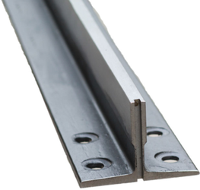

Figure 15.1 Example of a T-rail model

Rollers :
Elevator rollers and roller plastics are important components used in elevator systems and contribute to the safe and smooth operation of elevators.

Elevator Roller:
The elevator roller is essentially a component that moves the elevator cabin and guides its path. It interacts with the guide rails inside the elevator shaft. The elevator roller usually contains a wheel or bearing mounted on a foot installed either horizontally or vertically. This wheel or bearing allows the cabin to move smoothly along the rails.

Main functions of elevator rollers are:
- Proper Guidance: The elevator roller ensures that the cabin moves along the correct path. This allows the cabin to travel smoothly to floors, providing a safe journey.
- Reducing Friction: Rollers allow the cabin to move along the rails with low friction, which helps save energy and reduces wear.
- Reducing Vibration: Elevator rollers absorb vibrations that may occur when the cabin moves along the rails, providing a more comfortable ride.

Roller Plastics:
Roller plastics are the plastic parts underneath the elevator rollers. They help the cabin move along the rails with even less friction and also contribute to the safe and smooth guidance of the cabin.
- Reducing Friction: Roller plastics reduce friction between the elevator rollers and the rails, helping save energy.
- Ensuring Safe Movement of the Cabin: Roller plastics ensure that the elevator cabin moves safely along the rails, preventing unwanted stops or vibrations.

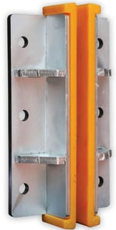

Figure 15.2 Example of a roller model

2. Ensuring Safety
Inspection and Monitoring:
Rails and rollers are among the most critical safety points of an elevator. Any wear, crack, or damage can lead to loss of control and possible accidents. Therefore, regular periodic inspections are carried out to detect any abnormalities in the rails and rollers early and intervene accordingly.

Emergency Functions:
With regular maintenance, signs such as abnormal friction, vibration, or increased noise on the rails and rollers can be detected early, allowing the elevator to enter emergency mode and the system to stop safely.

3. Performance and Comfort
Smooth Movement:
Rails and rollers enable the elevator and counterweight to move continuously, quietly, and step-by-step. This eliminates discomfort caused by noise, vibration, and irregular movements due to high friction.

Economic Impact of Maintenance:
A high-quality and compatible rail-roller system minimizes wear on elevator components in the long run. Thus, maintenance and repair costs are reduced, and downtime caused by failures is shortened.
4. Longevity and System Efficiency
Wear and Durability:
Regular inspection of rails and rollers prevents minor damages from worsening and causing cascading failures. This not only ensures the elevator’s safety but also extends the overall system’s lifespan.

Energy Efficiency:
A smoothly operating rail-roller system reduces the load on the elevator motor. This leads to energy savings and improves the overall efficiency of the system.

Conclusion:
In elevators, rails and rollers are not only mechanical support elements but also the fundamental guarantors of the system’s safe, comfortable, and efficient operation. With periodic inspections and regular maintenance ensuring the healthy operation of these components, both passenger safety is guaranteed and the elevator can be operated for a long time with minimal risk of breakdown.

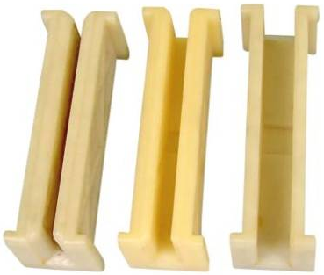

Figure 15.3 Various Roller Types

ADJUSTING RAILS AND ROLLERS AND CHECKING THEIR CONNECTIONS

In elevator maintenance, adjusting the rails and rollers and checking their connections is a critical task to maintain system safety and efficiency. This process involves regular inspection of both mechanical alignments and connection elements (bolts, nuts, beam connections, etc.).
Below are step-by-step explanations of how to perform this procedure:

- Safety Precautions:
- Before starting maintenance, ensure the elevator’s power supply is completely turned off and place “Under Maintenance” warning signs in the elevator area during the work.
- Authorized maintenance personnel and service teams must be present.

- Rail Inspection and Adjustment:
- Alignment and Parallelism: Ensure that the rails are properly and parallelly installed. Any gaps or bends between the rails or between the rails and the elevator cabin may prevent proper contact with the rollers in the future.
- Wear and Damage Inspection: Carefully examine the rail surfaces for scratches, wear, or deformations. If necessary, perform cleaning, lubrication, or rail repairs.
- Use of Measurement and Adjustment Tools: Use laser alignment devices or digital measuring instruments to precisely check the vertical and horizontal positioning of the rails.

- Roller Adjustment and Connection Check:
- Roller Positioning: Verify that the rollers make proper and full contact with the elevator rails. Rollers should not be too loose or excessively tight.
- Check Connection Elements: Inspect the tightness of screws, bolts, and nuts connecting the rollers to the rails. Any loose connections should be re-secured with the proper torque.
- Lubrication and Cleaning: Clean any dirt, dust, or old grease residues on roller surfaces and connection points. Lubricate using the manufacturer-recommended oil or grease.
- Wear Condition: If there is noticeable wear, deterioration, or breakage on the rollers, they should be replaced or repaired.

- Function Tests:
After completing adjustments and connection checks, run several manual or automatic test cycles of the elevator system to observe whether rails and rollers operate harmoniously.
During testing, if there is noise, vibration, or unexpected movement, recheck and correct the connections.

- Documentation and Records:
Record all maintenance procedures and adjustment inspections in detail. This documentation serves as an important reference for future maintenance intervals and potential fault analyses.
By following these steps, the rails and rollers in the elevator system are correctly adjusted and their connections ensured, thus increasing operational efficiency and minimizing safety risks in the long term.
For more detailed information, elevator maintenance manuals and manufacturer technical documents should be consulted.

MODULE-15 APPLICATION AND OUTPUTS

CHECKING RAIL CONNECTIONS WITH PROPER HAND TOOLS AND MAKING ADJUSTMENTS
Checking rail connections with appropriate hand and measuring tools is a critical maintenance task to ensure the safe and stable operation of elevator systems. This inspection is used not only to verify the tightness of connection elements (screws, bolts, pins, etc.) but also to confirm the proper alignment of rails and rollers and their contact suitability.
Below are the basic steps of this process and some of the hand measuring tools that can be used.
Safety and Preparation:
Before starting maintenance, cut off the elevator’s power supply and equip the maintenance area with proper warning signs.
Use of personal protective equipment (PPE) is mandatory.

Visual Inspection:
First, visually inspect rail connections and rollers for obvious wear, rust, cracks, or deformation.
Identify any loose or missing connection elements.

Measurements with Appropriate Hand Measuring Tools:

Digital or Vernier Caliper:
Used for precise measurement of gaps, thickness, and alignment distances between rails and rollers.

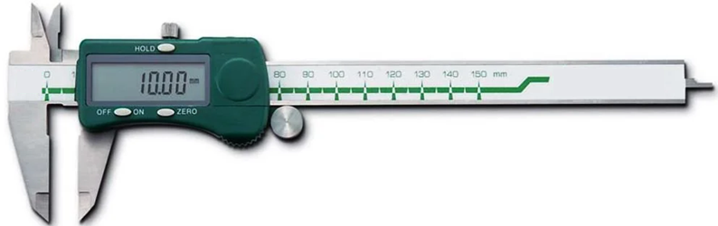

Figure 15.3 Digital Caliper

Used for precise measurements of rail thicknesses, gaps between connections, and the distance between the roller and the rail.
The measured values are compared with the tolerance values specified by the manufacturer.

Micrometer:

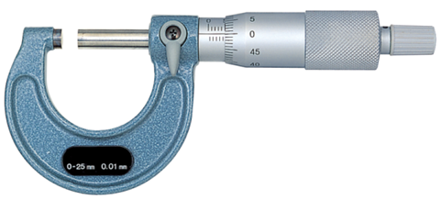
Figure 15.4 Digital Micrometer

Especially preferred for measuring small detailed parts and determining the amount of wear on connection elements.

Torque Wrench:
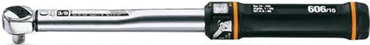

Figure 15.5 Torque Wrench

Used to ensure that connection elements (bolts and nuts) are tightened to the torque values specified by the manufacturer.

Measuring Tapes or Laser Measurement Devices:
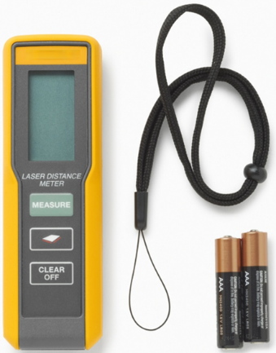

Figure 15.6 Laser Distance Meter

Ideal for checking rail alignment and straightness over longer distances. Laser measurement devices provide high precision in detecting slight bends and deviations in the rails.

Evaluation of Measurement Results:
All measurements are compared against the tolerance and measurement values specified in the relevant technical documents.
If deviations are found, necessary adjustments are made. For example, loosened connections are retightened; gaps or misalignments between rails are corrected using appropriate adjustment tools.

Adjustment and Repair Procedures:
Based on measurement results, if any looseness or incorrect positioning is found in connection elements, necessary adjustments are made with suitable hand tools (e.g., torque wrench, adjustment keys, etc.).
Ensure that the contact between rails and rollers is at an ideal level.

Documentation:
All measurements, adjustments, and detected deviations must be recorded in detail.
These records will serve as references for future maintenance and fault analysis.
These steps provide a basic guide for controlling rail connections using hand and measuring tools.
In every maintenance operation, it is very important to consider the calibration status of the tools used and the technical standards specified by the manufacturer.
Technical documents and manufacturer manuals will provide additional details specific to the model and equipment.

ROLLER CONNECTION AND ADJUSTMENT PROCEDURE

Below are the step-by-step instructions for performing roller connection and adjustment during elevator maintenance.
These procedures must only be carried out by authorized and trained personnel.

- Safety Measures and Preparation

- Power Cutoff: Before starting work, the elevator’s power source must be cut off or locked/tagged out to prevent unexpected operation.
- Personal Protective Equipment (PPE): Appropriate protective gear (gloves, goggles, etc.) should be worn.
- Work Area Arrangement: Place “Under Maintenance” warning signs and ensure only authorized personnel are present in the area.

- Visual and Physical Inspection

- Visual Check:
- Inspect roller surfaces, connection points, screws, and other mounting elements for rust, wear, cracks, or deformation.
- Check for any loose or missing connection components.
- Physical Examination:
- for any play or wobble in the roller’s position. Verify that the roller has full and correct contact with the rail.
- Check

- Detailed Checks Using Measuring Tools

- Digital/Vernier Caliper:
- Measure the distance between roller and rail to ensure it is within the manufacturer’s tolerance.
- Micrometer:
- Used to measure fine wear or deformations.
- Torque Wrench:
- Ensure connection elements (bolts, nuts) are tightened to manufacturer-specified torque values.
- Laser Measurement or Tape Measure:
- Used for long-distance alignment checks and deviation measurements of rails and rollers; ideal for this purpose.

- Adjustment and Connection Procedures
- Adjusting Connection Elements:
- Identify loose or incorrectly mounted screws and bolts, and tighten them according to manufacturer torque specifications using an appropriate torque wrench.
- Replace worn or damaged mounting components with spare parts if necessary.

- Adjusting Roller Position:
- Ensure proper contact between the roller and the rail.
- If adjustment mechanisms exist (such as screws, clamps, or adjustment pins), make precise adjustments according to manufacturer documentation.

- Lubrication:
- Apply appropriate oil or grease to roller surfaces and connection points as per manufacturer recommendations to reduce friction and slow wear.

- Functional Testing and Final Checks

- Test Cycle:
- After adjustments and connections are completed, run several test cycles of the elevator.
- Observe for any unusual noises, vibrations, or unexpected deviations during operation.

- Regular Maintenance Intervals:
- Record measurement results and adjustments in maintenance logs.
- Repeat inspections and adjustments at scheduled intervals to ensure long-term safety.

By following these steps, roller connections and adjustments can be safely, correctly, and according to manufacturer standards.
Always adhere to technical documentation and manufacturer maintenance instructions to minimize potential errors and safety risks.

INSPECTION OF COUNTERWEIGHT GUIDANCE SYSTEM

Inspecting the counterweight guidance system is one of the critical maintenance steps that ensure the elevator’s safe and stable operation. These inspections verify whether the counterweight moves properly along the rails or guide elements and detect any wear, looseness, or alignment deviations. The following steps should be followed during these inspections:

- Safety Precautions
- Power Cutoff: Before starting maintenance, the elevator’s operating systems must be disconnected from power or locked out/tagged out.
- Personal Protective Equipment (PPE): Protective glasses, gloves, safety shoes, and helmets (if necessary) should be worn.
- Work Area Safety: Appropriate warning signs should be placed around the maintenance area, and only trained personnel should intervene.

- Visual Inspection and Cleaning
- Condition of Rails and Guide Elements:
Visually inspect the surfaces of rails and guide elements (e.g., rollers, bearings, guide shoes) for damage such as breaks, cracks, wear, and rust.
If any foreign matter or buildup exists, clean it with appropriate materials (e.g., clean solvent or brush).
- Connection Points:
Check how the counterweight’s guide elements are connected to the rails, supports, or elevator structure.
Determine if screws, bolts, or clamps are loose or show any deformation.

- Measurement and Mechanical Inspection
- Alignment and Straightness:
Measure whether rails and guide elements are aligned within the tolerances specified by the manufacturer. Precision measurement tools such as laser alignment devices, vernier calipers, or tape measures can be used.
- Wear and Degradation Assessment:
Using measuring instruments (e.g., micrometer or caliper), measure rail thickness, roller thickness, and axial placement of guide elements. If wear exceeds limit values, replace the affected parts.
- Connection Elements:
Check tightness of connection elements using a torque wrench to ensure compliance with manufacturer-recommended torque values. Loose connections must be retightened.

- Lubrication and Movement Checks
- Lubrication:
Lubricate rails and guide elements with manufacturer-recommended oil or grease to reduce friction.
Lubrication frequency and quantity should follow the regular maintenance schedule.
- Movement Control:
Manually or with testing devices, verify that the counterweight moves freely and smoothly along the rails.
If there is any jamming, increased friction, or abnormal noise, the system must be readjusted or damaged parts replaced.

- Functional Testing and Documentation

- Test Cycles:
After adjustments and maintenance, put the elevator system into test mode and observe the counterweight’s movement. Check for vibrations, noise, or irregular movements during normal operation.
- Record Keeping:
All measurements, adjustments, and detected issues should be thoroughly documented. This documentation will serve as a reference for future periodic inspections and help maintain maintenance quality.

By following these steps, it can be ensured that the counterweight guidance system’s connections and adjustments are performed regularly and safely.
In every maintenance procedure, adherence to manufacturer documentation and national elevator standards (e.g., TS EN 81 series) is a fundamental safety requirement.

