MODULE-14

SHAFT COMPLIANCE INSPECTIONS

An elevator shaft is a tall, enclosed space within a building that facilitates the smooth vertical movement of passenger or freight elevators (depending on the type). It serves as the personal pathway of the elevator inside the building.
The shaft is designed to house the moving parts of the elevator and other elements critical for user safety.
Upon inspection, the shaft is typically constructed from fire-resistant materials and engineered to remain structurally reinforced in case of an accident.
The shaft contains the elevator car (which carries passengers and cargo), a counterweight (to ease movement), and guide rails (to protect and guide the elevator).
Essentially, the safety of the elevator largely depends on how sturdy and compliant the shaft is.

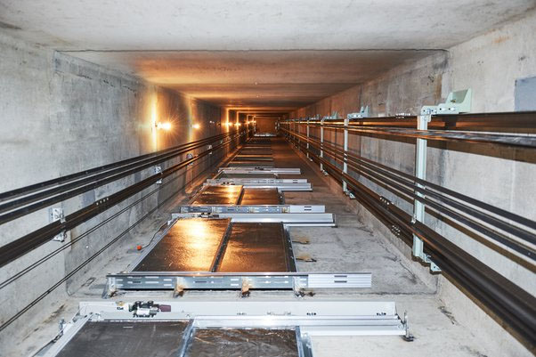

Figure 14.1

Components of an Elevator Shaft

An elevator shaft contains multiple parts, which are:
Elevator Shaft: The elevator shaft is the main component of the elevator space. It houses the path along which the elevator cabin and users move. It also helps users enter and exit the building.
Elevator Cabin: The elevator cabin or car is the compartment that transports passengers and cargo within the building. It has doors that serve as entry and exit points to the cabin.
Counterweight: The counterweight helps balance the elevator, stabilizing it and aiding its movement. It is connected to the cabin via ropes on the opposite side.
Machine Room: The machine that moves the elevator cabin is kept in a compartment at the top of the elevator shaft. This machine features a unique motor, gears, and special characteristics that help move the elevator between floors.
Shaft Ventilation: Proper ventilation inside the cabin is essential to keep the air clean and comfortable; therefore, having a high-quality ventilation system is non-negotiable. A clean ventilation system provides comfort to users and ensures smooth operation of the elevator. Good ventilation also prevents overheating.
Shaft Pit: The shaft pit is the area beneath the ground floor. It helps provide space for the elevator at the lowest floor.
Fire Resistance: Elevator shafts are constructed from fire-resistant materials. The purpose is to prevent fire from spreading easily within the building in case of an emergency.
Guide Rails: Guide rails are specialized rails on the walls of the elevator shaft. They help keep the elevator cabin stable during movement.
Overhead Space: This is the free space above the elevator shaft on the top floor of the building. It accommodates the elevator at the highest floor.
Shaft Lighting: The shaft lighting system is very important and is installed inside the elevator shaft to provide visibility for passengers and maintenance personnel.

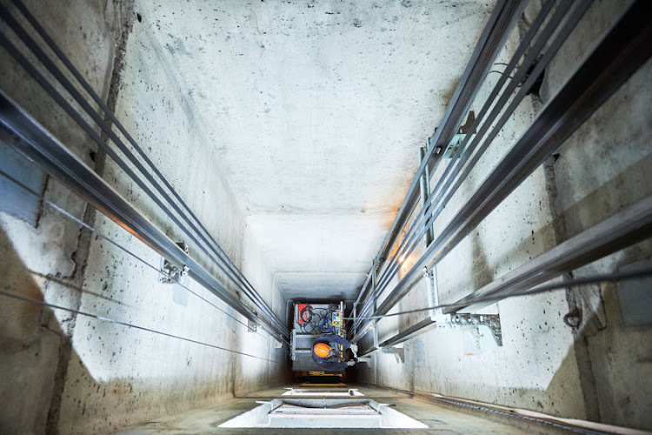

Figure 14.2

Types of Elevator Shafts:

Concrete Elevator Shaft:

A concrete elevator shaft serves as a safety path to help the elevator move efficiently. It is constructed from reinforced concrete to ensure durability and strength.
This concrete absorbs noise, stress, and vibrations to provide smooth operation. Concrete shafts are usually designed to accommodate different types of elevators and to enhance the aesthetics of the elevator system. Additionally, they include guide rails, emergency brakes, and backup power systems to ensure user safety.

Steel Frame Elevator Shaft:

In contrast to the concrete frame, the steel frame is built from solid, rigid, and robust steel or iron components. However, this does not make it superior to the concrete frame because it provides an equally safe path for the elevator cabin to move reliably within the building. The strength and reliability of the steel frame ensure it is sturdy enough to absorb stress and vibrations during operation.

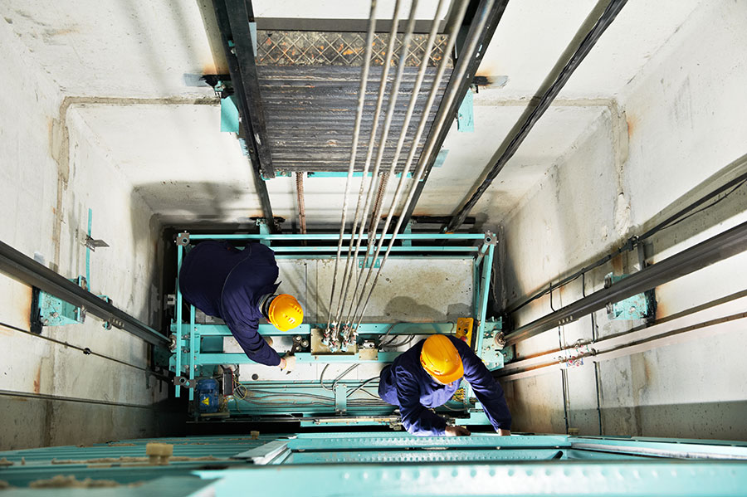

Figure 14.3
How Are Elevator Shafts Constructed?

Design and Planning
Designing an elevator shaft is a collaborative effort between architects, engineers, and elevator manufacturers. This design is typically based on the building layout, elevator type, and applicable building codes.
During this process, shaft dimensions, openings, pit depth, overhead clearance, and door openings are determined.

Foundation and Pit Construction
The foundation supports the elevator shaft structure and is vital for construction. Excavation and reinforced concrete foundation installation can also be included if required.
A pit is excavated at the bottom of the elevator shaft. This pit houses the counterweights and other mechanical components. It is important to note that the characteristics of your elevator determine the depth of the shaft pit.

Shaft Structural Frame
The vertical shaft structure is constructed from concrete, steel, or sometimes a combination of both. Concrete may be poured simultaneously with steel rods to form the shaft walls. This process supports the shaft and helps ensure the elevator moves safely.

Elevator Shaft Doors and Openings
There is an opening on each floor where the elevator stops during operation. This opening is called the door opening. Remember that this opening must be compatible with the size of the elevator doors.
Additionally, steel and other framing materials are added around the opening to provide structural support for the doors and ensure user safety.

Overhead Clearance and Machine Room
The parameters of the elevator system govern the overhead clearance, which facilitates smooth movement of the elevator cabin and counterweight.
In some cases, the elevator’s machine room, which houses mechanical components like the motor and control system, is located at the top of the shaft.

Elevator Cabin Installation
Once the structural frame is in place, the elevator cabin and all key components are installed inside the shaft. The cabin is connected to guide rails that run along the shaft. This connection ensures a smooth ride for users as they travel between floors.

Safety Features and Testing
Door sensors, brakes, and speed governors are installed and tested to ensure proper operation. The elevator undergoes comprehensive testing to verify its safety performance.

Final Touches
The elevator shaft is then fitted with fire-resistant materials, lighting, and other safety features. The interior space is developed and finalized to meet the building’s functional requirements.

AbIlIty to Perform PhysIcal SuItabIlIty Checks of the Elevator Shaft

Physical suitability checks of the elevator shaft are a critical step for ensuring safety and compliance with standards. To carry out these inspections, the following stages can be followed:

- Preparation and Documentation
To comply with standards, relevant regulations such as EN 81-20 and EN 81-50 should be reviewed and adhered to.
Equipment: Measurement devices (distance meters, illuminance lux meters), inspection tools, and checklists should be prepared.

- Pit Bottom Inspections
Sealing: Check that the pit bottom is resistant to liquids and moisture.
Lighting: Ensure a minimum illuminance of 50 lux is provided.
Refuge Area: Verify that the refuge space dimensions are appropriate (e.g., 50x70x100 cm).

- Shaft Wall Inspections
Durability: Assess the sturdiness and smoothness of the walls.
Fire Resistance: Confirm the use of fire-resistant materials (minimum 60 minutes resistance).
Protrusions: Check that no protrusions exceed 15 cm.

- Shaft Top Inspections
Refuge Area: Examine whether the refuge space on top of the cabin has the correct dimensions.
Guardrails: Verify that safety guardrails can withstand forces of 1000 N.
Emergency Lighting and Socket: Confirm the presence of at least 5 lux lighting and an electrical outlet.

- Reporting
All deficiencies identified during physical inspections must be recorded and reported accordingly.
Use of the elevator may be restricted until deficiencies are resolved.
To carry out this process efficiently, it may be necessary to work with a qualified engineer or an elevator inspection company.

MODULE-14 APPLICATIONS AND OUTCOMES

MEASURING THE SAFETY SPACES AT THE TOP AND BOTTOM OF THE ELEVATOR SHAFT

Elevator Shaft Top and Bottom Clearance Refuge Areas

The elevator machine room and the elevator shaft are the working areas for the elevator maintenance personnel and those who come for periodic inspections. Additionally, the machine room is also the space accessed by rescue personnel during the evacuation of people trapped inside the elevator.
According to the Elevator Directive (95/16/EC), elevators placed on the market and those installed before the enforcement of this Directive and still operational must have their maintenance and repairs performed by a TSE (Turkish Standards Institution) Certified Elevator Company or an Authorized Elevator Service, in compliance with the latest Elevator Operation, Maintenance, and Periodic Inspection Regulation published in the Official Gazette dated 24/06/2015.

Shaft Top Clearance:

When the counterweight is resting fully on the closed buffer, the following four conditions must simultaneously be met:
a) The cabin guide rail length must allow an upward travel distance of at least 0.1 + 0.035⋅v² meters (where v is the rated speed in m/s).
b) The free vertical distance between the top level of the cabin roof (including any beams or parts hanging below the ceiling that correspond to the cabin projection) and the lowest level of the shaft ceiling must be at least 1.0 + 0.035⋅v² meters.
c) From the lowest part of the shaft ceiling:

- The distance to the highest equipment part on top of the cabin (excluding those covered in item 2 below) must be at least 0.3 + 0.035⋅v² meters.
- The free clearance to the highest parts of skates or pulleys, rope connections, cabin top shield (if any), and vertically moving sliding door heads and parts (if any) must be at least 0.1 + 0.035⋅v² meters.
d) There must be a space on the cabin top capable of accommodating a rectangular block no smaller than 0.5 m x 0.6 m x 0.8 m, standing on one of its faces. Within the space occupied by this block, direct suspension system (1:1 suspension) ropes and their connections may be located; however, the center of any rope must not be more than 0.15 m away from the vertical faces of the block.

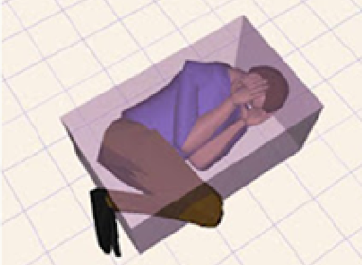

Figure 14.4 Tilted Position (14.1)

Shaft Bottom Clearance:

While the cabin is resting fully on the closed buffer, the following three conditions must also be met:
a) There must be a space in the shaft bottom clearance capable of accommodating a rectangular block standing on one face with minimum dimensions of 0.5 m x 0.6 m x 1.0 m.
b) The free vertical distance between the shaft floor and the lowest parts of the cabin must be at least 0.5 m. This distance can be reduced to a minimum of 0.1 m at:
The cabin skirt, the lowest parts of the vertically moving sliding door components, and adjacent walls.
Between the lowest parts of the cabin and the guide rails, at a horizontal distance of 0.15 m.
c) The highest fixed parts at the shaft bottom (e.g., the tensioning device of the compensation ropes in their highest position), excluding those specified in b) 1 and b) 2, must have at least 0.3 m of free vertical clearance from the lowest parts of the cabin.
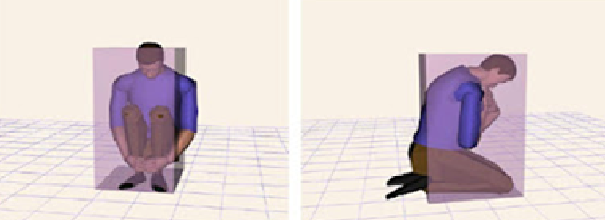
Figure 14.2 Sitting/Squatting Position Figure 14.3 Kneeling Position (4.2)

The space in the shaft bottom and shaft top clearance that can accommodate the required rectangular block is a refuge or shelter space in emergency situations.
If the elevator design does not fully comply with the relevant harmonized standards, what actions to take is explained in the Elevator Directive.

Compliance Principles:

EN 81-2:1998 § 5.7.1.1 – Compliance of elevator shaft clearance at the top floor height
EN 81-2:1998 § 5.7.2.3 – Elevator shaft bottom compliance
EN 81-2:1998 § 8.4 – Cabin skirt plate
As of 31/08/2017, TS EN 81-20 came into mandatory effect, specifying refuge area dimensions more explicitly, including refuge height. Elevator shafts for elevators manufactured according to this standard must have shaft bottom and top clearances compliant with it.
Elevators with declared speeds of 0.15 m/s and below are not covered under the Elevator Directive; these products are placed on the market according to the Machinery Safety Directive and have much lower shaft bottom and top clearances.

CHECKING THE SUITABILITY OF THE SHAFT WALLS, FLOOR, AND CEILING

Checking the suitability of the elevator shaft walls, floor, and ceiling is crucial for compliance with safety standards.
Shaft Walls Inspection:
- Durability: Walls must be made of high-strength, flat-surfaced, impact-resistant materials.
- Fire Resistance: Materials must withstand fire for at least 60 minutes (e.g., concrete or steel structures).
- Protrusions and Recesses: No protrusions or recesses exceeding 15 cm; if any, surfaces should be chamfered and leveled.
- Sealing: Walls must be designed to prevent liquid leakage.

Shaft Floor Inspection:
- Cleanliness and Safety: No flammable material, dirt, or water accumulation should be present.
- Lighting: Floor lighting must provide at least 50 lux.
- Refuge Area: There must be a safe working area of at least 0.5 m x 0.6 m x 1 m for maintenance personnel.
- Drainage: An effective drainage system should be installed if water ingress occurs.

Shaft Ceiling Inspection:
- Structural Strength: The ceiling must resist external impacts and conditions.
- Emergency Lighting: At least 5 lux emergency lighting should be installed.
- Access: The ceiling hatch must be easily openable with safety equipment (e.g., handles).
- Refuge Area: At least 0.5 m x 0.6 m x 0.8 m of clear space must be available on top of the cabin.

Inspection Process:
- Preparation: Gather lux meter, measuring devices, and inspection checklists.
- Visual Inspection: Check for cracks, deformations, or non-compliance in the physical structure.
- Measurements and Tests: Verify dimensions and compliance with standards.
- Reporting: Document any deficiencies in detail and provide recommendations for corrections.
- These inspections are usually performed by specialized teams and documented thoroughly.

