MODULE-10

Elevator Speed Governor (Speed Regulator)
What is an Elevator Speed Governor?
An elevator speed governor is a mechanism used to ensure the elevator does not exceed a specified speed limit. This device prevents the elevator from moving at excessive speeds, thereby ensuring safety.
How Does It Work?
The elevator speed governor is a speed detection device mounted in the elevator machine room. It has its own pulley that moves with a steel cable connected to the elevator cabin, meaning the governor pulley moves at the same speed as the cabin.
In simple terms, speed governors continuously monitor the elevator cabin’s speed. If the cabin accelerates excessively, a locking pawl inside the governor activates, causing the governor to engage a brake and trigger the cabin’s safety brake. (See Figure 10.1)
Before the governor mechanically engages, it electrically activates a safety contact to stop the elevator's movement. For elevators with a rated speed of 1.00 m/s or less, this electrical safety contact activates at or before the mechanical engagement of the speed governor.
When the governor cable stops moving, it triggers safety pawls (emergency brakes) which grip the guide rails, ensuring the elevator stops safely.
With advancements in technology, many foreign manufacturers have started producing electromechanical braking systems without speed governors, replacing the traditional governor-based brake systems long used in the industry.
There are many types of overspeed governors used in elevator systems depending on the application, including:
- UCM Coil-type
- UCM Non-coil-type
- Remote-controlled UCM coil-type
- Remote-controlled UCM non-coil-type
- Rail-type
- Pedestal-type
- Chain-pulley type (moves with the cabin)
- Tandem type
Speed governors and safety brake equipment are manufactured by meeting the requirements specified by the manufacturer according to TS EN 81-50 standard, clause 5.4, and other conditions outlined in TS EN 81-20.
A critical parameter is the speed at which the governor engages. According to clause 5.6.2.2 of the TS EN 81-20 standard, the safety equipment must ensure the speed governor engages under specified conditions.
Since most newly installed elevators have rated speeds of 1 m/s or higher, the governor engages considering these speeds.
Before mechanically engaging, the speed governor must electrically activate the safety contact and stop the elevator’s motion. For elevators with rated speeds 1.00 m/s and below, the safety contact activates at or before mechanical engagement; for speeds above 1.00 m/s, it must activate before mechanical engagement.
Speed governors are preset and calibrated before being supplied to the market. They are tested and sealed with springs adjusted to the engagement speed set between maximum and minimum speeds specified in the standard. This prevents installers from changing the settings later. Different springs with various stiffness and lengths are used for different speeds by manufacturers.

Types of Speed Governors
Elevator speed governors come in various types and have different features depending on their use:
- Mechanical Speed Governors: Control the elevator speed mechanically, usually activated via a rope or cable.
- Electronic Speed Governors: Use electronic sensors to monitor and control elevator speed electronically when needed.
- Hydraulic Speed Governors: Control elevator speed using hydraulic systems, employing hydraulic brakes to slow the elevator.
- Pneumatic Speed Governors: Use gas or air pressure systems to apply braking and control speed.

Maintenance and Inspection

Regular maintenance and inspection of elevator speed governors ensure safe and efficient elevator operation.

During inspections, check that mechanical connections are tight, the rubber wheel is not worn, there is no wear in the rope channel, and the electrical contacts are tested regularly.
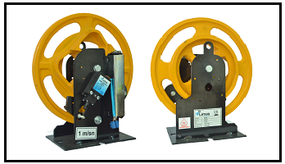

Figure 10.1 Various Types of Speed Governors

MODULE-10 APPLICATION AND OUTCOMES
INSPECTION OF THE SPEED GOVERNOR IN ACCORDANCE WITH STANDARDS
- Mechanical connections should be checked and tightened if loose.
- The rope channel should be inspected for wear; if wear is detected, the pulley must be replaced.
- The electrical contact should be tested using a measuring device.
- The rubber wheel should be checked; if worn, the wheel must be replaced.
- Check if the housing is present and intact.
- Visually inspect the governor in operation to confirm normal functioning.
- Check the label values; they must be compatible with the motor. (See Figure 10.2)
Additionally, the following points ensure proper standard maintenance of the speed governor:
- Cleaning: It is very important to keep the mechanical and electrical components of the speed governor clean. Dirt and oil deposits can prevent proper operation.
- Lubrication: Moving parts of the speed governor should be lubricated regularly. Proper lubrication reduces wear and extends the device’s lifespan.
- Electrical Tests: Electrical connections and control circuits must be regularly tested. Any loose connection or oxidation can cause failures.
- Brake System: The effectiveness of the speed governor’s brake system should be checked. If the brakes do not function properly, the device cannot stop safely.
- Vibration and Noise: Check whether the device produces abnormal vibrations or noise during operation. Such conditions may indicate mechanical problems.
- Trained Personnel: Maintenance should be performed by trained and experienced personnel. Proper and informed intervention ensures safe and efficient operation of the device.
Regular maintenance performed with attention to these factors ensures the safe and trouble-free operation of elevator speed governors.

PERFORMING SPEED GOVERNOR INSPECTIONS IN ACCORDANCE WITH STANDARDS
Standard inspections should be conducted according to the following points:
- The rated speed of the overspeed governor must be equal to or less than the rated speed of the elevator (design speed). The speed at which it engages must be less than 1.5 m/s for friction safety gears and instantaneous braking buffer type safety devices, and for rated speeds up to 1.0 m/s, it must engage at or before the mechanical engagement point.
- It must be verified that the overspeed governor is adjusted and sealed.
- The ratio between the diameter of the governor pulley (measured from center to center of the rope) and the nominal diameter of the governor rope must be at least 30.
- The governor rope must be tensioned by a tension pulley and guided by this pulley.
- During the operation of the safety device, the governor rope and its connections must not fail even if the braking distance exceeds the normal.
- If the speed governor is located inside the shaft, it must be accessible and reachable from outside the shaft.
- The rubber on the governor pulley (sheave) in the cabin must be replaced if worn.
- The governor base in the cabin must be firmly fixed.
- The speed governor must be securely mounted.
- The speed governor must be installed so that its operating direction is downward; if not, it must be corrected.
- Contact between the speed governor pulley and the wall must be prevented.
- Contact between the speed governor rope and the limit switch fork arms must be prevented.
- The speed governor must be put into working condition and checked.
- Remote access to the governor inside the shaft must be provided and the safety device test must be operable.
- If the speed governor does not automatically return to normal operation after the safety device is released, the elevator operation must be prevented by an electrical safety device according to TS EN 81-1 clause 14.1.2 until the speed governor returns to its normal position.
- The safety contact of the speed governor must be fixed.
- It must be confirmed that the locations where the speed governor is installed are accessible and reachable. (See Figure 10.3)

INSPECTION OF PROTECTION SYSTEM AGAINST UNINTENDED CABIN MOVEMENTS
Annex 3 (A3) was added to EN 81 in principle in 2009, introducing new definitions and additional safety measures for elevators [1].
Because A3 introduced significant innovations and changes, since its release it has been examined and discussed from various perspectives by all stakeholders in the elevator industry (manufacturers, installers, certifiers, etc.) [2].
To ensure compliance and product supply, the implementation deadline expired in 2012, making it mandatory that all newly commissioned elevators comply with the conditions in EN 81+A3.
The most important changes brought by EN 81+A3 are: cabin landing accuracy must be ±10 mm, and when the cabin is at the landing, a ±20 mm tolerance must be maintained by automatic leveling if necessary; the definition and prevention of unintended cabin movement.
Additional changes include definitions and measures for ensuring removed safety parts during maintenance are properly reinstalled, and the exclusion of systems operating below 0.15 m/s from the elevator standard scope.
1. DetectIon and PreventIon of UnIntended CabIn Movement
Different applications are possible for gearless and geared machines.
1.1. Detection and prevention of unintended cabin movement in gearless systems:
Gearless systems use motors with electromagnetic brakes on the drive shaft. These brakes are used to keep the cabin stationary, and they also serve as a safety component against uncontrolled upward movement.
In addition to these functions, they can be used to safely stop the cabin when unintended cabin movement is detected.
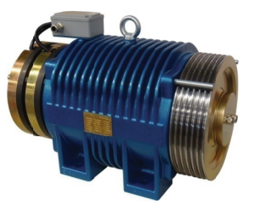
Figure 10.1 Synchronous Motor Used in Gearless Systems

1.2 Detection and Prevention of Unintended Cabin Movement in Geared Systems
In geared (asynchronous) elevator machines where the braking device is not on the main pulley shaft, and where no separate stopping mechanism is used on the pulley shaft or pulley, there is a need for a system that prevents unintended movement.
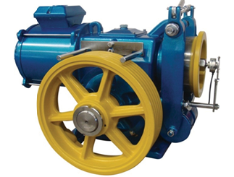
Figure 2. Screw Gearbox Elevator Motor
In this system, a classic speed governor is used. If the cabin speed exceeds the motor speed limits, the parachute mechanism is activated to stop the cabin by braking.
The first speed governor designed according to this system is the one developed for TSE EN 81-21, which contains a solenoid that normally keeps the governor locked while the cabin is stationary.
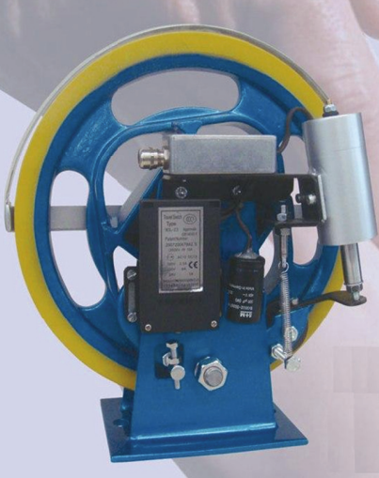
Figure 3. Normally Locked Speed Governor Compliant with EN81-21
Another speed governor developed considering the requirements of EN 81+A3 adopts a design approach different from the above by including the detection of unintended movement through the governor itself. In this way, the functions of unintended movement detection and stopping, which are defined separately in the standard, are combined into a single device.
For detecting unintended movement, after evaluating electronic solutions such as coupling an encoder or electronic counter to the governor pulley, a relatively more mechanical detection method was chosen due to higher system reliability and better immunity to electromagnetic noise. This method uses two inductive sensors that detect inductive protrusions at suitable intervals on the governor pulley.
Thanks to these inductive sensors, a contact combination is designed to lock the governor via a solenoid when two consecutive changes are detected in the door opening zone indicating any cabin movement. Additionally, microswitches that convert the coil's movement into an electrical signal are used to perform control functions such as dropping the brake contactor and cutting off the motor power circuit.
The main goal is to cut off the motor electrical circuit and bring the system to a stop after detecting unintended movement and before the slip brake is triggered.
The figure shows a speed governor designed in accordance with EN81+A3.

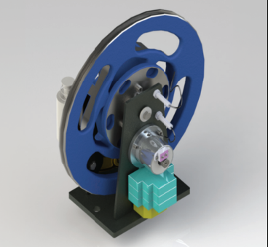
Figure 10.5 Speed Governor Designed According to EN81+A3
Since the enforcement of EN 81+A3 at the beginning of 2012, newly designed elevators are required to have the necessary equipment to prevent unintended cabin movements as stipulated by the standard.
The protection system against unintended cabin movements is a critical component for elevator safety. This system is designed to prevent uncontrolled movement of the cabin. The required checks for these operations are listed below:
1- Detection and Prevention:
The system detects unintended cabin movements and stops the cabin within allowed distances. This is ensured by a stopping accuracy of ±10 mm and leveling accuracy of ±20 mm. (10.6) This condition must be checked.
2- Locking Systems:
Locking systems that secure the cabin in place when stopped help prevent unintended movements. These should be inspected.
3- Electromechanical Brakes:
Electromechanical brakes used in gearless systems are employed to prevent uncontrolled cabin movements. These must be checked. (10.7)
4- Automatic Leveling:
Automatic leveling against unintended cabin movements increases safety and must be verified.
5- Safety Tests:
Regular safety tests should be conducted to ensure elevators comply with EN 81-1/2+A3 standards.
The results of these tests must be reviewed.

