MODULE-1
OCCUPATIONAL HEALTH AND SAFETY, FIRE AND EMERGENCY RULES
WHAT IS OCCUPATIONAL HEALTH?
Occupational health and safety (OHS) refers to systematic and scientific studies carried out to protect against conditions that may harm health during the execution of work in the workplace and to improve the existing health and safety conditions. (1.1)
WHAT IS OCCUPATIONAL SAFETY?
Occupational safety involves providing a healthy environment for employees in the workplace, protecting them from adverse effects of the working environment, ensuring the best possible harmony between work and the worker, completely eliminating or minimizing possible risks and damages (both material and moral), and increasing work and production efficiency. (1.2)
WHAT IS OCCUPATIONAL HEALTH AND SAFETY?
According to the International Labour Organization (ILO) and the World Health Organization (WHO), occupational health refers to activities aimed at maintaining and improving the physical, mental, and social well-being of employees in all occupations. On the other hand, occupational safety refers to the set of technical rules introduced to eliminate or, if not possible, reduce the dangers encountered by employees at work and in the workplace. Essentially, occupational safety primarily targets the elimination of risks that threaten the life and physical integrity of employees. (1.3)
Based on these definitions, it can be said that occupational health and occupational safety are complementary concepts. Improvements in health contribute to creating a safe environment by isolating threats for employees, while enhancing safety significantly helps to prevent occupational accidents and diseases, thereby contributing to a healthy and safe working environment. A standardized definition that brings these supporting concepts together in a single sentence is as follows:
Systematic and scientific studies carried out to protect against conditions that may harm health due to various reasons during the execution of work in workplaces are explained by the concept of “Occupational Health and Safety.”
This concept has three main objectives:
1. To Protect Employees:
This is the primary goal of occupational health and safety efforts. It includes reducing the negative effects on employees in the workplace, ensuring they work in a comfortable and safe environment, in other words, protecting employees against occupational accidents and diseases.
2. To Ensure Production Safety:
Ensuring production safety in a workplace is very important, as it increases productivity. If an environment free from occupational accidents and diseases is created with the help of occupational health and safety measures, the sense of security provided to employees will reduce workforce and workday losses, leading to increased productivity.
3. To Ensure Enterprise Safety:
Measures taken in the workplace can eliminate conditions that might endanger the enterprise, such as machinery failures, malfunctions, shutdowns, explosions, and fires resulting from unsafe or unhealthy working environments. This ensures enterprise safety.
Occupational health and safety is one of the most critical areas that require maximum effectiveness in the workplace. A robust legal structure should exist in a workplace that covers a maximum number of risks with a minimum number of regulations.
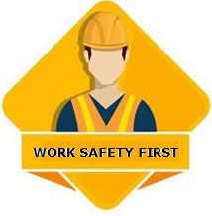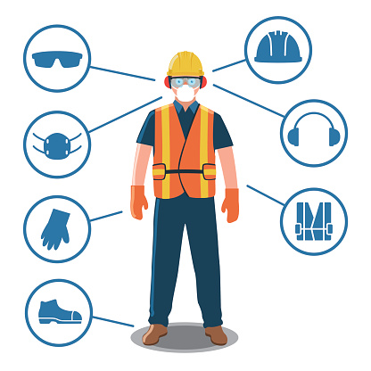
Figure 1.1. Occupational Safety Equipment
To implement occupational health and safety rules in the workplace and to ensure healthy production, it is necessary to receive training related to occupational health and safety.
Training should be received by both employees and employers.
WHAT IS OCCUPATIONAL SAFETY TRAINING?
Basic Occupational Health and Safety Training is a fundamental training program prepared to teach employees the general rules of occupational safety, how to protect themselves from accidents, raise awareness about the necessary precautions, and aim for a safer work environment. (1.4)
OCCUPATIONAL HEALTH AND SAFETY LEGISLATION
Employers are responsible for ensuring the health and safety of their employees. This is because the sources of dangers that threaten the physical and mental health of employees during work stem from the employer’s organizational activities. By entering into an employment contract, the employee becomes a part of the employer’s organization and is exposed to many workplace-related hazards and risks. For this reason, the employer has an obligation arising from the employment contract to safeguard the employee and ensure occupational health and safety.
Nevertheless, the relationship between occupational health and safety and the right to life, which is guaranteed by Article 17 of the Constitution, takes this matter beyond being just the responsibility of the employer or the employee. As a requirement of the social state principle, the state, society, and all stakeholders involved in this field are directly and closely responsible for occupational health and safety. Therefore, the state must intervene as a key actor in occupational health and safety.
This results in a tripartite legal relationship involving the state as a party, alongside the employee and employer, concerning occupational health and safety. (1.5)
Due to the constantly evolving nature of working life, frequent amendments are required in the legislation concerning this field.
Recently, the first legal regulation specifically related to occupational health and safety, Law No. 6331 on Occupational Health and Safety, has become actively effective in this area. In addition, Law No. 6098 (Turkish Code of Obligations) has significantly changed the provisions regarding employment contracts and introduced many new regulations. Substantial amendments have also been made to Law No. 4857 (Labor Law), particularly following the enactment of Law No. 6331, and the provisions related to occupational health and safety within this law have been repealed.
Risk Assessment and Management
What is Risk Management?
Risk management is the process of identifying, analyzing, and controlling threats that an enterprise may face concerning its capital and earnings. These risks can arise from various sources, such as financial uncertainties, technological issues, legal liabilities, strategic errors due to management, and environmental factors. For this reason, risk management has become more crucial than ever for modern enterprises. The risks encountered by businesses operating in competitive markets have become increasingly complex, driven by the rapid pace of globalization. (1.6)
In recent years, the COVID-19 pandemic can be considered an example of a global risk that entered our lives. Initially regarded as an external risk affecting the supply chain, the pandemic quickly intensified its impact, influencing employees' health and safety, ways of working, interactions with customers, and the corporate reputation of businesses.
Even though the pandemic process is now under control, the experience has led enterprises to consider how they can make their operations, employees, corporate reputation, and supply chains more resilient to external risks in the future.
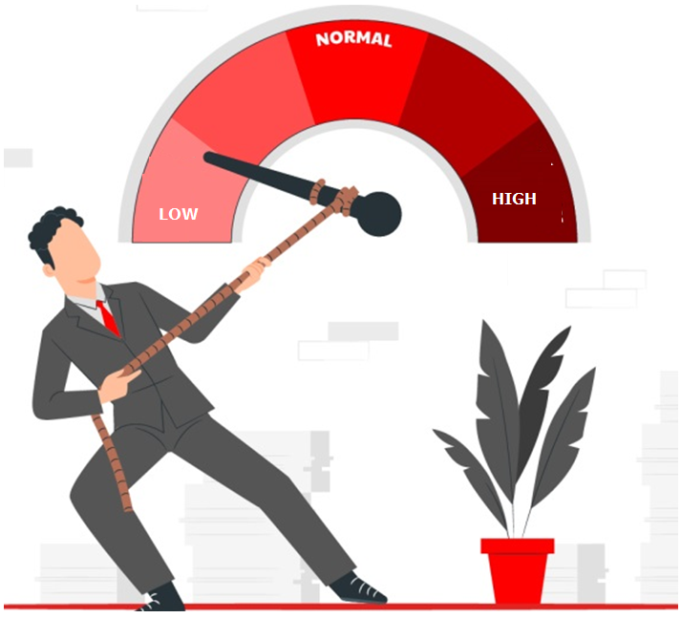
Figure 1.2. Risk Management

On the other hand, today’s businesses are achieving their strategic objectives by taking advantage of technologies such as social media, Machine Learning (ML), Big Data Analytics, Artificial Intelligence (AI), and Augmented Reality (VR), all of which have become widespread due to the proliferation of digital technology. However, this era also brings with it new, digitally-based risks for businesses.
This concept, known as digital risk, is one of the outcomes of digital transformation and is a type of risk that businesses must learn to manage if they wish to survive. All these mentioned risks—and many others—make effective risk management essential for businesses. A successful risk management program helps a business identify all potential risks in advance and find solutions to mitigate them. Risk management not only analyzes the potential risks faced by the business but also evaluates the cascading impact these risks might have on the enterprise’s strategic objectives. Therefore, it is of vital importance for managers to implement a risk management process within their organizations.
What is the Risk Management Process?
There are numerous resources that document what businesses need to do in order to manage risks effectively. In Turkey, one of the best sources explaining this process is the ISO 31000 Risk Management Standard, published by the Turkish Standards Institute (TSE).

Figure 1.3. Risk
The risk management process, which provides all these benefits to businesses and is structured in accordance with the ISO 31000 Standard, can be described using the following principles:
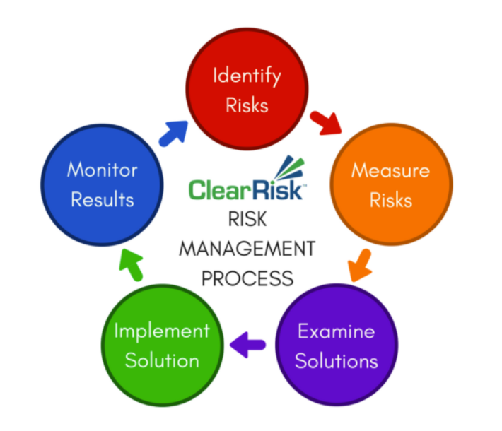
Figure 1.4. Risk Management Process

1. Identifying the Risk:
The first step in the risk management process is to identify all events that could negatively (risk) or positively (opportunity) affect the organization’s goals, including key stages of the process, the scope of the process, and financial infrastructure.
Identifying risks can be a positive experience that includes the participation of all employees, and it also enhances communication within the organization.
2. Measuring the Risk:
In the second step, you need to assess the likelihood of each identified risk occurring. It is useful to create a risk map for each potential risk, indicating both the probability of occurrence and the potential impact if it does occur.
This enables the organization to understand the frequency and severity of risks, helping to save time and money while allowing for a more efficient allocation of resources.
3. Exploring Alternative Solutions:
This step involves reviewing the alternative solutions businesses can implement in response to the risks they face. At this stage, the most appropriate solution is identified. The options typically include:
Avoiding the risk: The business avoids the risk by withdrawing from the activity that creates it.
Reducing the risk: The business takes action to limit or reduce the impact of the potential risk.
Transferring the risk: The business attempts to reduce the impact and cost of the potential risk by transferring it to a third party, such as an insurance company.
Accepting the risk: The business acknowledges the risk without taking preventive measures.
4. Implementing the Appropriate Solution:
In this step, the organization selects and implements the most suitable solution for each potential risk. During this process, employees are involved, properly informed, and if necessary, trained on the issue. This helps ensure consistent implementation of risk solutions across the organization.
5. Monitoring the Results:
Risk management is not a one-time project but an ongoing process, as the risks businesses face are constantly evolving. Therefore, it is crucial to develop a reporting infrastructure to monitor potential risks and recommend appropriate solutions. Additionally, reviewing the solutions applied to previously encountered risks can provide valuable insights for managing future risks.
Risk Assessment Processes and Building a Safety Culture in the Workplace
Today, occupational health and safety (OHS) is vital for increasing workplace productivity and protecting employee well-being. Risk assessment processes and establishing a safety culture are critical components in preventing workplace accidents and ensuring legal compliance.
Risk Assessment Processes:
Risk assessment is a systematic process designed to identify potential hazards that threaten the health and safety of workers and to plan measures to minimize these risks. The steps include:
Hazard Identification:
Identifying existing or potential hazards in the workplace, including physical, chemical, biological, and ergonomic risks.
Risk Analysis and Evaluation:
Analyzing the possible impacts of identified hazards on employees and evaluating the likelihood of their occurrence.
Risk Control:
Planning and implementing technical and administrative measures to reduce risks to a minimum.
Review and Continuous Improvement:
Periodically reviewing the risk assessment process to identify new risks and enhance current preventive measures.
Creating a Safety Culture in the Workplace
A safety culture emerges when employees and managers adopt attitudes and behaviors that prioritize occupational health and safety. To foster a strong safety culture, the following steps should be taken:
Management Commitment:
Top management must lead by example and take the initiative on safety matters.
Training and Awareness:
Employees should receive regular training on occupational health and safety topics.
Participation and Communication:
Encourage active participation of employees in safety processes and maintain open communication.
Monitoring and Feedback:
Regularly audit safety practices and provide constructive feedback for improvement.
Incentives and Recognition:
Encourage and reward employees who follow safety rules and prioritize safety in their work.
Effective implementation of risk assessment processes and building a safety culture is critical to preventing workplace accidents and safeguarding employee health. These processes support continuous improvement and help create a safer work environment.
Furthermore, applying the following measures will also help reduce risk factors in the workplace.

1. Work Accidents and Occupational Diseases
Causes of Work Accidents and Precautionary Measures to Prevent Them
Work Accident:
The term "accident" is defined in dictionaries with descriptions such as: "without a visible cause," "unexpected," "aimless behavior," or "coincidence." In some cultures, accidents are interpreted merely as "fate" without making any effort to understand the underlying causes. Clearly, a single definition cannot adequately explain all aspects of accidents. (1.7)
There are various definitions of work accidents. According to the International Labour Organization (ILO), a work accident is defined as "an unplanned and unexpected event that results in specific damage or injury."
Another definition describes a work accident as "an event that suddenly occurs while the worker is traveling to work or training, or while working inside the enterprise, or maintaining work tools, resulting in physical harm to the worker."
The World Health Organization (WHO) defines work accidents as "unplanned events that often lead to personal injuries, damage to machinery, tools, or equipment, and may cause production to be halted for a certain period of time."
From a social policy and occupational safety perspective, work accidents are defined as:
“An event in which the worker, due to working conditions, the nature and execution of the work, or the machines, tools, and materials used, is harmed during work hours, resulting in partial or total loss of labor capacity.”
According to Social Insurance Law No. 506, work accidents within the context of social insurance are evaluated based on the extent to which a person’s earning capacity is affected. The law defines them as events that cause disability.
The concept of an accident generally refers to the outcome of an event. For instance, an accident can be defined as:
“An undesired event that damages a system or individual, or negatively affects the achievement of the system’s purpose or the individual’s task.”
For an event to be classified as an accident, it is generally expected to score low in the following areas:
Predictability
Avoidability
Intent (inclination to cause the accident)
In other words, accidents are undesired, unavoidable, and unintentional interactions with the environment. The more these criteria are met, the more likely it is for an event to be defined as an accident.
Main Causes of Work Accidents
Approaches to Accident Causation
When evaluating accident causes from a general perspective, it is evident that human error is almost always involved in some way. However, this human-related error is not limited solely to the individual who was injured or directly involved in the incident.
In most cases, the concept of human error has been used to describe operator mistakes or errors made by injured workers. However, this is only a narrow part of the full scope of human error. Broader systemic and organizational factors often contribute to accidents as well.
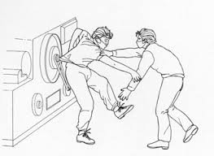
Figure 1.5. Work Accidents
From the architect who designed the factory project, to the engineer who planned and installed the machinery, from the maintenance and repair worker, to the operator and even the factory doctor—a wide range of individuals may be responsible when it comes to errors.
From a broader perspective, some researchers have summarized this with the statement:
"The root cause behind all accidents is human."
Unsafe Conditions and Acts
The cause of a work accident is not limited to the person who was injured during the incident—many contributing factors play a role. Based on this, many recent researchers have examined accidents under the categories of "unsafe conditions" or "unsafe acts."
Research shows that accidents are often linked to unsafe behaviors and hazardous conditions.
According to these researchers, both elements are usually present in any given accident.
Unsafe Conditions (Hazardous Situations)
All conditions that compromise workplace safety and pose dangers in the work environment—generally arising from the environment, machinery, or materials—are considered unsafe conditions.
Examples include:
Machines without protective guards, or machines with inadequate safety measures, as well as errors in assembly or design
Defective or incomplete equipment
Slippery, weak, or damaged floor surfaces
Failure to select production systems suitable for the physical properties of the materials used
Improper use of machines for the tasks at hand
Disorganized workplace, inadequate lighting, noise, temperature issues, and poor health conditions in the work environment
All of these are classified as unsafe conditions.
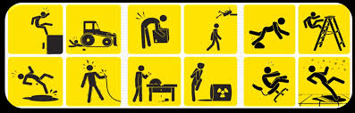
Figure 1.6. Work Accidents Caused by Unsafe Conditions
Unsafe Acts (Hazardous Behaviors)
Unsafe acts stem from faulty actions and behaviors of employees that jeopardize workplace safety. Factors such as education level, experience, and psychological state of workers play a significant role in the occurrence of unsafe acts.
Examples include:
Assigning workloads or overtime that are inappropriate for the worker’s education level or physical and mental capacity
Lack of awareness about safety measures or disregard for their importance
Not using or disabling existing protective safety measures
Using unsafe materials, improper loading and stacking, and performing maintenance or repairs on running machinery or equipment
Behaviors such as horseplay or causing distractions in the workplace
A key factor is that workers continue working without proper awareness, leaving themselves vulnerable to accidents. As a result, the likelihood of injury during an accident becomes very high.
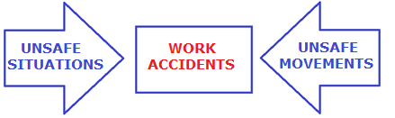
Figure 1.7. The Impact of Unsafe Acts on Work Accident
Accident Theories
Several theories have been developed to explain the causes of accidents, including:
Domino Theory
Human Factors Theory
Accident/Incident Theory
Epidemiological Theory
System Theory
Combination Theory
1. Domino Theory
One of the earliest developed accident causation theories. This theory suggests that injuries result from a series of factors. The Domino Theory consists of ten statements often referred to as industrial safety actions. According to this theory, there are five basic factors leading to accidents:
Hereditary-social environment, human error, unsafe acts/mechanical or physical hazards, accident, and injury.
2. Accident/Incident Theory
This theory is an extended version of the Human Factors Theory. Additionally, it introduces new elements such as ergonomic deficiencies, error-prone decisions, and system failures.
3. Epidemiological Theory
This theory argues that models used to determine and study the relationship between environmental factors and diseases can also be applied to explain the causal relationship between environmental factors and accidents.

4. System Theory
This theory views any situation where an accident can occur as a system consisting of three components:
(Note: The three components are not listed in the original text. Usually, they are human, machine, and environment.)
5. Combination Theory
This theory claims that no single theory can explain all incidents by itself. According to Combination Theory, the true cause of accidents can be derived from a combination of two or more models.
6. Human Factors Theory
This theory connects accidents to a chain of events ultimately caused by human error. It includes three major factors that lead to human error:
Overload
Inappropriate response
Misplaced activities
Accidents resulting from human error depend on many factors. Undoubtedly, fundamental human factors include the worker's lack of education, unsuitability for the job, incompatibility, lack of training and knowledge, inexperience, fatigue, emotional states such as excitement or sadness, absent-mindedness, carelessness, indifference, disorganization, lack of skill, and illness, among others. Additionally, a worker’s failure to comply with rules despite these factors is also a key cause linked to human factors.
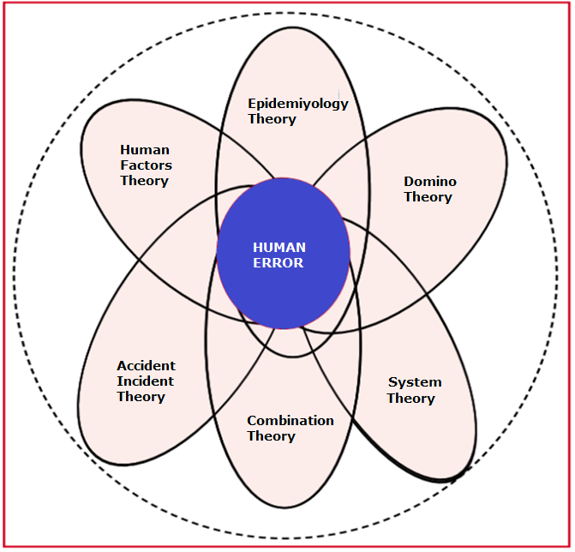
Figure 1.8. Accident Theories Theory

Human Error
Approaches related to "human error" in safety studies first found application in the military during World War II and gradually expanded to the chemical and transportation sectors. Nowadays, these types of studies are frequently used in industries such as weapons manufacturing and nuclear power plants for the quantitative evaluation of human errors.
Despite the difficulties in determining the percentage of accidents attributable to human error, many researchers have succeeded in this task. Starting with Heinrich (1959), such studies have continued to the present day. Heinrich determined that 85% of accidents are caused by human errors.
More recent researchers, Sanders and Shaw, conducted fifteen studies on this topic and found that the percentage of accidents potentially caused by human error varies between 4% and 90%. They examined 338 accident cases and stated that in 50% of the accidents, the primary cause was human error; however, in no case was the cause solely human error.
An important secondary factor that can affect the proportion of accidents attributed to human error is which other factors are considered alongside human error during the analysis.
In light of accident causation theories, various classifications have been developed attempting to illustrate unsafe behaviors and factors contributing to accidents. The oldest model categorizes accidents as caused either by unsafe human behaviors or unsafe environments.
In the literature, the causes of work accidents and contributing factors often overlap with accident causation theories and accident classifications. Sometimes these terms are used interchangeably, and as a result, no universally accepted classification or consensus has yet been established.
Therefore, in this study, alongside accident causation theories, approaches developed up to the present related to the topic have been compiled and examined.
A person is in close interaction with their environment, workplace, and the materials, machinery, and equipment they use.
Of course, within these interactions, not just one but multiple factors play a role in the occurrence of an accident. Thus, beyond explaining accidents, perhaps a more useful approach is the evaluation of factors contributing to accidents.
It is certainly not possible to explain the causes of accidents by only one of the classifications or factors described in this study. Treating these factors independently has some limitations. The belief that accidents result from the combined influence of multiple factors at varying degrees has gained strong acceptance. Therefore, in efforts to prevent accidents, all related factors should be analyzed together, and new techniques should be developed to alert management about accident-causing elements, enabling early preventive actions.
New work in this field should be supported by the interdisciplinary scientific discipline known as Ergonomics. This is because the total safety of a workplace depends on the safe design of all physical, psychological, and sociological working conditions, and consequently, the provision of working conditions appropriate to human performance and capacity.

Figure 1.9. Human Factor in Work Accidents
Measures to Minimize Work Accidents
Minimizing work accidents is of great importance both to ensure the safety of employees and to increase work efficiency. The following steps should be implemented in workplaces to prevent accidents:
Organize Occupational Health and Safety (OHS) Training
Regular occupational health and safety (OHS) training should be provided to employees.
Especially new employees should undergo an orientation program focused on workplace safety.
Training on emergency procedures should be conducted.
Conduct Risk Assessment
Potential hazards in the workplace should be identified and risk analysis performed.
Additional safety measures should be taken for high-risk areas.
The risk assessment process should be regularly reviewed and updated.
Ensure Use of Personal Protective Equipment (PPE)
Employees should be provided with appropriate personal protective equipment (helmet, gloves, goggles, safety shoes, etc.) required for their tasks.
Use of protective equipment should be monitored, and employees encouraged to comply.
Equipment should be regularly maintained and replaced when necessary.
Create a Safe Working Environment
Work areas should be kept orderly, clean, and safe.
Warning signs, barriers, and safety markings should be placed in hazardous zones.
Physical risks such as slippery floors and inadequate lighting should be eliminated.
Perform Regular Inspections and Controls
Regular safety inspections should be conducted at the workplace.
Checks should be made for any deficiencies or hazards in the work environment and equipment.
Identified shortcomings should be corrected promptly.
Encourage Employee Participation
Employees should be actively involved in safety processes.
Suggestions and feedback related to safety should be taken into consideration.
Employees who comply with safety rules should be rewarded.
Prepare Emergency Plans and Conduct Drills
Plans should be developed for emergencies such as fires, explosions, or chemical spills.
Regular emergency drills should be held to teach employees how to act in crises.
Ensure Compliance with Legal Regulations
Full compliance with occupational health and safety laws must be ensured.
Current regulations should be followed and integrated into the workplace.
Adjustments should be made to avoid deficiencies during official inspections.
In conclusion, minimizing work accidents is only possible through the joint efforts of employers and employees. For this, OHS training is essential and mandatory.
How to Receive Basic Occupational Health and Safety (OHS) Training?
Those who want to receive Basic OHS Training can apply to authorized training centers that provide this education. Trainings are generally conducted face-to-face, but recently online training options have also become widespread. (1.8)
Face-to-Face Trainings: These trainings are usually delivered in a classroom setting by expert instructors. During the training, participants receive both theoretical knowledge and practical applications.
Distance Trainings: Distance Basic OHS Training options allow employees to receive training outside of working hours or from their homes. These trainings are preferred for their flexibility.
After completing the training, participants are given an OHS certificate. This certificate is a legally required document at the workplace and indicates that the employees have sufficient knowledge about occupational health and safety.
Every employee is required to take and implement this training. As a result of this process:
They keep OHS protective and intervention tools in proper and working condition.
They ensure the safety of the work area and personnel by placing and maintaining warning signs and labels according to instructions related to the work.
They ensure that flammable and explosive materials are stored safely.
What is Work Equipment?
According to the Regulation on Health and Safety Conditions in the Use of Work Equipment, any type of machinery, tools, installations, and facilities used in the execution of work are defined as work equipment.
In the elevator sector, using appropriate equipment is also legally mandatory. (1.9)
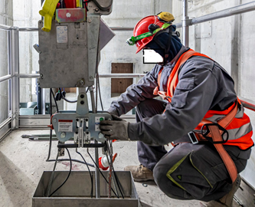
Figure 1.10. Proper Use of Work Equipment

Emergency Procedures Specific to Machinery and Work Processes
These procedures are applied to ensure workplace safety and prevent hazards.
Some basic procedures include:
Emergency Stop Button: A button that can quickly stop the machine or system in any situation that threatens work safety or disrupts production quality.
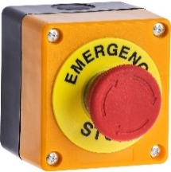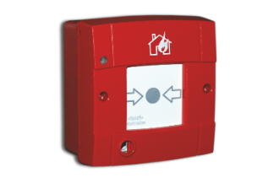
Figure 1.11. Various Emergency Stop Buttons
Exit and Escape Procedures: These are established procedures to ensure that employees can safely find exit routes and escape during emergencies.
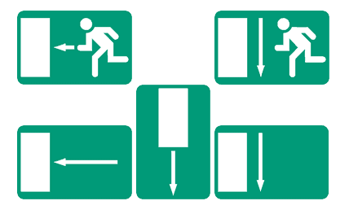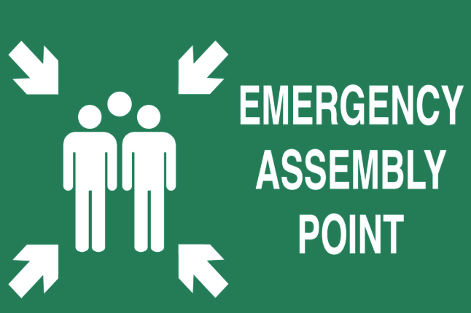
Figure 1.12. Various Exit and Escape Plans
Communication and Notification Systems: Rules and systems set up to quickly notify authorities and employees in case of an emergency.

Figure 1.13. Emergency 911 or 112 Call Center Symbol
Equipment and Tool Inspections: Regular inspections of machines and equipment and taking necessary measures to ensure their safety.

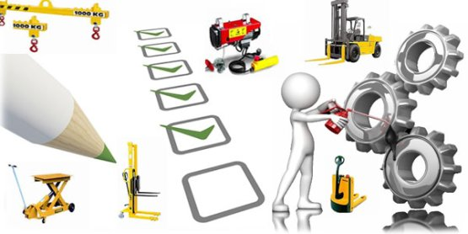
Figure 1.14. Equipment Inspection
Training and Warnings: Regular training sessions and warnings to ensure employees know the emergency procedures and can respond quickly when needed.

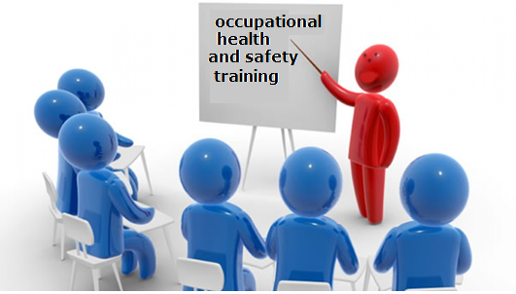
Figure 1.15. Occupational Safety Training

MODULE APPLICATION AND OUTCOMES
Implementing Occupational Health and Safety Rules in Compliance with Legislation
Applying occupational health and safety (OHS) rules correctly in elevator maintenance and repair is crucial to protect workers' safety and health. According to the Elevator Operation and Maintenance Regulation (Official Gazette dated 29/6/2016, No. 29757) valid in Turkey, compliance with OHS rules is mandatory. The regulation requires regular maintenance, periodic inspections, and repairs of elevators. Additionally, those who install and maintain elevators must work in accordance with occupational health and safety standards.
Implementing Legal and Workplace-Specific Occupational Health and Safety Rules
Legal regulations and workplace-specific rules concerning occupational health and safety in elevator maintenance and repair are designed to protect employees' safety. The General Directorate of Occupational Health and Safety (İSGM) published the report titled Risk Assessment and Solution Recommendations in Elevator Maintenance Work, which evaluates the risks that may arise during maintenance and offers solutions.
Key precautions include:
Employing trained personnel,
Providing suitable and adequate equipment,
Using safety harnesses in areas with fall and slip risks,
Ensuring electrical work is performed only by authorized personnel,
Correct marking on equipment,
Taking necessary safety measures in the working area.
Reducing Risk Factors
Reducing risk factors in elevator maintenance and repair is vital for both worker safety and proper functioning of the elevator. Some practical methods include:
Training and Awareness: Workers should receive regular training on OHS, equipment use, and emergency procedures.
Personal Protective Equipment (PPE): Workers must use required protective gear such as helmets, safety glasses, gloves, and safety harnesses.
Regular Inspections: Periodic checks of elevators and maintenance equipment help detect hazards early.
Proper Tools and Equipment: Appropriate tools must be used to carry out work safely and correctly.
Markings and Warnings: Hazardous areas should be clearly marked, and warnings provided.
Electrical Safety: Electrical tasks must be done by authorized personnel after ensuring power is cut off.
Ergonomic Working Conditions: Avoid prolonged, strenuous positions by providing ergonomic work environments.
Emergency Plans: Prepare and train employees on emergency response plans.
Work Continuity and Rest Periods: Ensure workers have adequate rest and balanced workloads.
These steps help minimize risks and maintain a safe working environment.
If you want, I can also provide a version tailored for a specific audience or industry terminology. Would you like that?

IMPLEMENTING EMERGENCY PROCEDURES IN CASE OF DANGER
Applying emergency procedures during elevator maintenance and repair in dangerous situations is critical to ensure the safety of both workers and users. The general steps to be followed are:
Assess the Situation: First, evaluate the nature and severity of the danger to determine the correct actions.
Activate Emergency Plan: Implement the workplace’s emergency plan, which includes predefined steps and responsibilities.
Notify Authorities: Immediately inform the relevant authorities and personnel. Use communication channels to provide necessary information.
Cut Off Electricity: If the danger involves electricity, cut the main power supply to ensure safety.
Evacuation and First Aid: Ensure the safe evacuation of workers and users. Alert first aid teams if necessary and assist the injured.
Safe Assembly Area: Gather people in a safe area away from the hazardous zone.
Coordinate with Authorities: Work with fire department, ambulance, and other emergency services to control the situation.
Incident Report: Prepare a detailed report about the incident and actions taken. This will help prevent similar situations in the future.
Improvement Measures: Review and improve emergency procedures and safety measures based on the incident.
These steps are vital for quick and effective response during emergencies to protect human health.

IMPLEMENTING EMERGENCY EXIT PROCEDURES
Applying emergency exit procedures during elevator maintenance and repair is essential for the safety of both workers and users. The general steps to be followed are:
Assess the Situation: Quickly evaluate the emergency situation in the elevator and decide to implement emergency exit procedures.
Emergency Button: Use the emergency button inside the elevator cabin to call for help.
Cut Off Electricity: If the emergency involves electricity, cut the main power supply to ensure safety.
Stabilize the Elevator Cabin: Secure the elevator cabin to prevent any movement.
Open Doors Manually: Manually open the elevator doors to allow safe exit of the people inside. This should be done by trained personnel.
Evacuation: Ensure safe evacuation of people from the elevator using stairs or emergency exits.
Safe Assembly Area: Gather people in a safe area away from the danger zone.
Notify Authorities: Immediately inform relevant authorities and personnel using communication channels.
Incident Report: Prepare a detailed incident report describing the situation and actions taken, to aid future prevention.
These steps ensure a rapid and effective response during emergencies.

SECTION ASSESSMENT
1- Which of the following refers to systematic and scientific efforts made to protect against conditions that may harm health during the execution of work at the workplace and to improve the existing health and safety conditions?
A- Occupational Safety
B- Occupational Health
C- Ensuring Production Safety
D- Ensuring Business Safety
2- What is the primary duty of employers?
A- To pay their employees.
B- To ensure the protection of employees' health and safety.
C- To provide training to employees.
D- To give leave to employees.
3- What is the process called that involves identifying, analyzing, and controlling threats to a business's capital and profits?
A- Occupational safety
B- Occupational health
C- Risk management
D- Giving leave to employees
4- What is the term for unplanned events that often cause personal injuries, damage to machines, tools, and equipment, and may lead to a temporary halt in production?
A- Work accident
B- Risk
C- Work training
D- Risk management
5- What are the factors leading to human error in work accidents?
A- Overload, inappropriate response, and misplaced activities.
B- The environment in which the person lives, workplace, and surroundings
C- Education, city of residence, age
D- Culture, language, country

